[](https://www.comsol.com/)

Thetau0p020a

|  |  |
| --- | --- |
| Report date | Jun 1, 2025, 10:12:22 PM |

Contents

1. Global Definitions

1.1. Parameters

1.2. Functions

2. Component 1

2.1. Geometry 1

2.2. Weak Form PDE

2.3. Mesh 1

3. Study 1

3.1. Time Dependent

3.2. Solver Configurations

4. Results

4.1. Data Sets

4.2. Plot Groups

# Global Definitions

|  |  |
| --- | --- |
| Date | Apr 19, 2025, 8:20:34 PM |

Global settings

|  |  |
| --- | --- |
| Name | Thetau0p020a.mph |
| Path | /media/amaury/Expansion/Geoquimica2025/HansDanoutubro2023/casos/01032024c-d2A/comsol/austad/thetazero/thetau0p020a.mph |
| Version | COMSOL Multiphysics 6.2 (Build: 339) |
| Unit system | SI |

Used products

|  |
| --- |
| COMSOL Multiphysics |

Computer information

|  |  |
| --- | --- |
| CPU | 12th Gen Intel(R) Core(TM) i5-12500H, 8 cores, 31.04 GB RAM |
| Operating system | Linux |

## Parameters

Parameters 1

| **Name** | **Expression** | **Value** | **Description** |
| --- | --- | --- | --- |
| se2 | ((0.5 - swc)/(1 - swc))^(-1/labda) | 1.3128 | normalization factor capillary pressure |
| krww | ((1 - sor - swc)/(1 - swc))^(2/labda + 3) | 0.70651 |  |
| kroo | (1 - ((1 - sor - swc)/(1 - swc)))^2*(1 - ((1 - sor - swc)/(1 - swc))^(2/labda + 1)) | 0.0011938 |  |
| TTK | (71.11 + 273.15)[K] | 344.26 K | temperature |
| fac | 0 | 0 | pressure stabilization |
| Clbound | 0.04 | 0.04 |  |
| sigma | 0.03[N/m] | 0.03 N/m | surface tension |
| swc | 0.10398[1] | 0.10398 | connate water |
| spsat | 0.2/5000 | 4E−5 |  |
| sor | 0.081[1] | 0.081 | residual oil |
| Clinit | 4 | 4 | clhoride |
| phi | 0.37[1] | 0.37 | porosity |
| muw | 1.0e-3[Pa*s] | 0.001 Pa·s | viscosity |
| difu | 1.0e-4 | 1E−4 | pressure diffusion |
| uinj | 1.0e-5[m/s] | 1E−5 m/s | injection velocity |
| difsw | 1.0e-09[m^2/s] | 1E−9 m²/s | capillary diffusion |
| dif | 1.0e-08[m^2/s] | 1E−8 m²/s | diffusion coeff |
| pleft | 10 | 10 | inlet pressure |
| dift | 10 | 10 | time stabilization |
| pright | 10 - 0.1/2.4 | 9.9583 | outlet pressure |
| pHbound | 3.8 | 3.8 |  |
| pHinit | 3.8 | 3.8 |  |
| muo | 2e-3[Pa*s] | 0.002 Pa·s | oil viscosity |
| labda | 3.0[1] | 3 | parameter for rel perms |
| rat | 4e-5/2.4e-6 | 16.667 |  |
| perm | 5.0e-7[m^2] | 5E−7 m² | permeability |
| HRAT | 5.94[1] | 5.94 | ratio aq/oleic henry coef |
| roo | 800[kg/m^3] | 800 kg/m³ | oil density |
| fww | krww/muw/(krww/muw + kroo/muo) | 0.99916 |  |
| fac1 | 0.01*Do | 5.9755E−6 |  |
| difsw1 | 0.01*Do | 5.9755E−6 | diffusion |
| difsw12 | 0.01*D1 | 5.9755E−6 | diffusion |
| difsw13 | 0.01*D1 | 5.9755E−6 | diffusion |
| difsw2 | 0.01*Do | 5.9755E−6 | diffusion |
| dif2 | 0.3*Do | 1.7926E−4 | diffusion |
| difsw3 | 0.5*Do | 2.9877E−4 | diffusion |
| difsw31 | 0.01*D1 | 5.9755E−6 | diffusion |
| difsw4 | 0.01*Do | 5.9755E−6 | diffusion |
| difsw41 | 0.01*D1 | 5.9755E−6 | diffusion |
| uinj2 | 1.004*uinj | 1.004E−5 m/s |  |
| dif3 | 0.01*Do | 5.9755E−6 | diffusion |
| uini | 0.00001 | 1E−5 |  |
| c | 0.0005 | 5E−4 |  |
| Do | 0.00059754975251 | 5.9755E−4 | diffusion |
| D1 | 0.00059754975251 | 5.9755E−4 |  |
| difsw42 | 0.01*Do | 5.9755E−6 |  |
| u | uinj | 1E−5 m/s |  |
| difswn | 0.01*Do | 5.9755E−6 |  |
| difn | 0.01*D1 | 5.9755E−6 |  |
| dfsw2 | 0.01*Do | 5.9755E−6 |  |
| u4 | 0.00001 | 1E−5 |  |
| as | 1 | 1 |  |
| swc1 | 0.20 | 0.2 |  |
| ko | 0.5 | 0.5 |  |
| kw | 0.25 | 0.25 |  |
| no | 2 | 2 |  |
| nw | 3 | 3 |  |
| SorwLS | 0.15 | 0.15 |  |
| SorwHL | 0.35 | 0.35 |  |
| theta1 | (sor - SorwLS)/(SorwHL - SorwLS) | −0.345 |  |
| kwhl | 0.25 | 0.25 |  |
| kwls | 0.41 | 0.41 |  |
| kohl | 0.5 | 0.5 |  |
| kols | 0.75 | 0.75 |  |
| theta2 | 0.8 | 0.8 |  |
| tbplow | 0.3841 | 0.3841 |  |
| tbphigh | 0.534 | 0.534 |  |
| tbp | 0.3942 | 0.3942 |  |
| theta_old | (tbp - tbplow)/(tbphigh - tbplow) | 0.067378 |  |
| mgl | 0.02 | 0.02 |  |
| mgh | 2.38 | 2.38 |  |
| newformu | 1 | 1 |  |
| tbpn | tbp(pHinit, Clbound, mgh) | 0.65303 |  |
| tbpls | tbp(pHinit, 0.049, 7) | 0.65374 |  |
| tbphs | tbp(pHinit, 4.3, 0.01) | 1.1198 |  |
| thetap | (tbpn - tbpls)/(tbphs - tbpls) | −0.0015277 |  |
| kol | 1.26 | 1.26 |  |
| koh | 0.54 | 0.54 |  |
| nol | 3.38 | 3.38 |  |
| noh | 4.47 | 4.47 |  |
| kwh | 2.92 | 2.92 |  |
| kwl | 3.6 | 3.6 |  |
| nwl | 7.05 | 7.05 |  |
| nwh | 3.92 | 3.92 |  |
| theta | 0.2 | 0.2 |  |

## Functions

### Clinin

|  |  |
| --- | --- |
| Function name | Clini |
| Function type | Analytic |

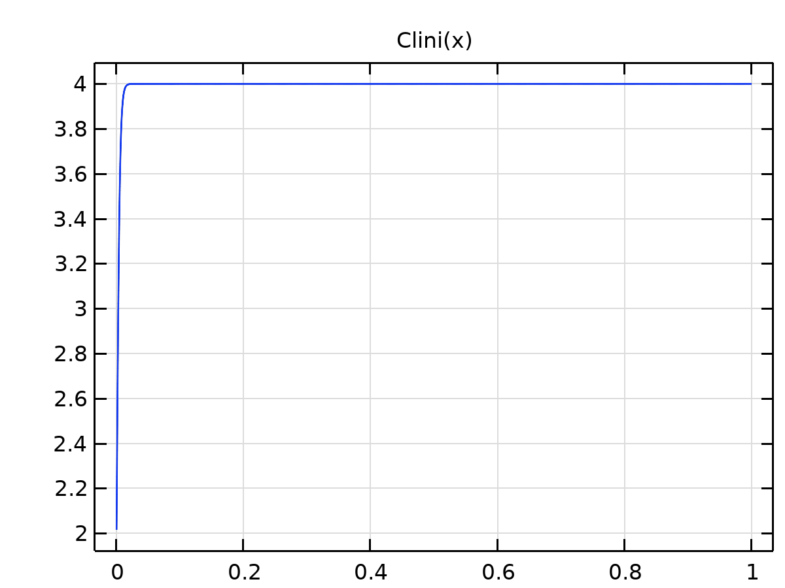

Clinin

Definition

| **Description** | **Value** |
| --- | --- |
| Expression | Clinit + (1 - tann(x))*(Clbound - Clinit) |
| Arguments | x |

Units

| **Argument** | **Unit** |
| --- | --- |
| x |  |

### Piecewise 4

|  |  |
| --- | --- |
| Function name | fo |
| Function type | Piecewise |

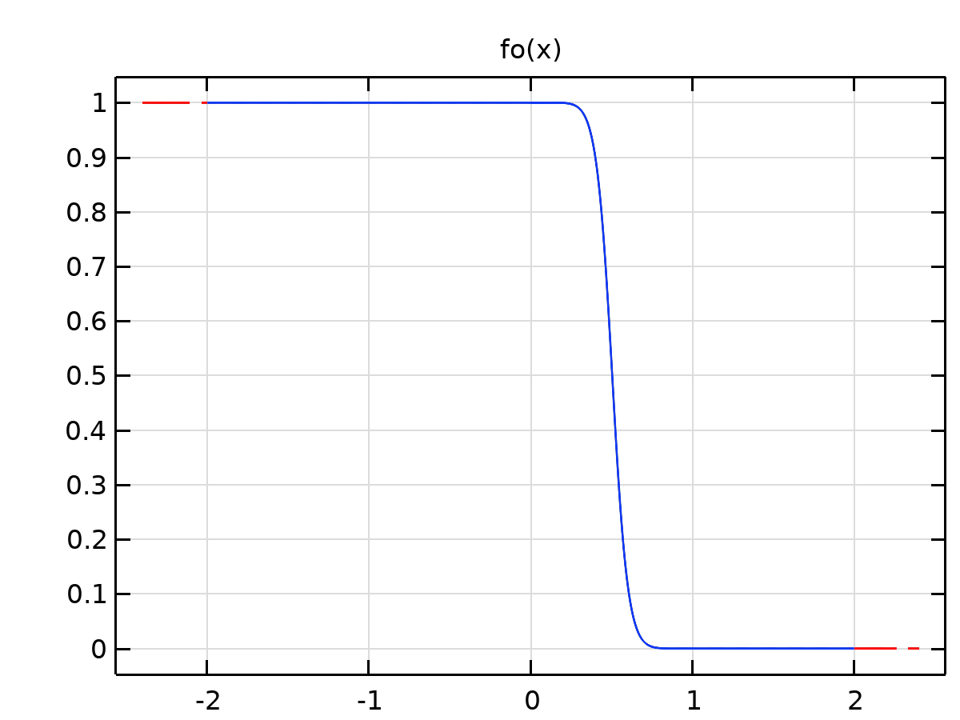

Piecewise 4

Definition

| **Description** | **Value** |
| --- | --- |
| Argument | x |
| Extrapolation | Constant |
| Smoothing | Continuous second derivative |
| Size of transition zone | 0.01 |

Definition

| **Start** | **End** | **Function** |
| --- | --- | --- |
| -2 | swc | 1 |
| swc | 1 | kro(x)/muo/(krw(x)/muw+kro(x)/muo) |
| 1 | 2 | 0 |

### Piecewise 3

|  |  |
| --- | --- |
| Function name | fw |
| Function type | Piecewise |

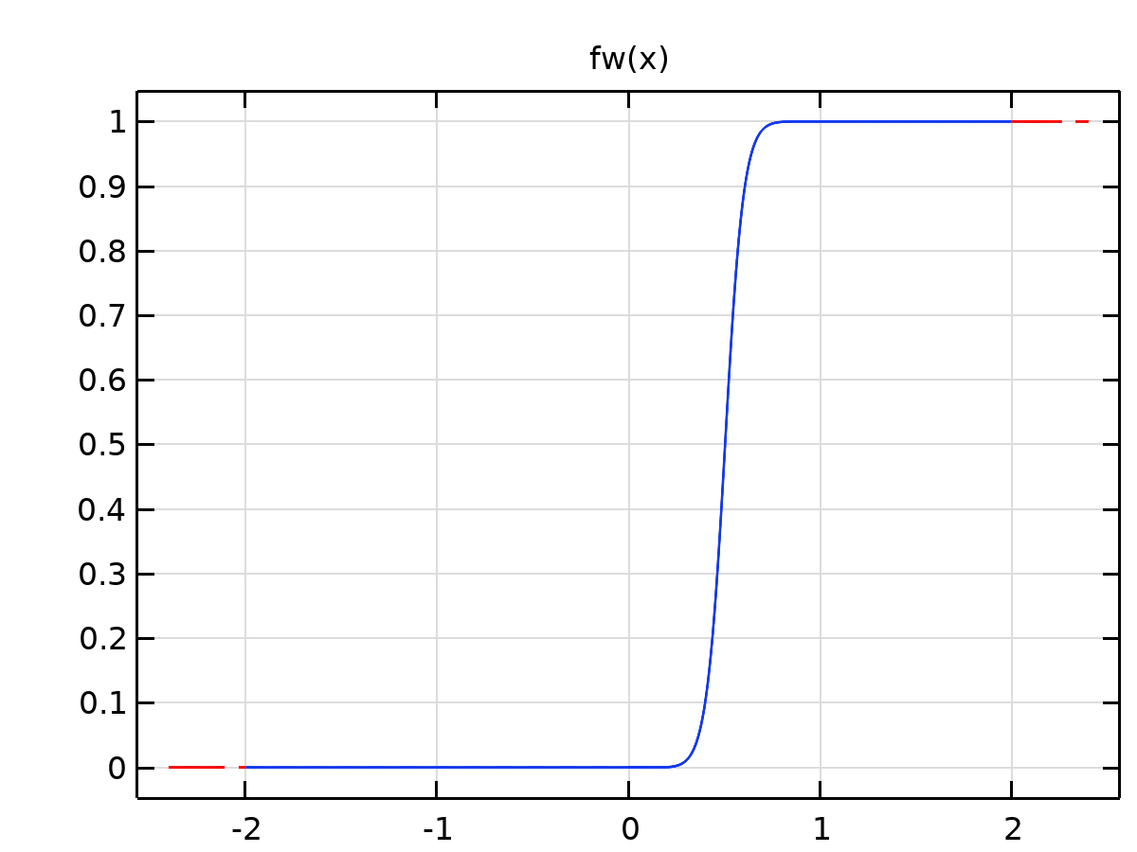

Piecewise 3

Definition

| **Description** | **Value** |
| --- | --- |
| Argument | x |
| Extrapolation | Constant |
| Smoothing | Continuous second derivative |
| Size of transition zone | 0.01 |
| Smooth at endpoints | On |

Definition

| **Start** | **End** | **Function** |
| --- | --- | --- |
| -2 | swc | 0 |
| swc | 1 | krw(x)/muw/(krw(x)/muw+kro(x)/muo) |
| 1 | 2 | 1 |

### Analytic 2

|  |  |
| --- | --- |
| Function name | gauss |
| Function type | Analytic |

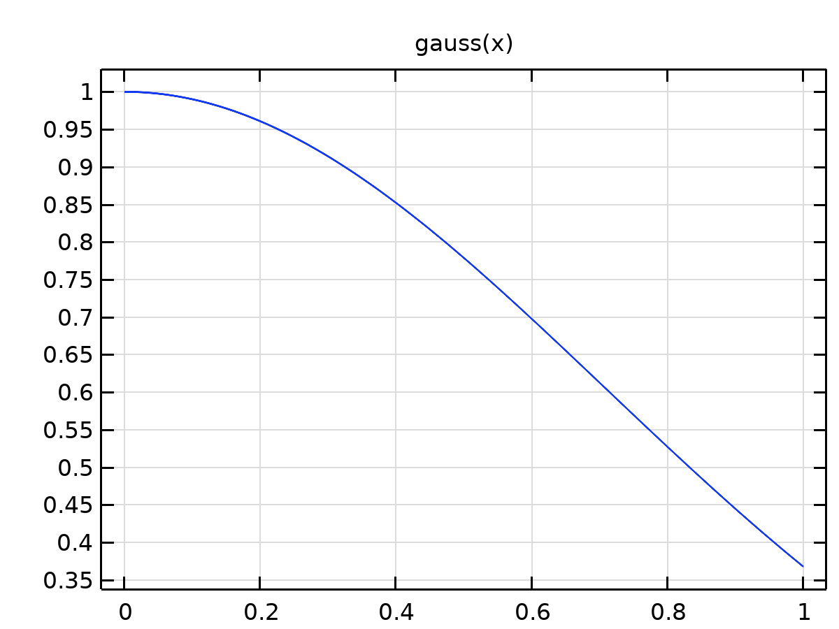

Analytic 2

Definition

| **Description** | **Value** |
| --- | --- |
| Expression | exp(-x*x) |
| Arguments | x |

Units

| **Argument** | **Unit** |
| --- | --- |
| x |  |

### Piecewise 2

|  |  |
| --- | --- |
| Function name | krols |
| Function type | Piecewise |

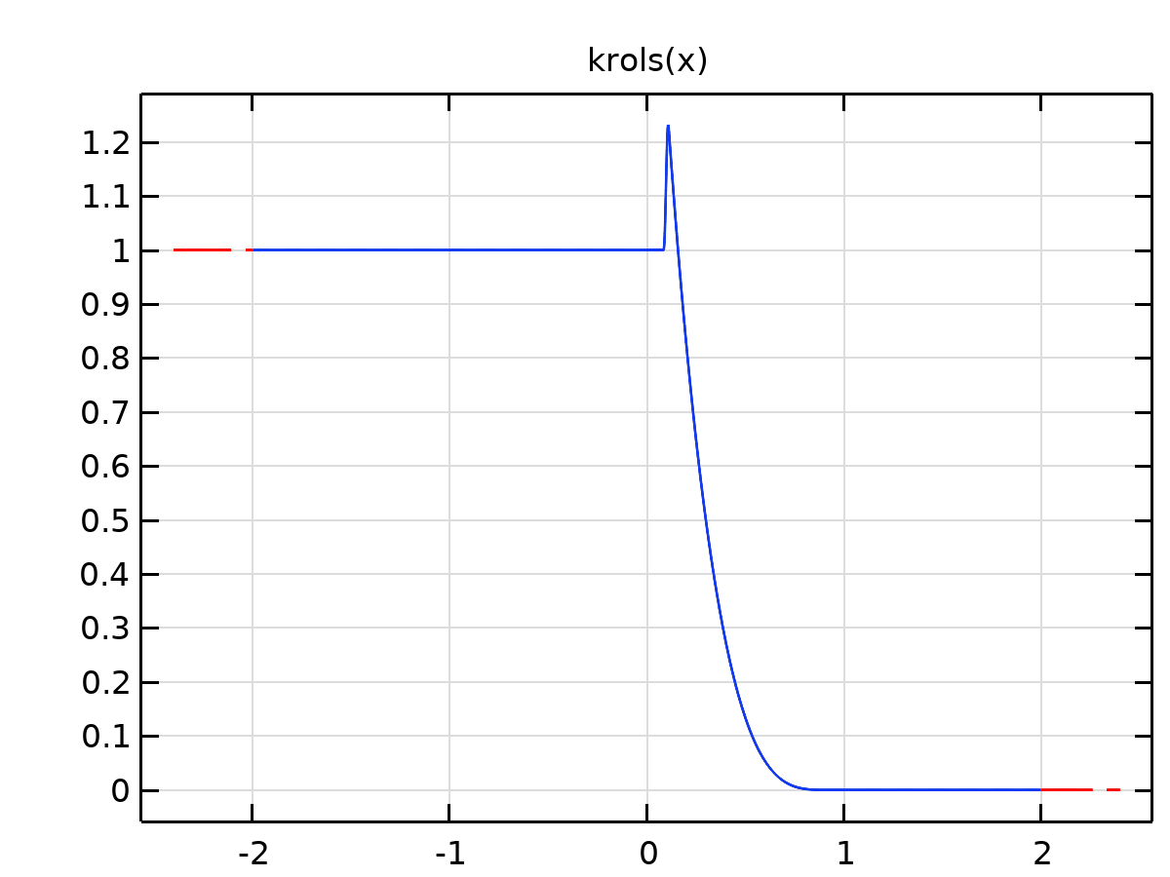

Piecewise 2

Definition

| **Description** | **Value** |
| --- | --- |
| Argument | x |
| Extrapolation | Constant |
| Smoothing | Continuous second derivative |
| Size of transition zone | 0.01 |

Definition

| **Start** | **End** | **Function** |
| --- | --- | --- |
| -2 | swc | 1 |
| swc | 0.92 | kol*(1-se(x))^nol |
| 0.92 | 2 | 0 |

### Piecewise 1

|  |  |
| --- | --- |
| Function name | krwls |
| Function type | Piecewise |

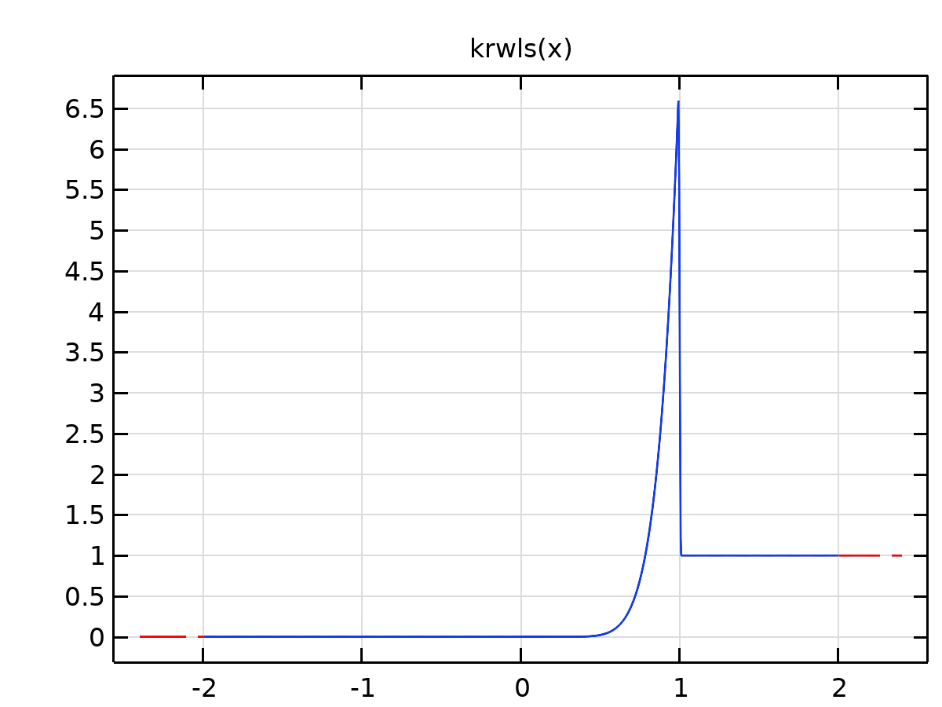

Piecewise 1

Definition

| **Description** | **Value** |
| --- | --- |
| Argument | x |
| Extrapolation | Constant |
| Smoothing | Continuous second derivative |
| Size of transition zone | 0.01 |
| Smooth at endpoints | On |

Definition

| **Start** | **End** | **Function** |
| --- | --- | --- |
| -2 | swc | 0 |
| swc | 1 | kwl*se(x)^nwl |
| 1 | 2 | 1 |

### Analytic 6

|  |  |
| --- | --- |
| Function name | logistic |
| Function type | Analytic |

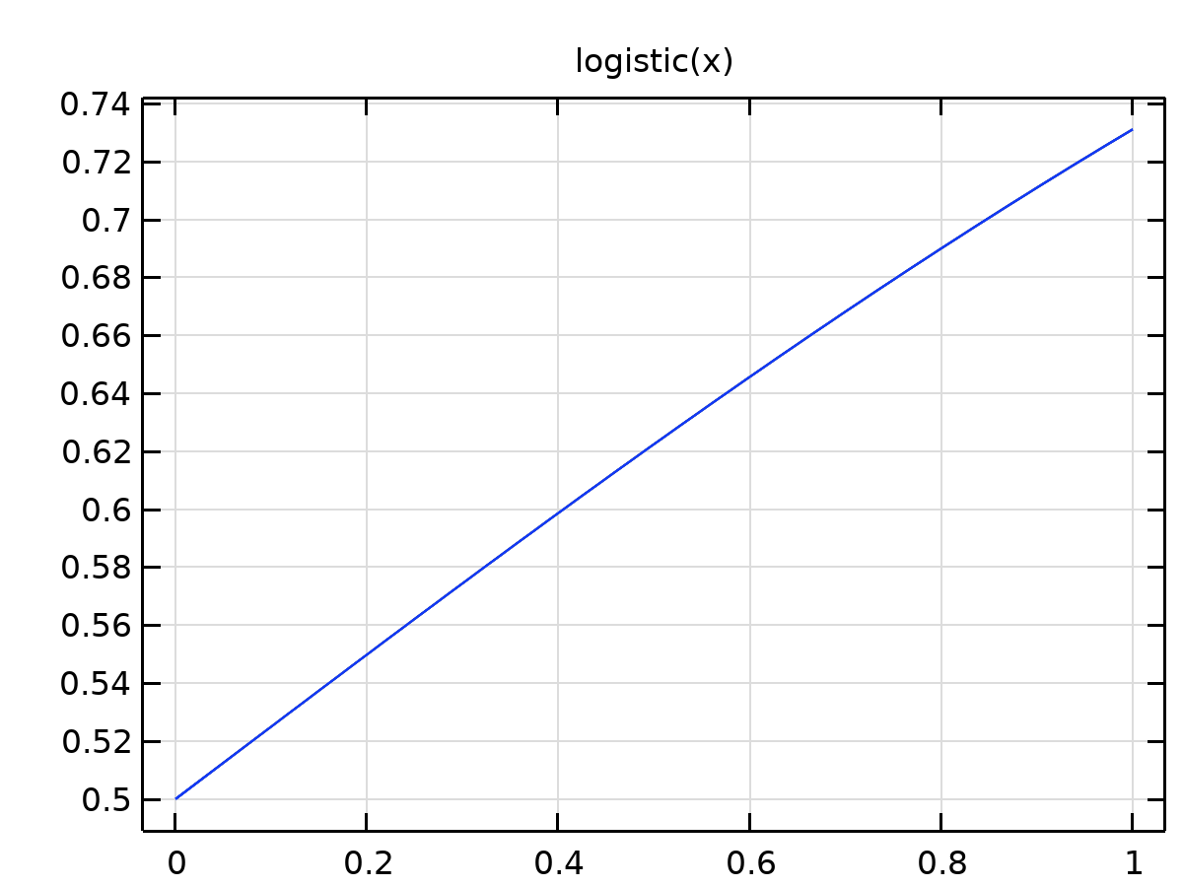

Analytic 6

Definition

| **Description** | **Value** |
| --- | --- |
| Expression | 1.0/(1 + exp(-x)) |
| Arguments | x |

Units

| **Argument** | **Unit** |
| --- | --- |
| x |  |

### Analytic 8

|  |  |
| --- | --- |
| Function name | pHini |
| Function type | Analytic |

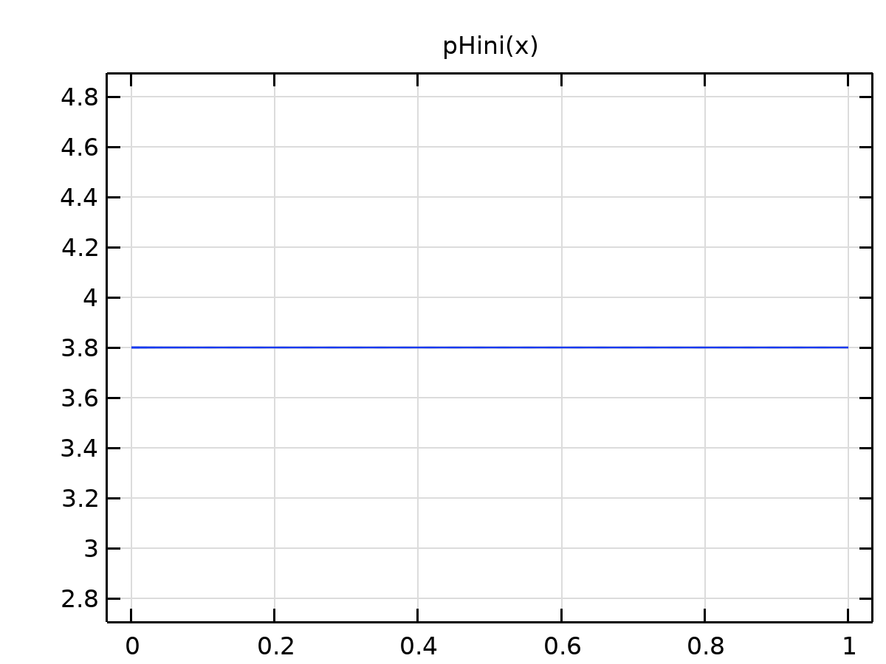

Analytic 8

Definition

| **Description** | **Value** |
| --- | --- |
| Expression | (pHinit + (1 - tann(x))*(pHbound - pHinit)) |
| Arguments | x |

Units

| **Argument** | **Unit** |
| --- | --- |
| x |  |

### Analytic 10

|  |  |
| --- | --- |
| Function name | sini |
| Function type | Analytic |

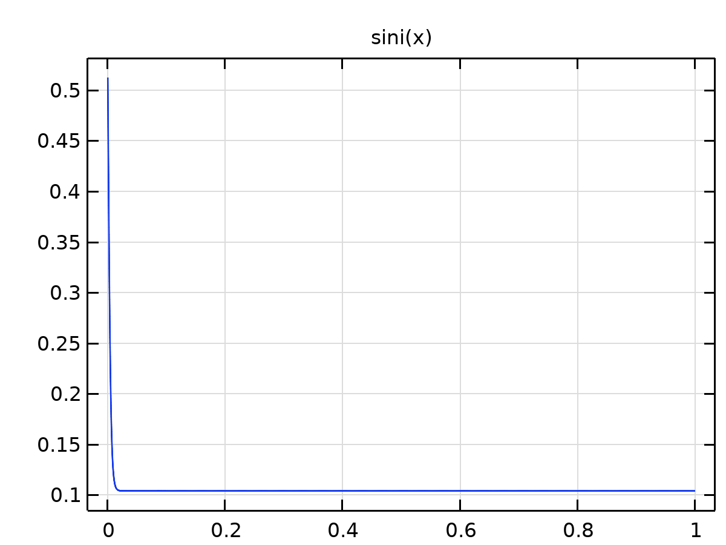

Analytic 10

Definition

| **Description** | **Value** |
| --- | --- |
| Expression | swc + (1 - tann(x))*(1 - sor - swc) |
| Arguments | x |

Units

| **Argument** | **Unit** |
| --- | --- |
| x |  |

### Analytic 9

|  |  |
| --- | --- |
| Function name | tann |
| Function type | Analytic |

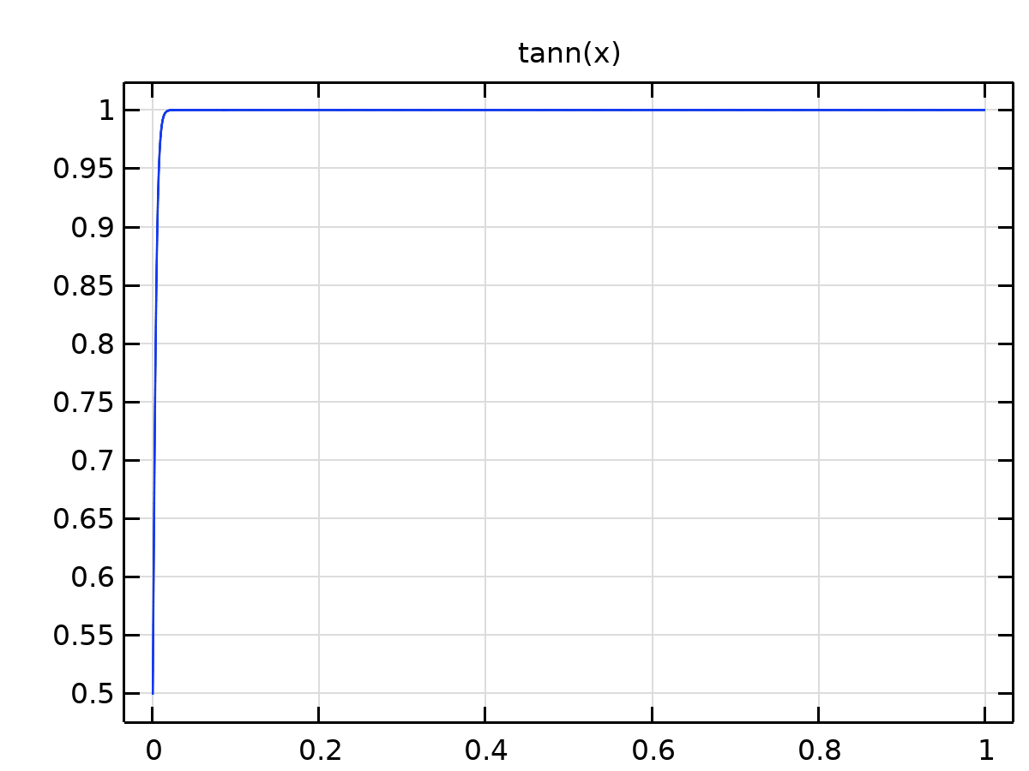

Analytic 9

Definition

| **Description** | **Value** |
| --- | --- |
| Expression | 0.5*(1 + tanh((x - 0.00001)/0.005)) |
| Arguments | x |

Units

| **Argument** | **Unit** |
| --- | --- |
| x |  |

### Analytic 12

|  |  |
| --- | --- |
| Function name | dfwsw |
| Function type | Analytic |

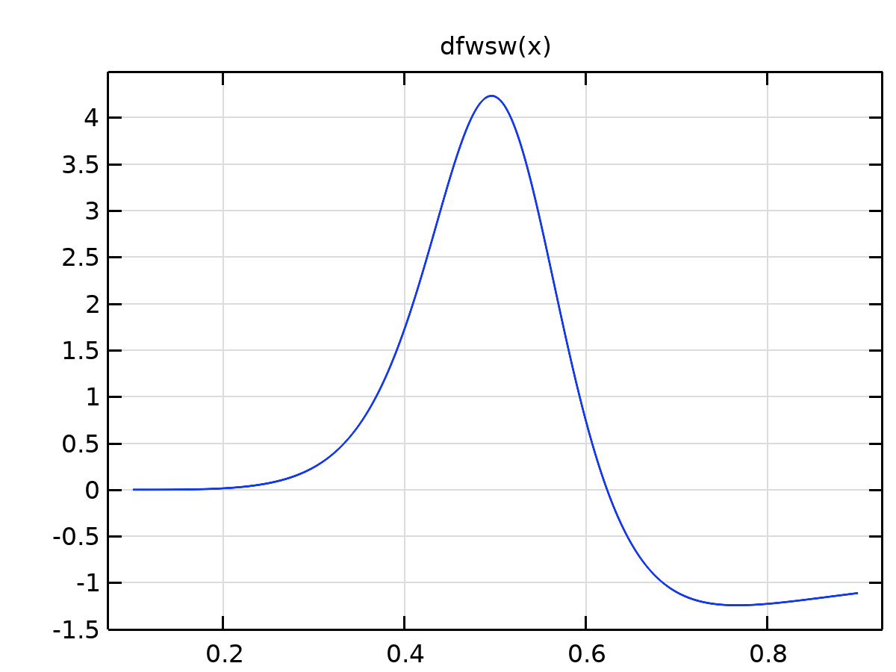

Analytic 12

Definition

| **Description** | **Value** |
| --- | --- |
| Expression | (fw(x + 0.001) - fw(x - 0.001))/0.002 - fw(x)/x |
| Arguments | x |

Units

| **Argument** | **Unit** |
| --- | --- |
| x |  |

### Analytic 13

|  |  |
| --- | --- |
| Function name | sped |
| Function type | Analytic |

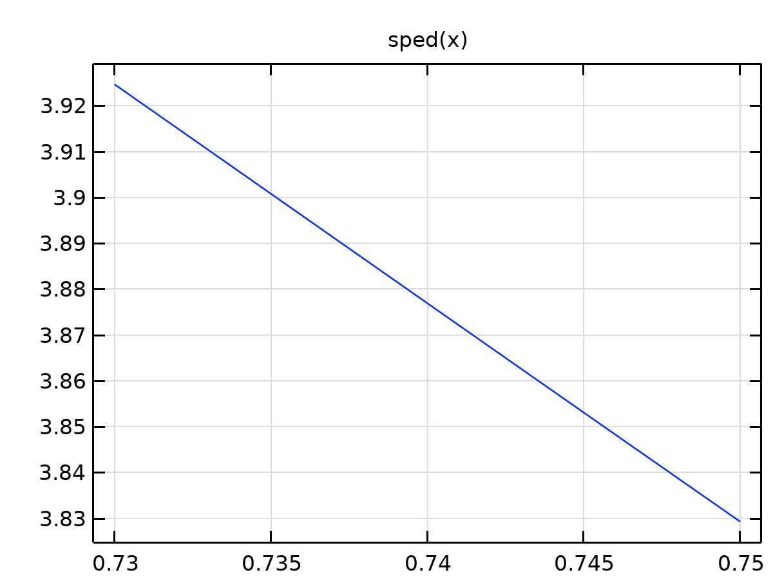

Analytic 13

Definition

| **Description** | **Value** |
| --- | --- |
| Expression | 1.066*fw(x)/x/phi |
| Arguments | x |

Units

| **Argument** | **Unit** |
| --- | --- |
| x |  |

### Analytic 14

|  |  |
| --- | --- |
| Function name | fwmindfsw |
| Function type | Analytic |

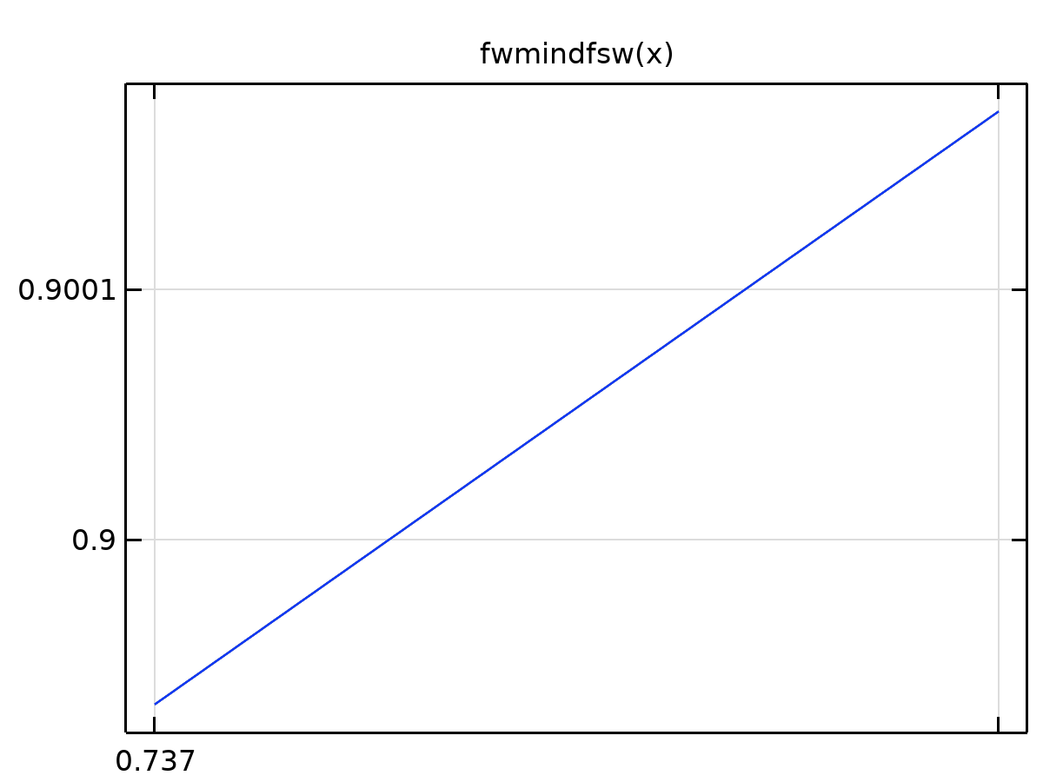

Analytic 14

Definition

| **Description** | **Value** |
| --- | --- |
| Expression | fw(x) - x*(fw(x + 0.001) - fw(x - 0.001))/0.002 |
| Arguments | x |

Units

| **Argument** | **Unit** |
| --- | --- |
| x |  |

### Analytic 15

|  |  |
| --- | --- |
| Function name | fomindfso |
| Function type | Analytic |

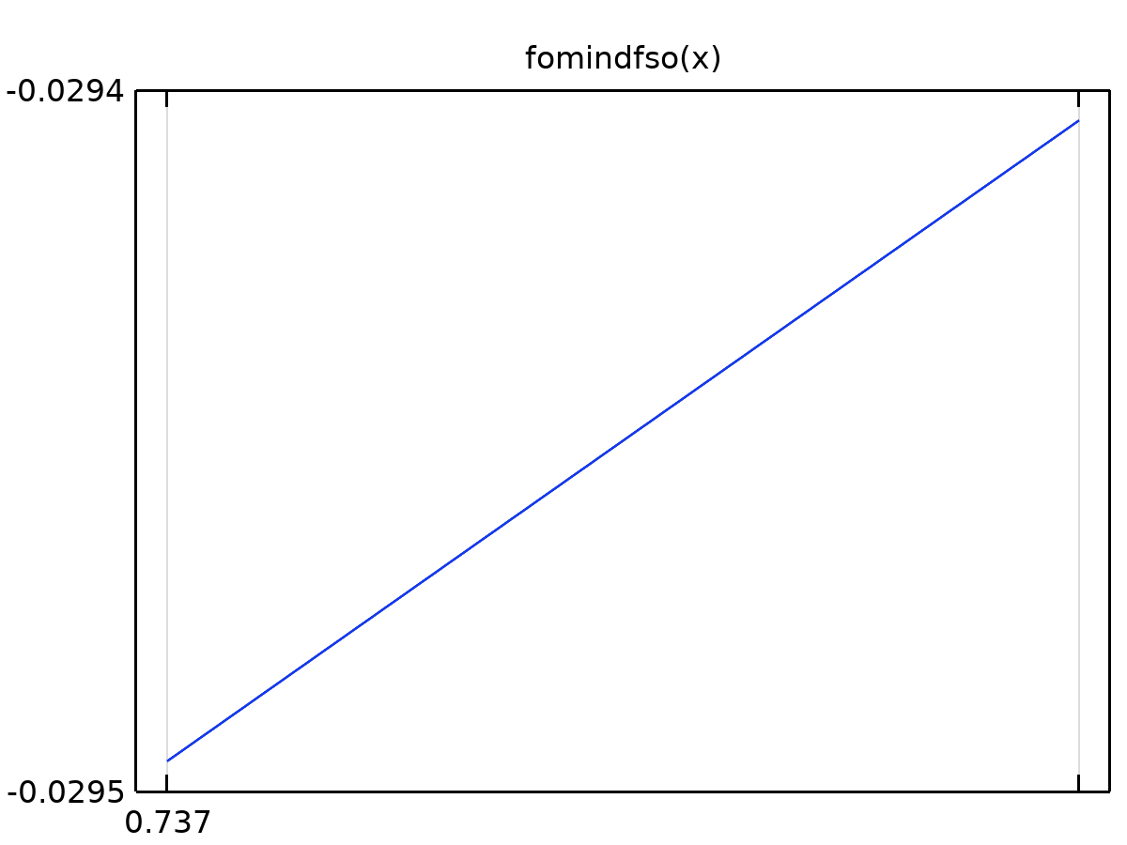

Analytic 15

Definition

| **Description** | **Value** |
| --- | --- |
| Expression | fo(x) - (1 - x)*(fw(x + 0.001) - fw(x - 0.001))/0.002 |
| Arguments | x |

Units

| **Argument** | **Unit** |
| --- | --- |
| x |  |

### Analytic 16

|  |  |
| --- | --- |
| Function name | fomindfsoln |
| Function type | Analytic |

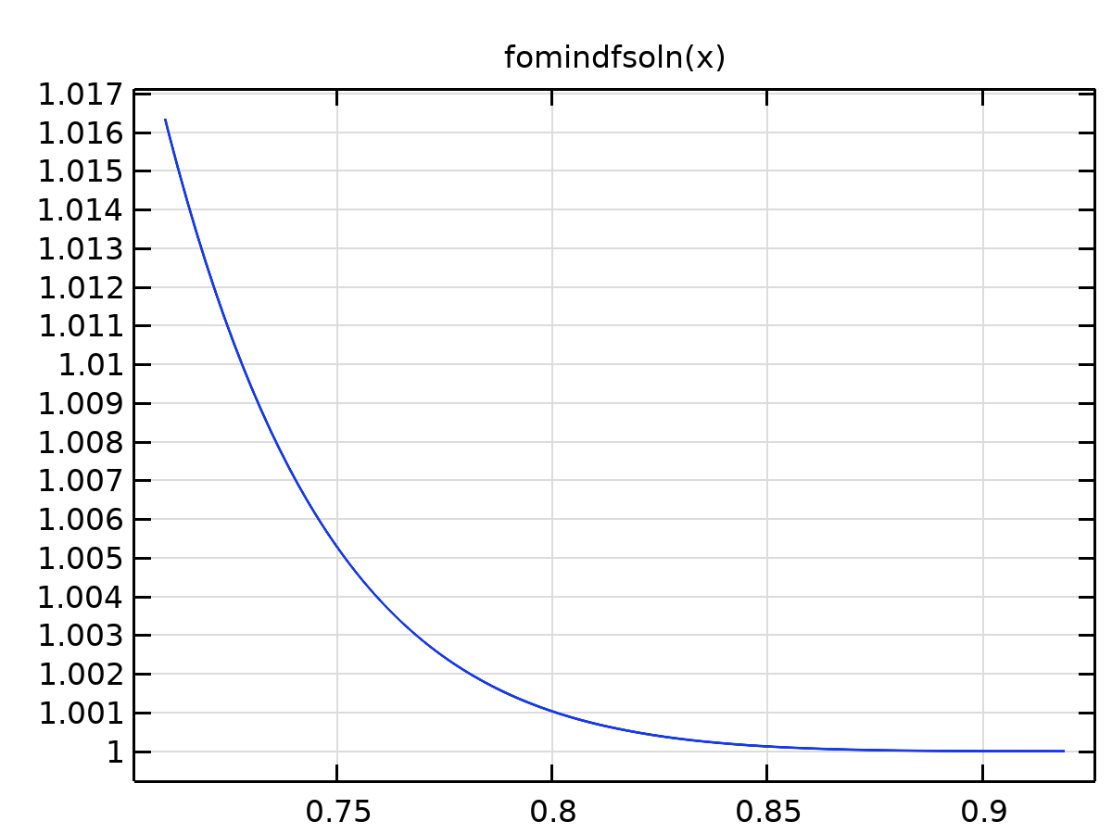

Analytic 16

Definition

| **Description** | **Value** |
| --- | --- |
| Expression | exp(-log(3.375/2.6)*(fo(x) - (1 - x)*(fw(x + 0.001) - fw(x - 0.001))/0.002)) |
| Arguments | x |

Units

| **Argument** | **Unit** |
| --- | --- |
| x |  |

### Analytic 17

|  |  |
| --- | --- |
| Function name | dfwswc |
| Function type | Analytic |

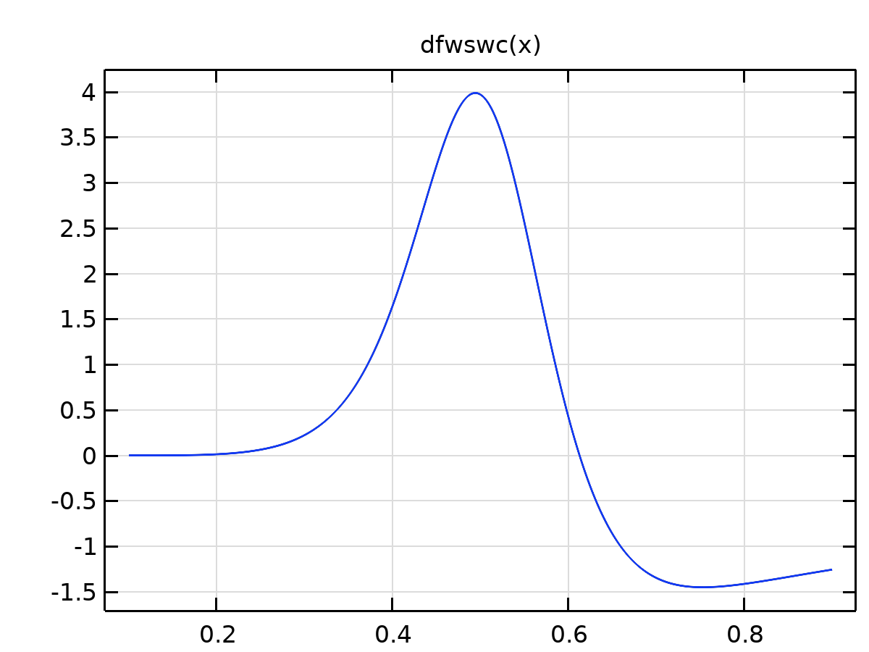

Analytic 17

Definition

| **Description** | **Value** |
| --- | --- |
| Expression | (fw(x + 0.001) - fw(x - 0.001))/0.002 - fw(x)/(x - swc) |
| Arguments | x |

Units

| **Argument** | **Unit** |
| --- | --- |
| x |  |

### Analytic 19

|  |  |
| --- | --- |
| Function name | mu |
| Function type | Analytic |

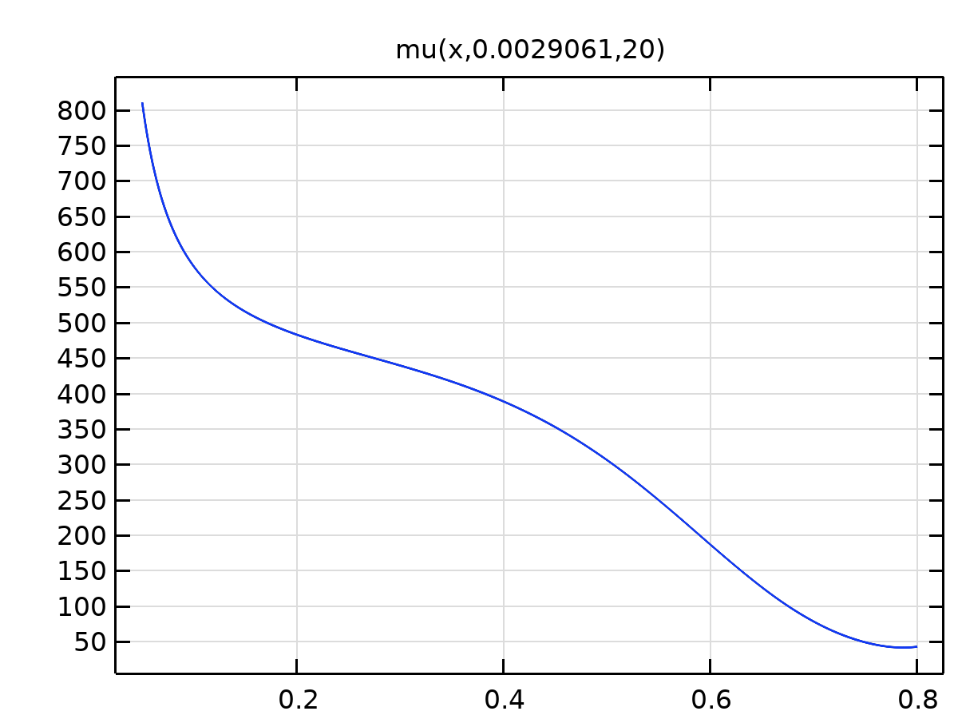

Analytic 19

Definition

| **Description** | **Value** |
| --- | --- |
| Expression | exp(2.4188972776909 + 1172.01620720374*w + 0.0107389610051526*p + 0.0332220538318791/x + 0.0125939658284849*w*2587448^x - 1.42883605553454*w*11308^x) |
| Arguments | {x, w, p} |

Units

| **Argument** | **Unit** |
| --- | --- |
| x |  |
| w |  |
| p |  |

### Analytic 20

|  |  |
| --- | --- |
| Function name | mu2 |
| Function type | Analytic |

Definition

| **Description** | **Value** |
| --- | --- |
| Expression | exp(2.4188972776909 + 1172.01620720374*w + 0.0107389610051526*p + 0.0332220538318791/xx(pH, Cl) + 0.0125939658284849*w*2587448^xx(pH, Cl) - 1.42883605553454*w*11308^xx(pH, Cl)) |
| Arguments | {pH, Cl, w, p} |

Units

| **Argument** | **Unit** |
| --- | --- |
| pH |  |
| Cl |  |
| w |  |
| p |  |

### Analytic 21

|  |  |
| --- | --- |
| Function name | muww |
| Function type | Analytic |

Definition

| **Description** | **Value** |
| --- | --- |
| Expression | cone+ctwo*exp(aone*(T - 273.15)) + cthree*exp(atwo*m) + cfour*exp(athree*0.01*(T - 273.15) + m) + cfive*exp(afour*(0.01*(T - 273.15) - m)) |
| Arguments | {T, m} |

Units

| **Argument** | **Unit** |
| --- | --- |
| T |  |
| m |  |

### rhow1

|  |  |
| --- | --- |
| Function name | rhow1 |
| Function type | Analytic |

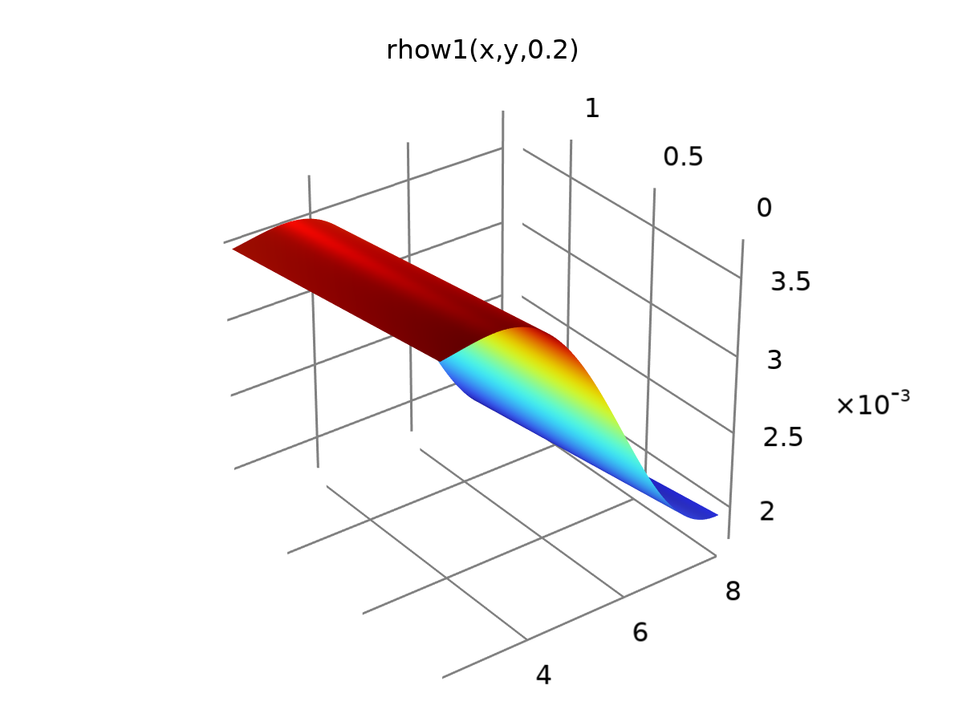

rhow1

Definition

| **Description** | **Value** |
| --- | --- |
| Expression | 0.01*(0.06448 + 0.3039 * exp(-0.005546 * x^3 * z) - sin(z) * sin(0.008639 * x^2) * cos(z + 0.8679 * x) * exp(-0.005546 * x^3 * z) - 0.01526 * y) |
| Arguments | {x, y, z} |

Units

| **Argument** | **Unit** |
| --- | --- |
| x |  |
| y |  |
| z |  |

### rhoo1

|  |  |
| --- | --- |
| Function name | rhoo1 |
| Function type | Analytic |

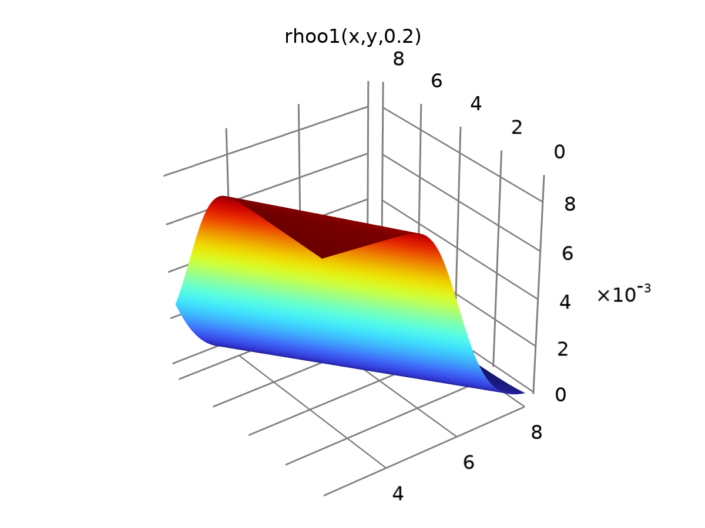

rhoo1

Definition

| **Description** | **Value** |
| --- | --- |
| Expression | 0.01*(0.7981 + 0.1363 * gauss(z + 0.1171 * x) - 0.7981 * gauss(9.645 * gauss(0.2577 * x + 0.1349 * y)) - 0.1558 * gauss(z + 0.1171 * x) * gauss(9.645 * gauss(0.2577 * x + 0.1349 * y))^2) |
| Arguments | {x, y, z} |

Units

| **Argument** | **Unit** |
| --- | --- |
| x |  |
| y |  |
| z |  |

### rhor1

|  |  |
| --- | --- |
| Function name | rhor1 |
| Function type | Analytic |

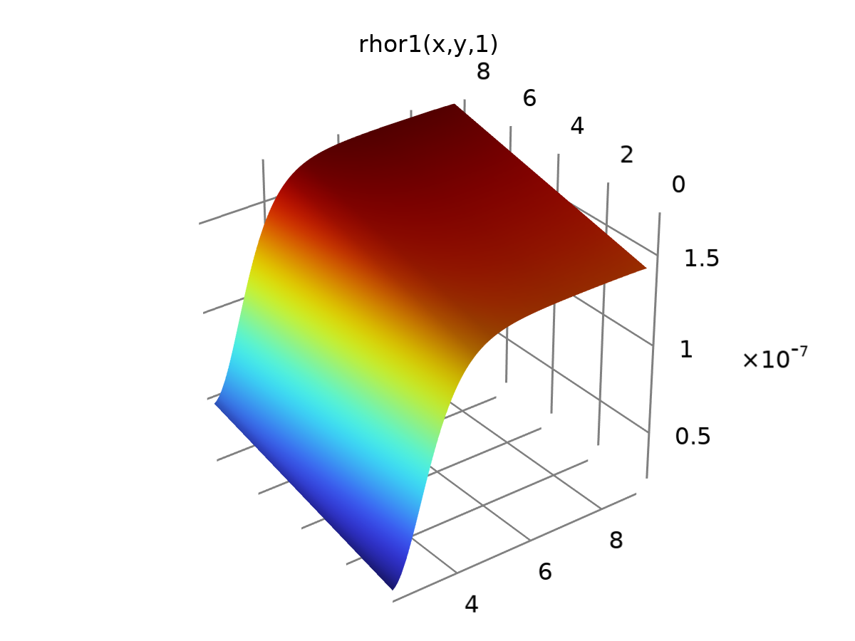

rhor1

Definition

| **Description** | **Value** |
| --- | --- |
| Expression | 0.0000001*(4.606 + 0.0343*y - 3.094/tanh(1.418 + z) - 1.236*exp(-(1.236*x + 0.4345*z - 0.001579*x/z - 2.789 - 0.08079*x^2)^2)) |
| Arguments | {x, y, z} |

Units

| **Argument** | **Unit** |
| --- | --- |
| x |  |
| y |  |
| z |  |

### rhoo2

|  |  |
| --- | --- |
| Function name | rhoo2 |
| Function type | Analytic |

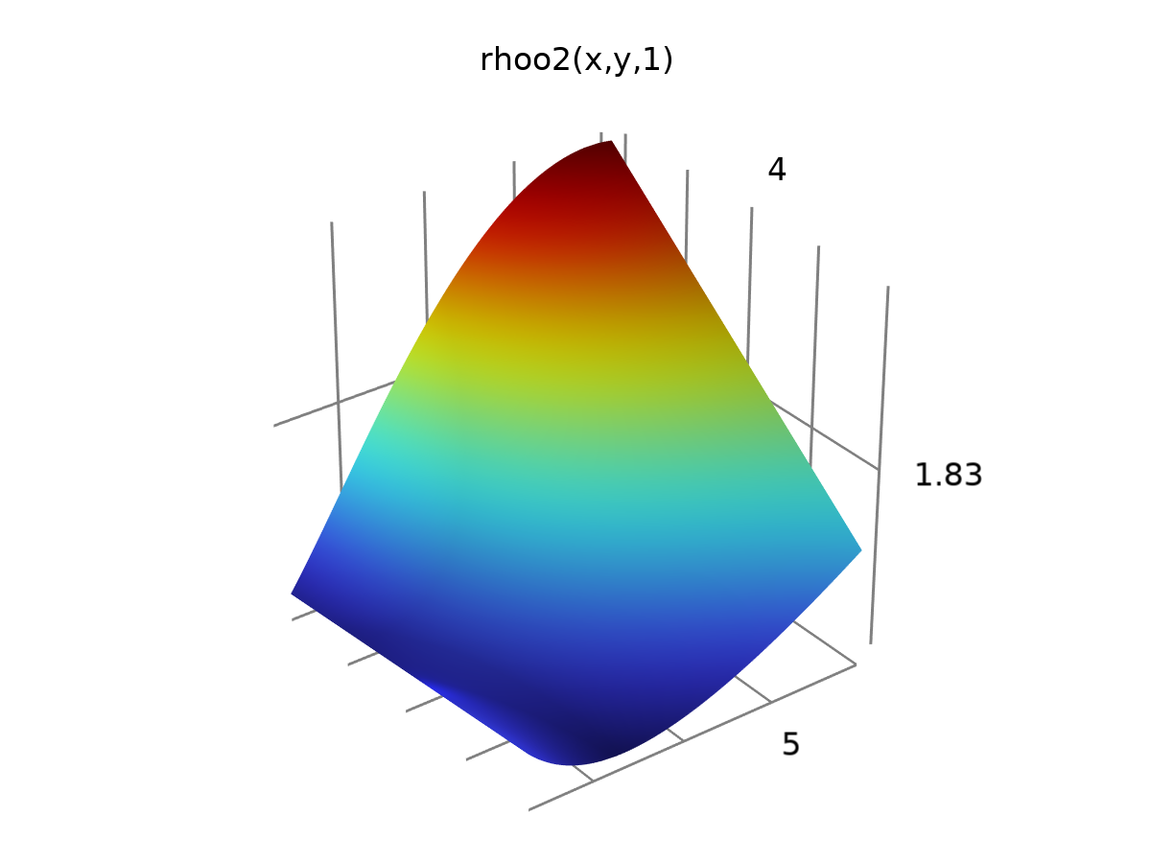

rhoo2

Definition

| **Description** | **Value** |
| --- | --- |
| Expression | 1.825 + 0.001116*x + 0.01245/x + 0.0006694*x*y - 0.001236*y - 6.613e-5*x^2*y + 0.00000000001*z |
| Arguments | {x, y, z} |

Units

| **Argument** | **Unit** |
| --- | --- |
| x |  |
| y |  |
| z |  |

### rhow3

|  |  |
| --- | --- |
| Function name | rhow3 |
| Function type | Analytic |

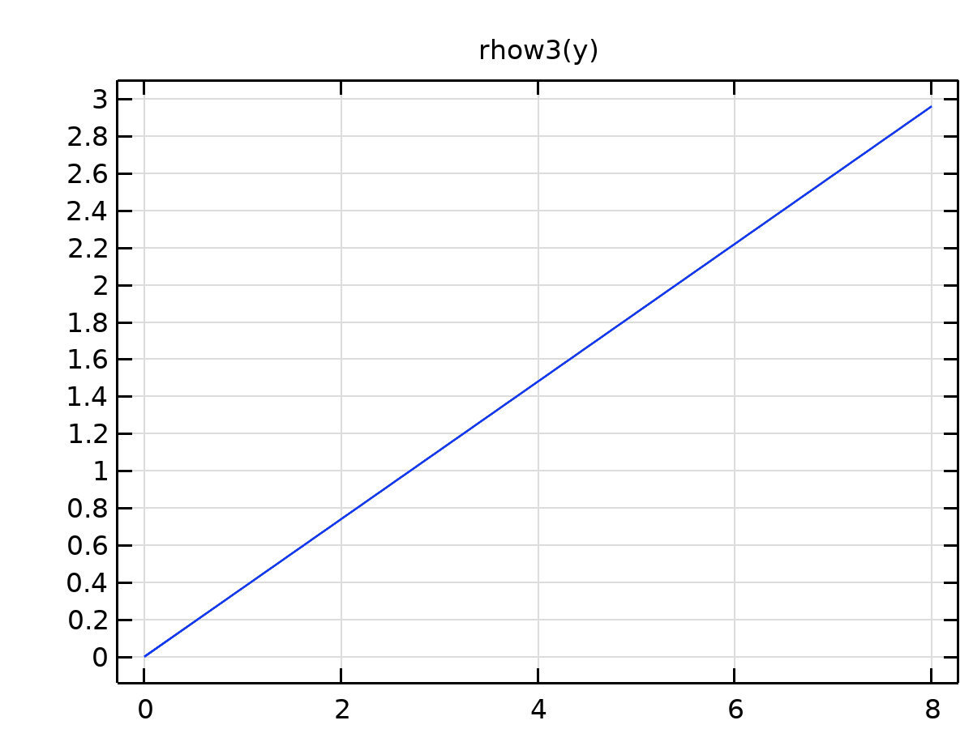

rhow3

Definition

| **Description** | **Value** |
| --- | --- |
| Expression | phi*y |
| Arguments | y |

Units

| **Argument** | **Unit** |
| --- | --- |
| y |  |

### rhow4

|  |  |
| --- | --- |
| Function name | rhow4 |
| Function type | Analytic |

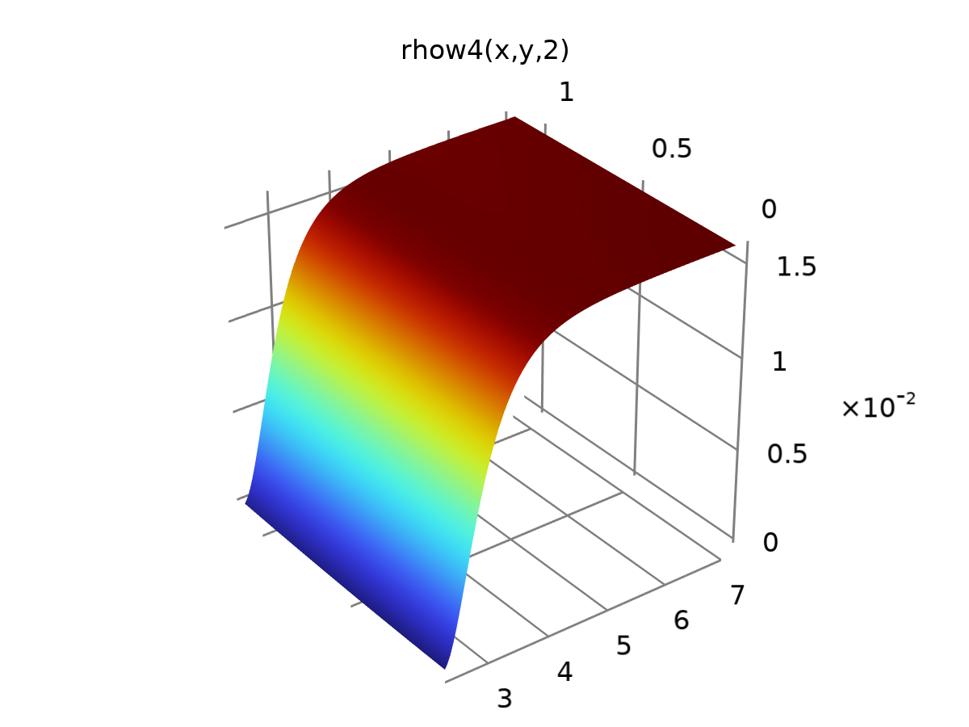

rhow4

Definition

| **Description** | **Value** |
| --- | --- |
| Expression | 0.01*(1.694*z^0.1511 + 0.03021*y^2*gauss(3.087 + 0.4009*z - 8.76/x) - 0.1311*z - 1.57*z^0.07416*gauss(3.087 + 0.4009*z - 8.76/x)) |
| Arguments | {x, y, z} |

Units

| **Argument** | **Unit** |
| --- | --- |
| x |  |
| y |  |
| z |  |

### rhoo4

|  |  |
| --- | --- |
| Function name | rhoo4 |
| Function type | Analytic |

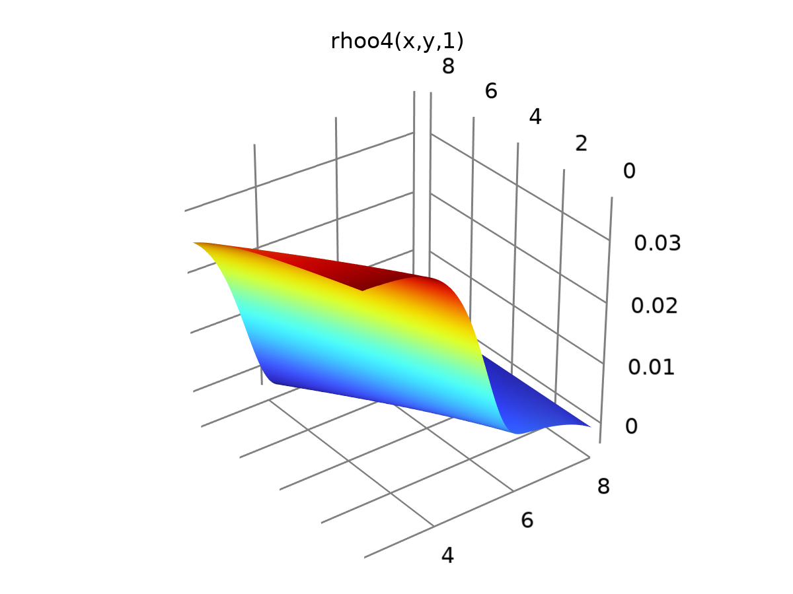

rhoo4

Definition

| **Description** | **Value** |
| --- | --- |
| Expression | 0.004749 + 3.376e-7*y*exp(x) + 0.03217*gauss(0.001988*exp(x) + 0.003211*z*exp(x + 0.2729*y)) - 0.001043*y - 1.609e-6*exp(x) |
| Arguments | {x, y, z} |

Units

| **Argument** | **Unit** |
| --- | --- |
| x |  |
| y |  |
| z |  |

### rhor4

|  |  |
| --- | --- |
| Function name | rhor4 |
| Function type | Analytic |

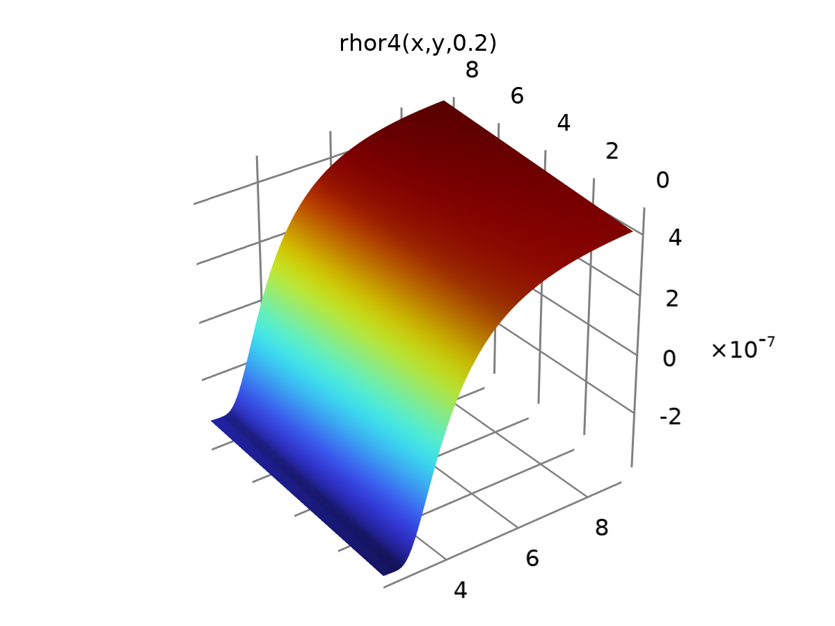

rhor4

Definition

| **Description** | **Value** |
| --- | --- |
| Expression | 0.000001*(0.008068*y + -0.0004481*x/z + 0.9067*gauss(5.256/(2.514*x + 0.3922*x^2*z - 5.256)) - 0.372 - 0.005255*x) |
| Arguments | {x, y, z} |

Units

| **Argument** | **Unit** |
| --- | --- |
| x |  |
| y |  |
| z |  |

### Analytic 31

|  |  |
| --- | --- |
| Function name | sini2 |
| Function type | Analytic |

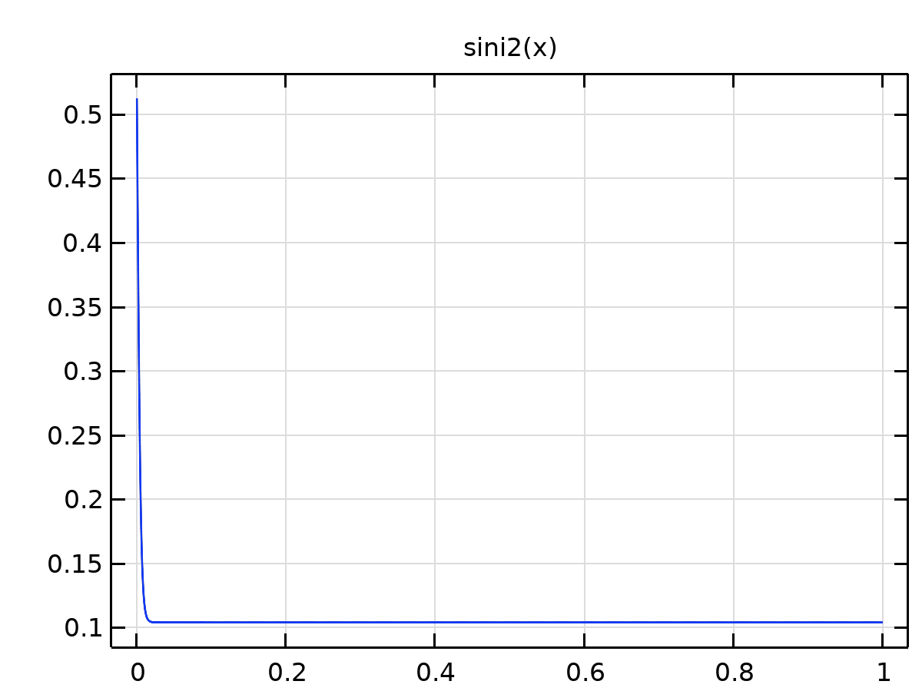

Analytic 31

Definition

| **Description** | **Value** |
| --- | --- |
| Expression | swc + (1 - tann(x))*(1 - sor - swc) |
| Arguments | x |

Units

| **Argument** | **Unit** |
| --- | --- |
| x |  |

### Analytic 32

|  |  |
| --- | --- |
| Function name | uini |
| Function type | Analytic |

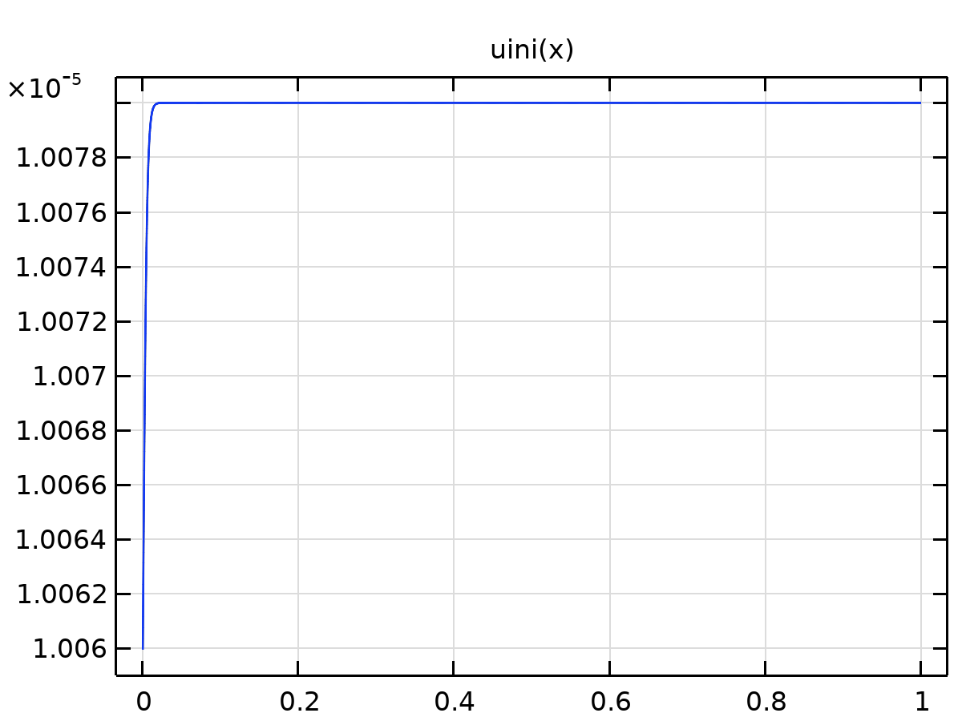

Analytic 32

Definition

| **Description** | **Value** |
| --- | --- |
| Expression | (uinj + 0.00001 + 0.008*(1 + tann(x))*(uinj))/2 |
| Arguments | x |

Units

| **Argument** | **Unit** |
| --- | --- |
| x |  |

### Analytic 33

|  |  |
| --- | --- |
| Function name | rho1 |
| Function type | Analytic |

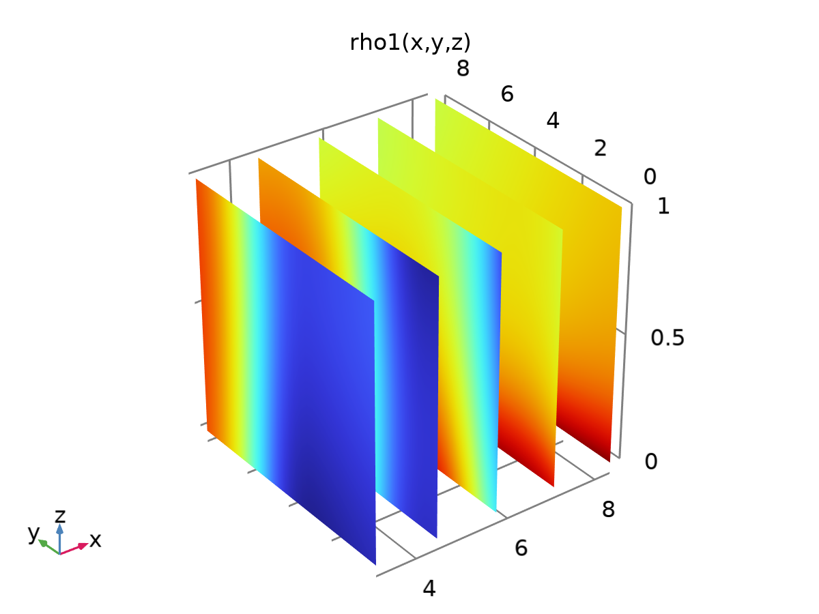

Analytic 33

Definition

| **Description** | **Value** |
| --- | --- |
| Expression | rhow1(x, y, z) - rhoo1(x, y, z) |
| Arguments | {x, y, z} |

Units

| **Argument** | **Unit** |
| --- | --- |
| x |  |
| y |  |
| z |  |

### Analytic 34

|  |  |
| --- | --- |
| Function name | rho4 |
| Function type | Analytic |

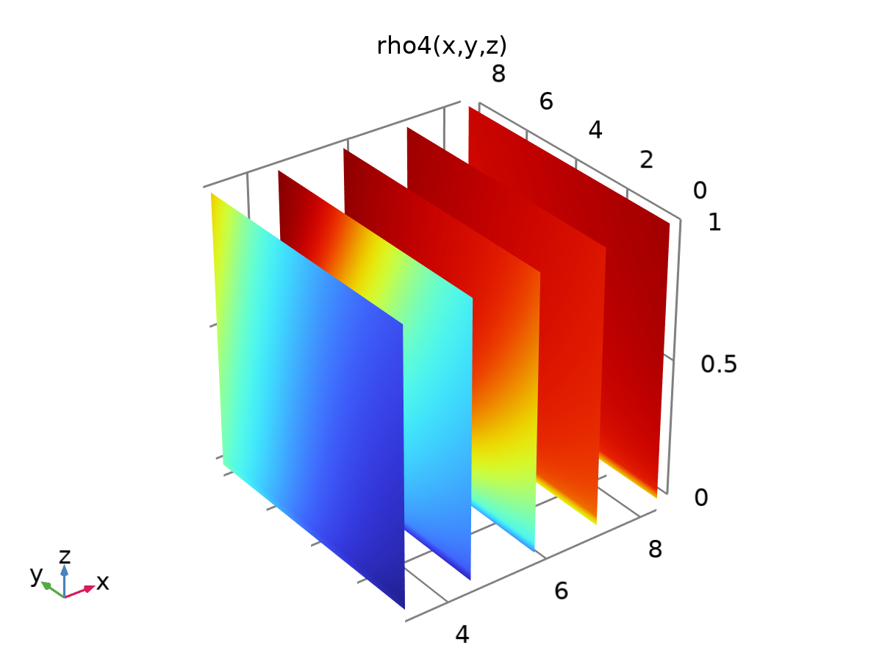

Analytic 34

Definition

| **Description** | **Value** |
| --- | --- |
| Expression | rhow4(x, y, z) - rhoo4(x, y, z) |
| Arguments | {x, y, z} |

Units

| **Argument** | **Unit** |
| --- | --- |
| x |  |
| y |  |
| z |  |

### rhow1.1

|  |  |
| --- | --- |
| Function name | rhow1y |
| Function type | Analytic |

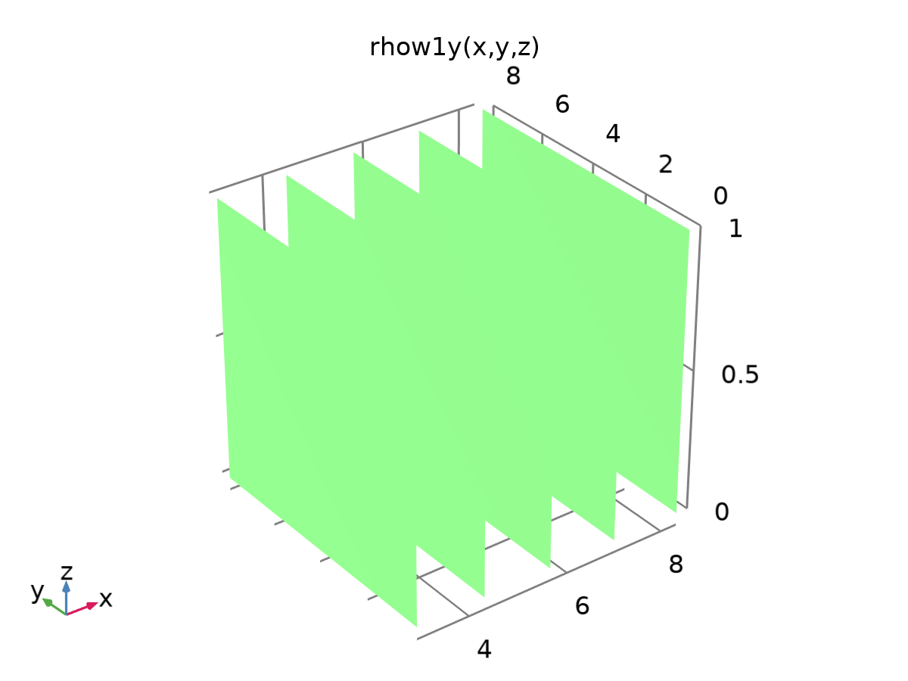

rhow1.1

Definition

| **Description** | **Value** |
| --- | --- |
| Expression | d(rhow1(x, y, z), y) |
| Arguments | {x, y, z} |

Units

| **Argument** | **Unit** |
| --- | --- |
| x |  |
| y |  |
| z |  |

### rhoo1.1

|  |  |
| --- | --- |
| Function name | rhoo1y |
| Function type | Analytic |

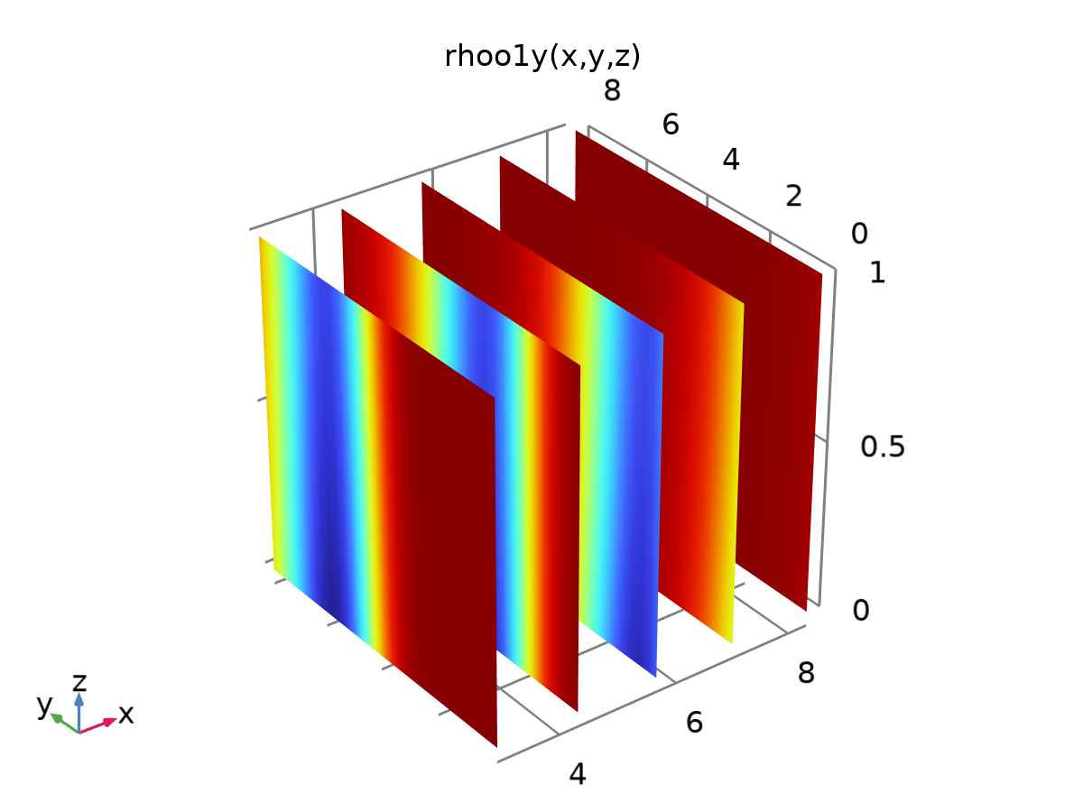

rhoo1.1

Definition

| **Description** | **Value** |
| --- | --- |
| Expression | d(rhoo1(x, y, z), y) |
| Arguments | {x, y, z} |

Units

| **Argument** | **Unit** |
| --- | --- |
| x |  |
| y |  |
| z |  |

### rhor1.1

|  |  |
| --- | --- |
| Function name | rhor1y |
| Function type | Analytic |

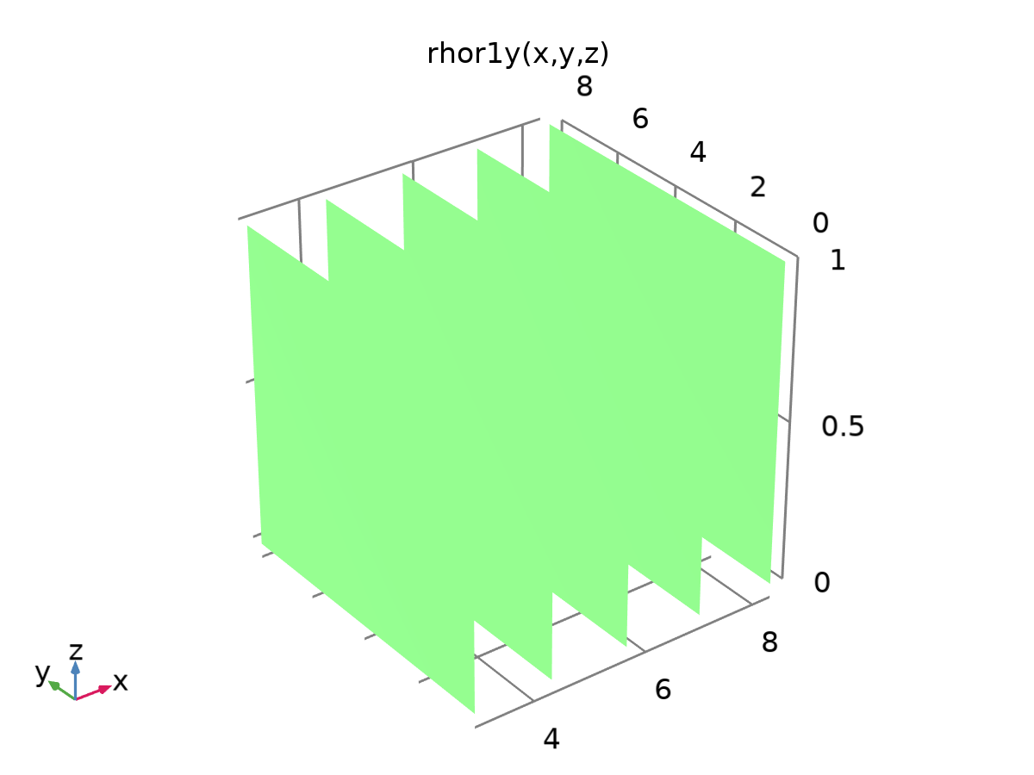

rhor1.1

Definition

| **Description** | **Value** |
| --- | --- |
| Expression | d(rhor1(x, y, z), y) |
| Arguments | {x, y, z} |

Units

| **Argument** | **Unit** |
| --- | --- |
| x |  |
| y |  |
| z |  |

### rhow1.1.1

|  |  |
| --- | --- |
| Function name | rhow1x |
| Function type | Analytic |

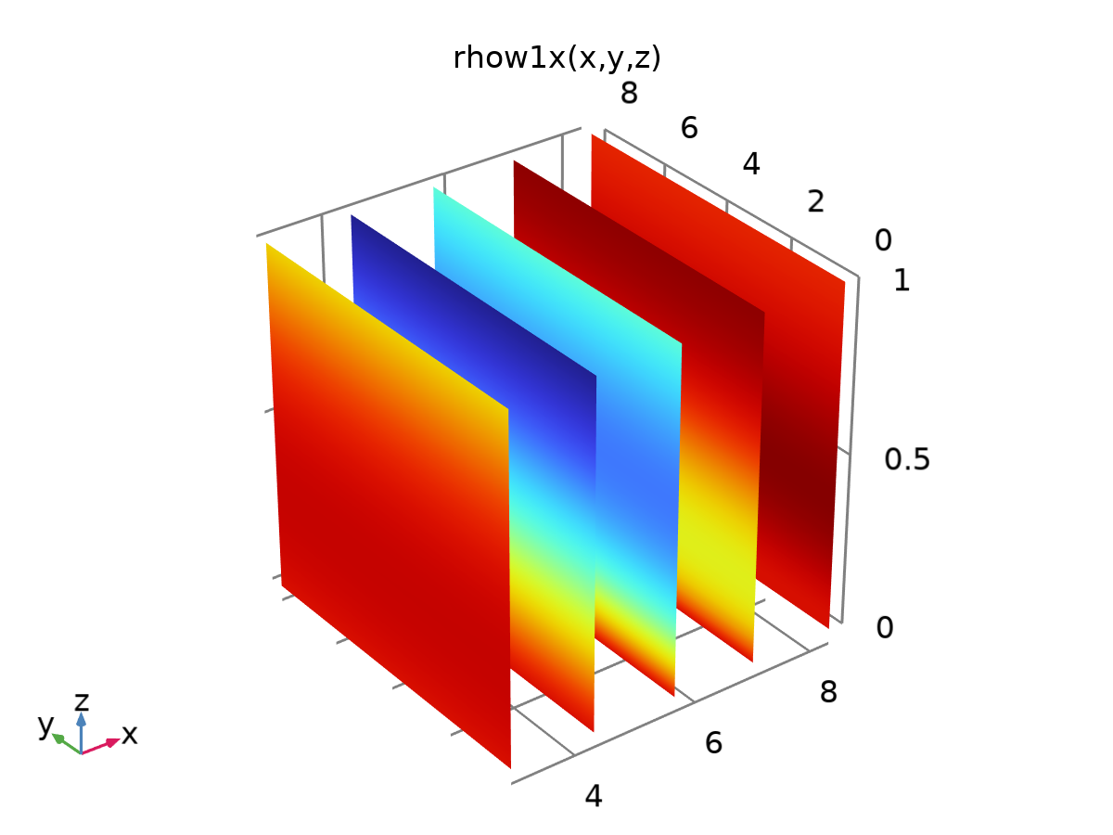

rhow1.1.1

Definition

| **Description** | **Value** |
| --- | --- |
| Expression | d(rhow1(x, y, z), x) |
| Arguments | {x, y, z} |

Units

| **Argument** | **Unit** |
| --- | --- |
| x |  |
| y |  |
| z |  |

### rhoo1.1.1

|  |  |
| --- | --- |
| Function name | rhoo1x |
| Function type | Analytic |

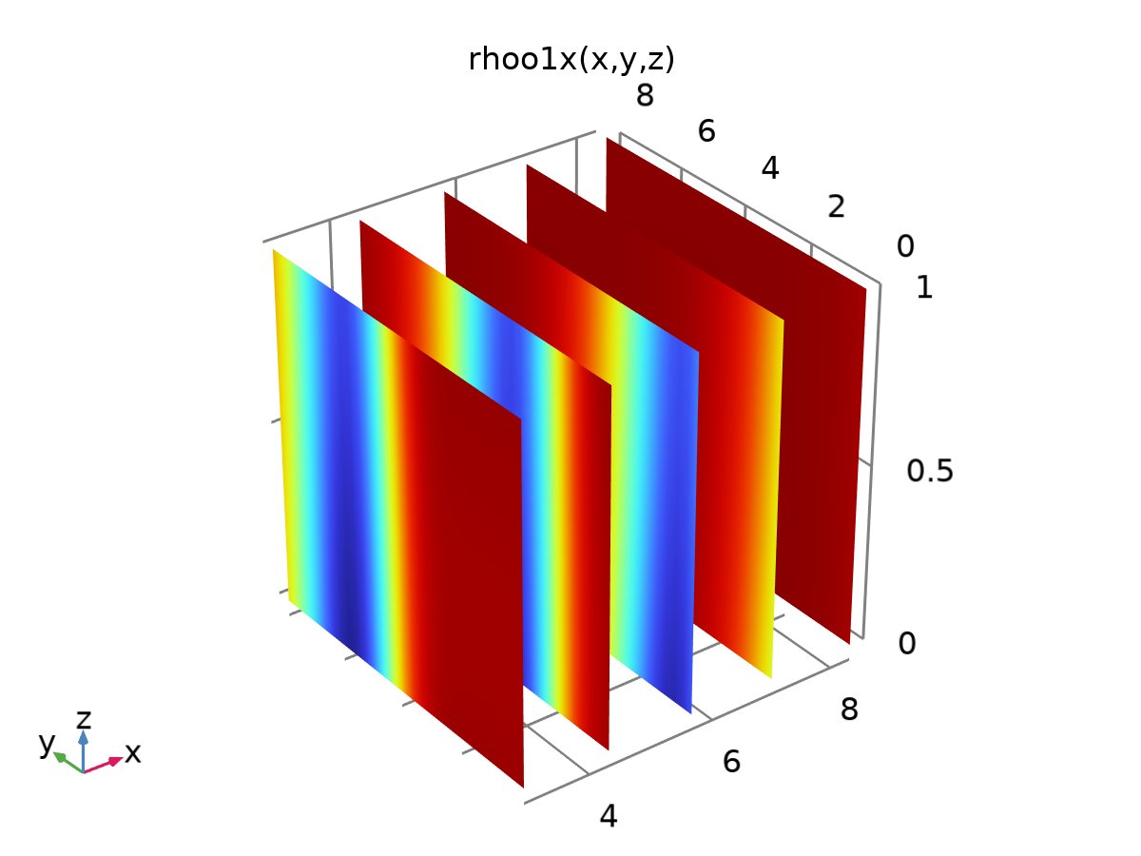

rhoo1.1.1

Definition

| **Description** | **Value** |
| --- | --- |
| Expression | d(rhoo1(x, y, z), x) |
| Arguments | {x, y, z} |

Units

| **Argument** | **Unit** |
| --- | --- |
| x |  |
| y |  |
| z |  |

### rhor1.1.1

|  |  |
| --- | --- |
| Function name | rhor1x |
| Function type | Analytic |

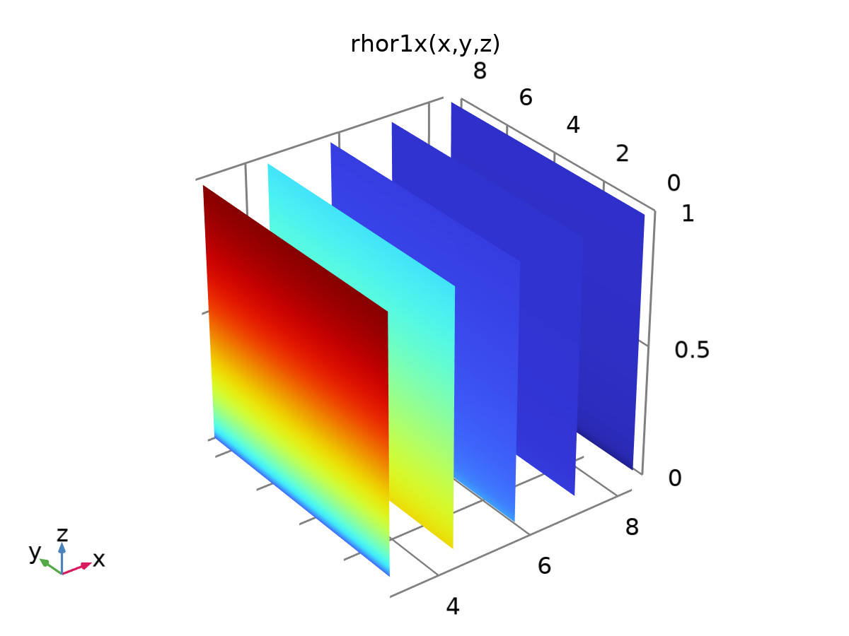

rhor1.1.1

Definition

| **Description** | **Value** |
| --- | --- |
| Expression | d(rhor1(x, y, z), x) |
| Arguments | {x, y, z} |

Units

| **Argument** | **Unit** |
| --- | --- |
| x |  |
| y |  |
| z |  |

### Analytic 51

|  |  |
| --- | --- |
| Function name | uini1 |
| Function type | Analytic |

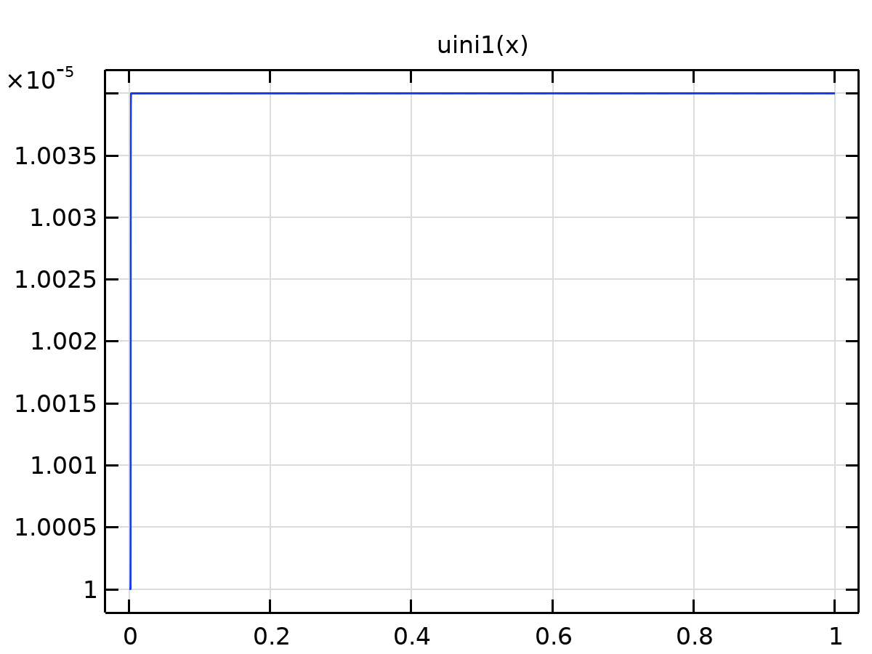

Analytic 51

Definition

| **Description** | **Value** |
| --- | --- |
| Expression | uinj + (1 - tann2(x))*(uinj2 - uinj) |
| Arguments | x |

Units

| **Argument** | **Unit** |
| --- | --- |
| x |  |

### Analytic 52

|  |  |
| --- | --- |
| Function name | tann2 |
| Function type | Analytic |

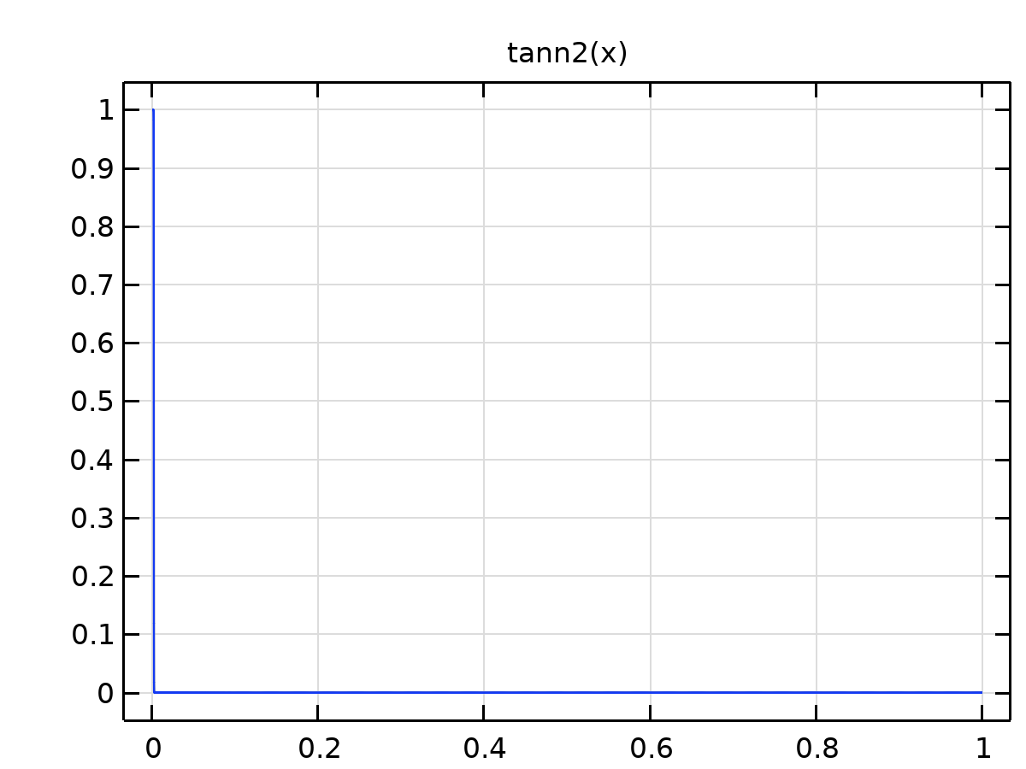

Analytic 52

Definition

| **Description** | **Value** |
| --- | --- |
| Expression | 0.5*(1 - tanh((x - 0.0018)/0.0001)) |
| Arguments | x |

Units

| **Argument** | **Unit** |
| --- | --- |
| x |  |

### Analytic 53

|  |  |
| --- | --- |
| Function name | uf |
| Function type | Analytic |

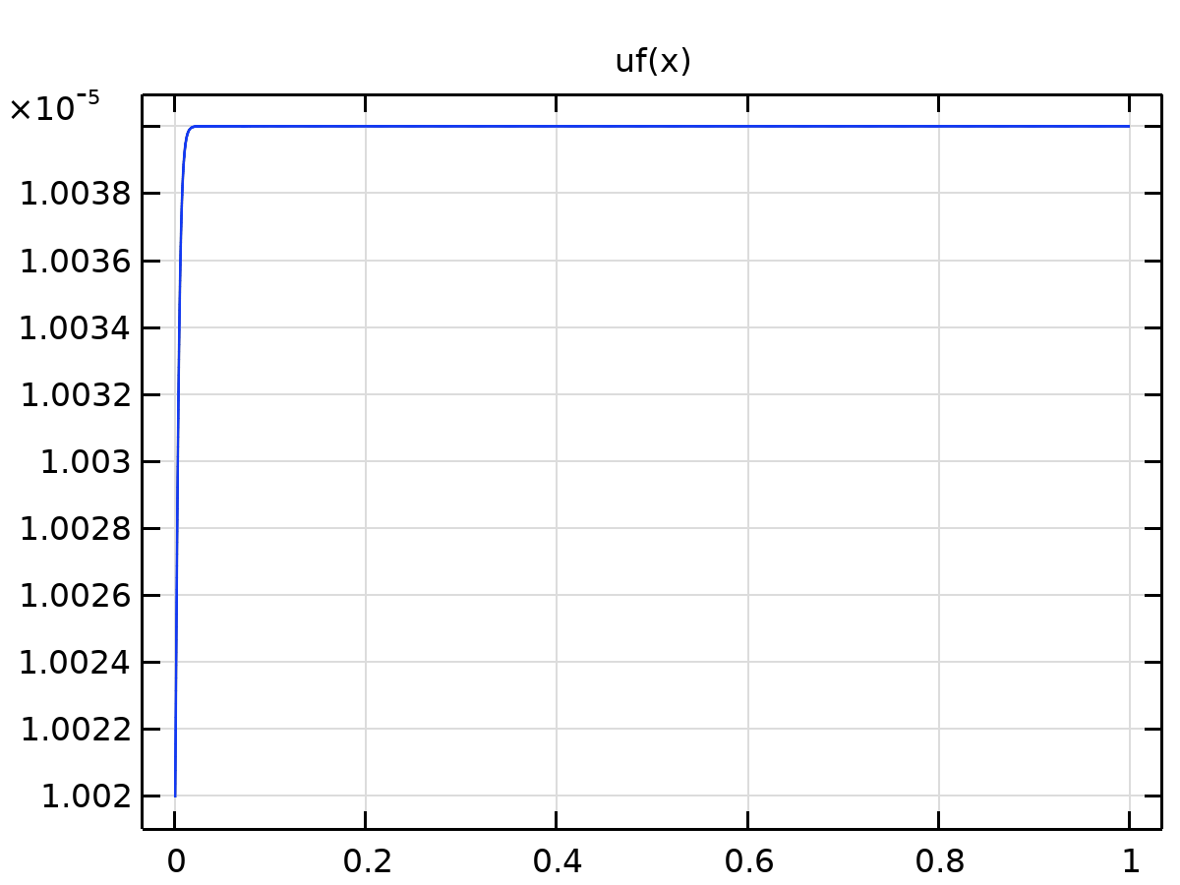

Analytic 53

Definition

| **Description** | **Value** |
| --- | --- |
| Expression | uinj2 + (1 - tann(x))*(-uinj2 + uinj) |
| Arguments | x |

Units

| **Argument** | **Unit** |
| --- | --- |
| x |  |

### rhor4.1

|  |  |
| --- | --- |
| Function name | rhor4x |
| Function type | Analytic |

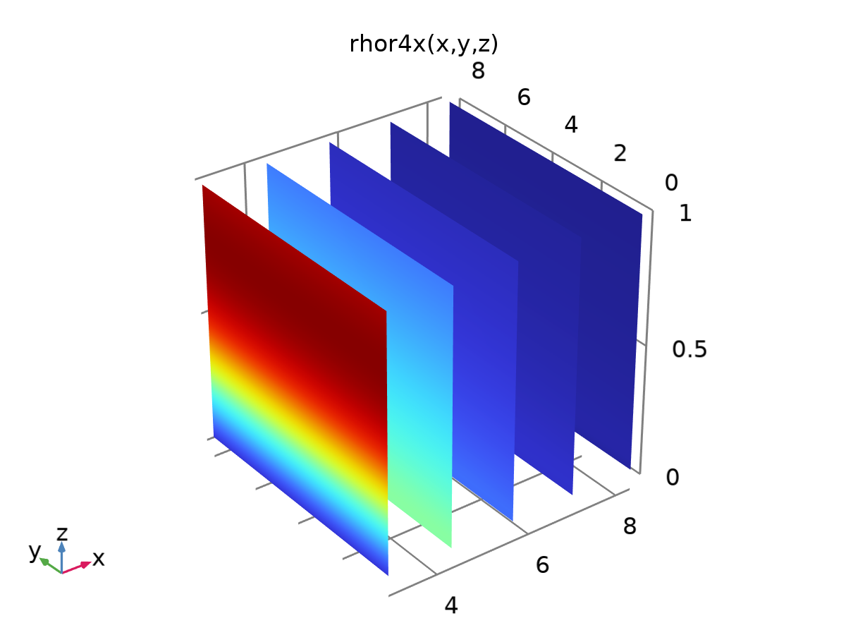

rhor4.1

Definition

| **Description** | **Value** |
| --- | --- |
| Expression | d(rhor4(x, y, z), x) |
| Arguments | {x, y, z} |

Units

| **Argument** | **Unit** |
| --- | --- |
| x |  |
| y |  |
| z |  |

### rhor4.1.1

|  |  |
| --- | --- |
| Function name | rhor4y |
| Function type | Analytic |

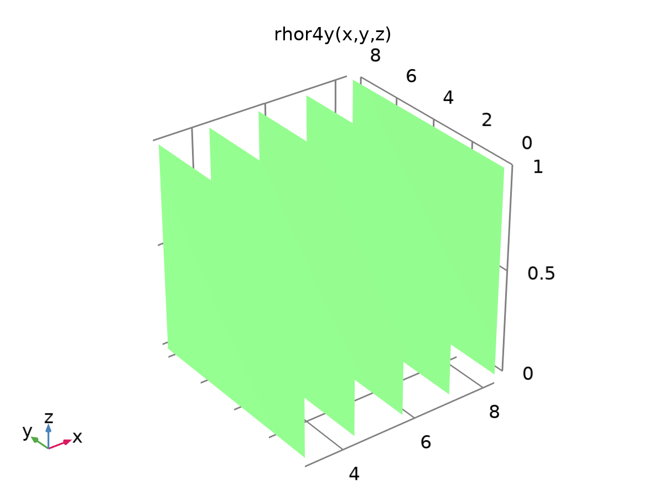

rhor4.1.1

Definition

| **Description** | **Value** |
| --- | --- |
| Expression | d(rhor4(x, y, z), y) |
| Arguments | {x, y, z} |

Units

| **Argument** | **Unit** |
| --- | --- |
| x |  |
| y |  |
| z |  |

### Analytic 70

|  |  |
| --- | --- |
| Function name | an70 |
| Function type | Analytic |

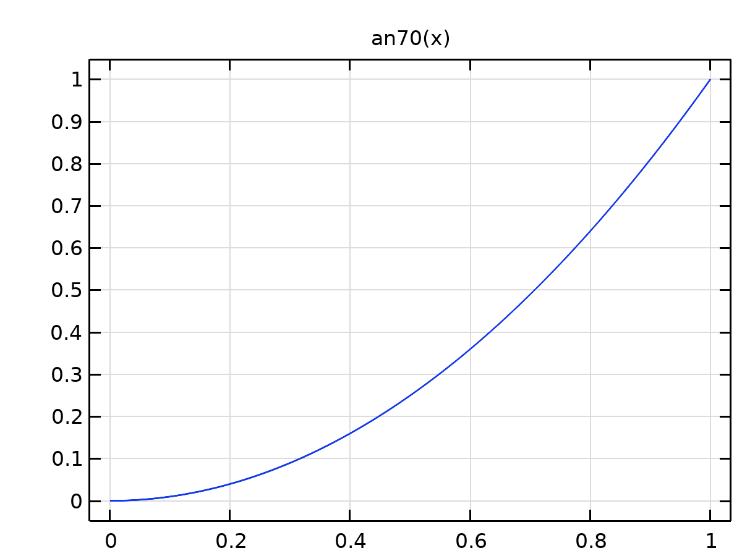

Analytic 70

Definition

| **Description** | **Value** |
| --- | --- |
| Expression | x^2 |
| Arguments | x |

Units

| **Argument** | **Unit** |
| --- | --- |
| x |  |

### Analytic 72

|  |  |
| --- | --- |
| Function name | tann3 |
| Function type | Analytic |

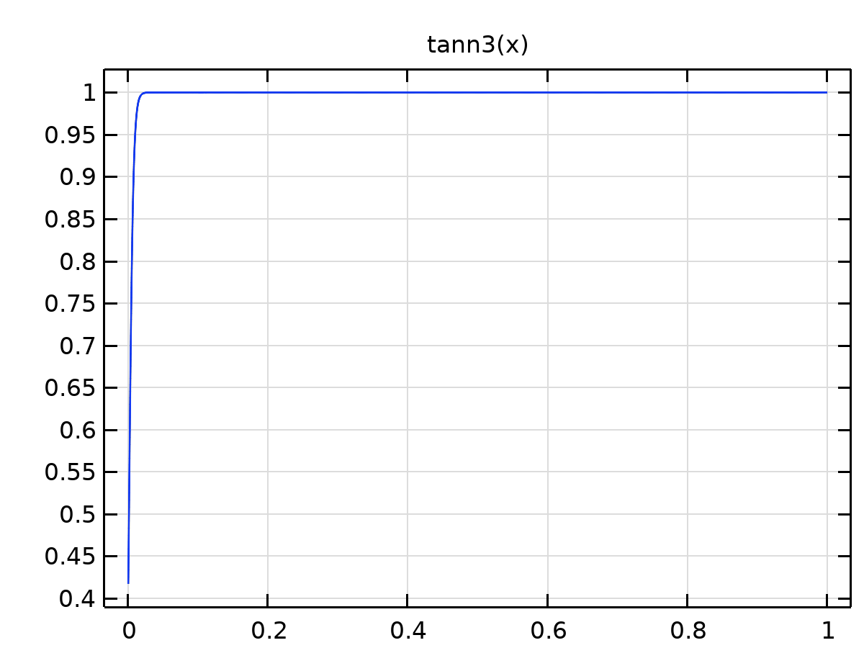

Analytic 72

Definition

| **Description** | **Value** |
| --- | --- |
| Expression | 0.5*(1 + tanh((x - 0.001)/0.006)) |
| Arguments | x |

Units

| **Argument** | **Unit** |
| --- | --- |
| x |  |

### Step 1

|  |  |
| --- | --- |
| Function name | step1Cl |
| Function type | Step |

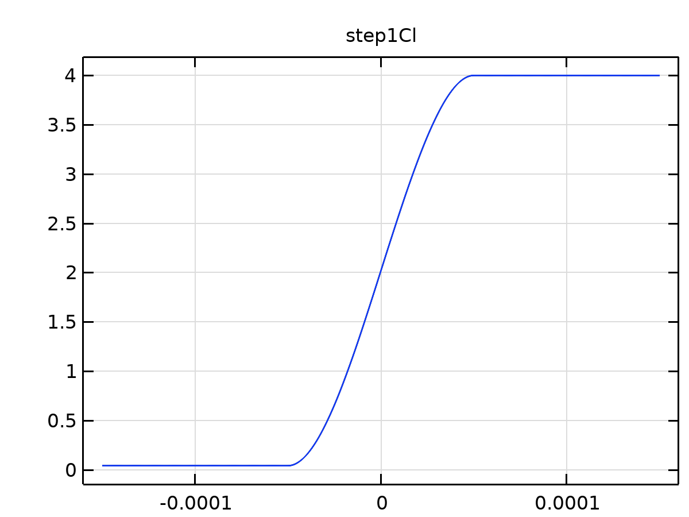

Step 1

Parameters

| **Description** | **Value** |
| --- | --- |
| Location | 0 |
| From | Clbound |
| To | Clinit |

Smoothing

| **Description** | **Value** |
| --- | --- |
| Size of transition zone | 1E-4 |
| Number of continuous derivatives | 1 |

### Step 2

|  |  |
| --- | --- |
| Function name | step1sw |
| Function type | Step |

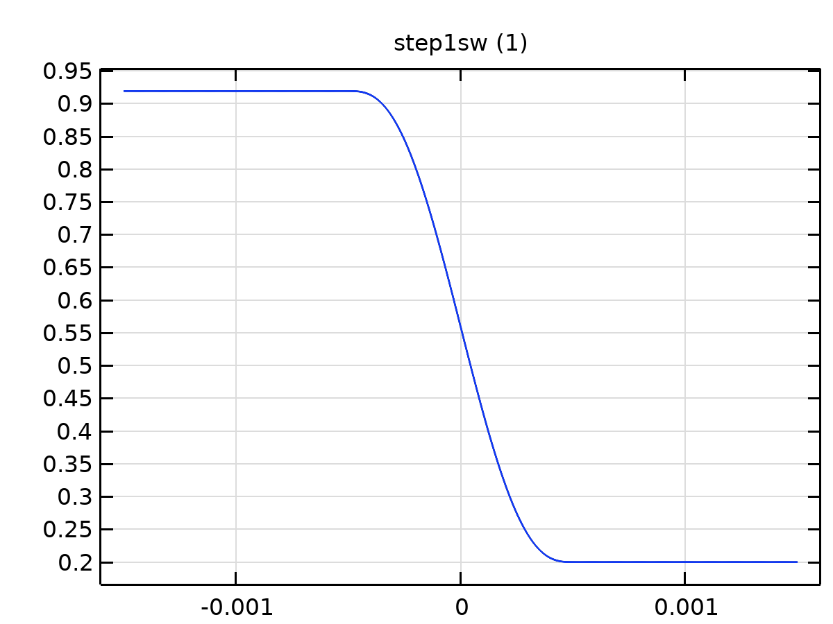

Step 2

Parameters

| **Description** | **Value** |
| --- | --- |
| Location | 0 |
| From | 1 - sor |
| To | 0.2 |

Smoothing

| **Description** | **Value** |
| --- | --- |
| Size of transition zone | 0.001 |

### Piecewise 5

|  |  |
| --- | --- |
| Function name | fw2 |
| Function type | Piecewise |

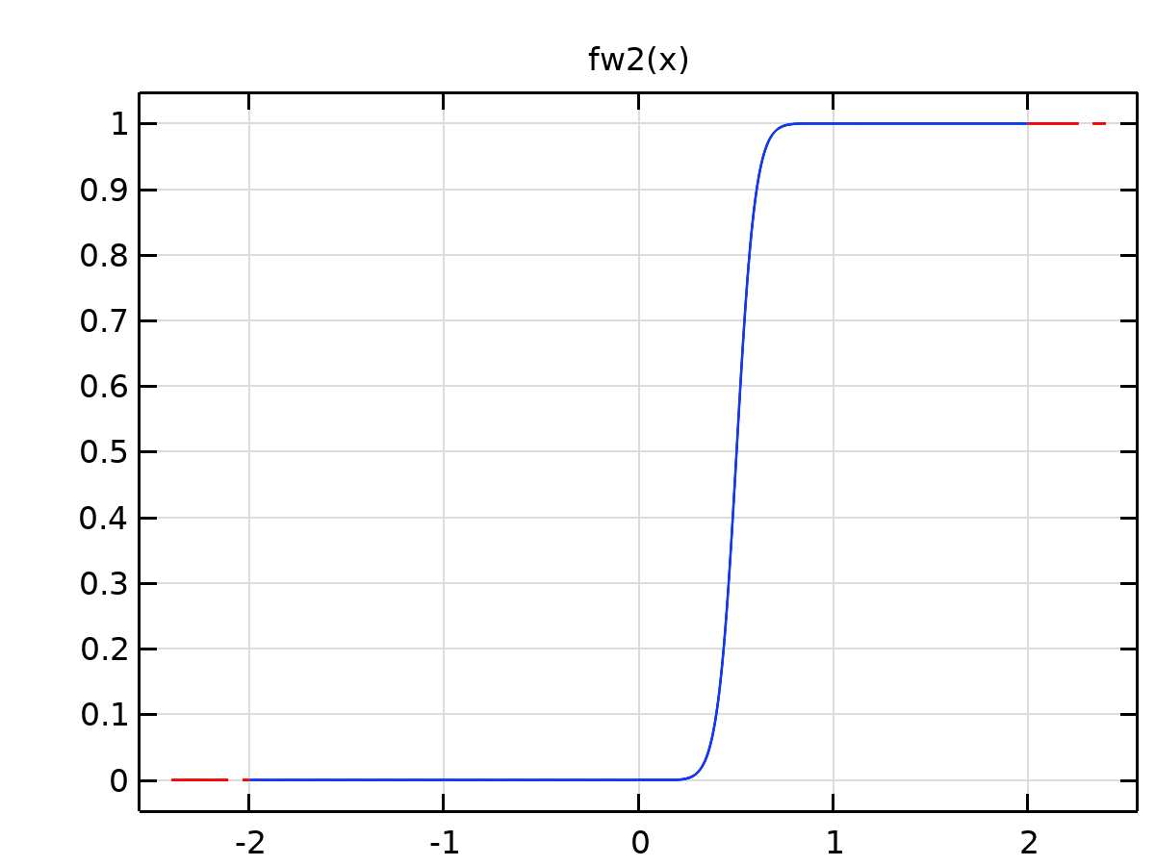

Piecewise 5

Definition

| **Description** | **Value** |
| --- | --- |
| Argument | x |
| Extrapolation | Constant |
| Smoothing | Continuous second derivative |
| Size of transition zone | 0.01 |
| Smooth at endpoints | On |

Definition

| **Start** | **End** | **Function** |
| --- | --- | --- |
| -2 | swc | 0 |
| swc | 1 | krw(x)/muw/(krw(x)/muw+kro(x)/muo) |
| 1 | 2 | 1 |

### Analytic 73

|  |  |
| --- | --- |
| Function name | fwHS |
| Function type | Analytic |

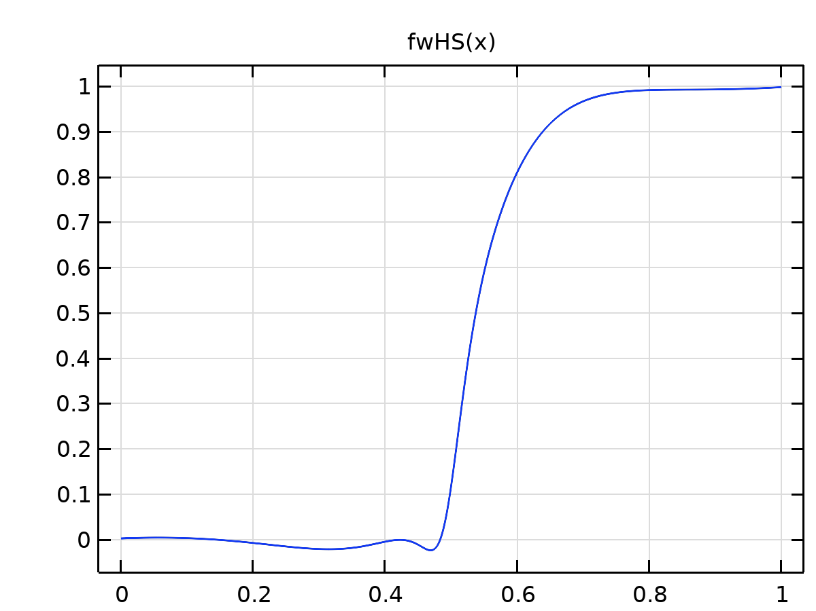

Analytic 73

Definition

| **Description** | **Value** |
| --- | --- |
| Expression | ((1171*x^5)/2500 - (337*x^4)/500 + (3417*x^3)/10000 - (3409*x^2)/50000 + (7694598121746097*x)/2305843009213693952 + 739714437355753/4611686018427387904)/(x^4 - (2011*x^3)/1000 + (1557*x^2)/1000 - (5483*x)/10000 + 1477/20000) |
| Arguments | x |

Units

| **Argument** | **Unit** |
| --- | --- |
| x |  |

### Piecewise 6

|  |  |
| --- | --- |
| Function name | se |
| Function type | Piecewise |

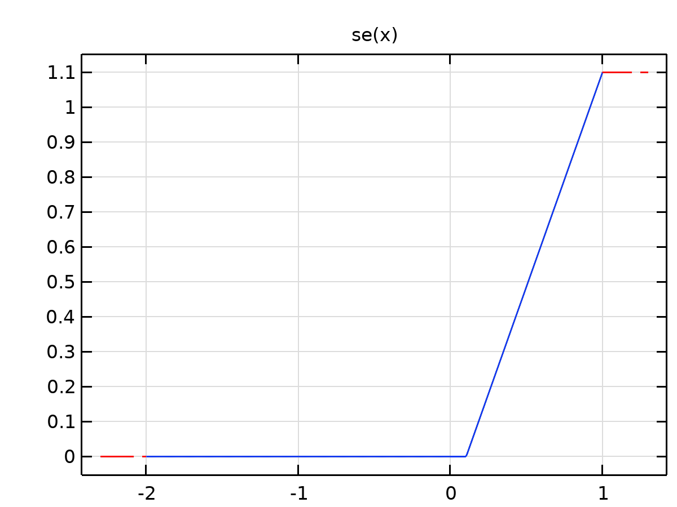

Piecewise 6

Definition

| **Description** | **Value** |
| --- | --- |
| Argument | x |
| Extrapolation | Constant |
| Smoothing | Continuous second derivative |
| Size of transition zone | 0.01 |

Definition

| **Start** | **End** | **Function** |
| --- | --- | --- |
| -2 | swc | 0 |
| swc | 1 | (x-swc)/(1-swc-sor) |

### Piecewise 7

|  |  |
| --- | --- |
| Function name | kro |
| Function type | Piecewise |

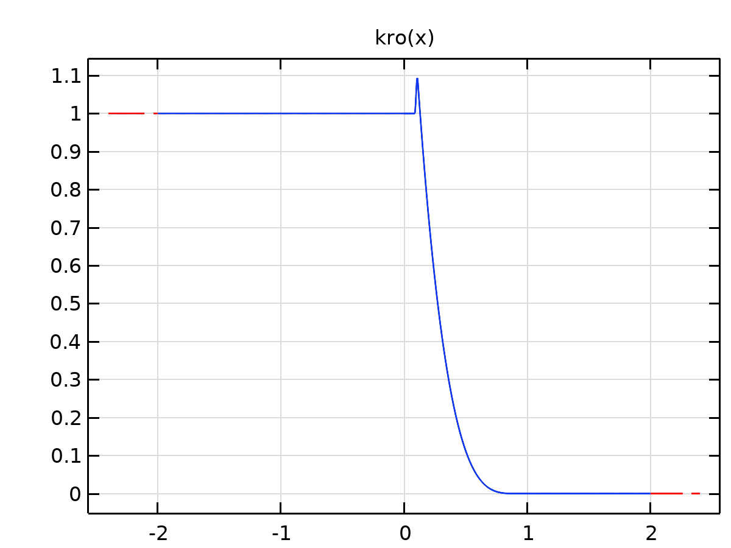

Piecewise 7

Definition

| **Description** | **Value** |
| --- | --- |
| Argument | x |
| Extrapolation | Constant |
| Smoothing | Continuous second derivative |
| Size of transition zone | 0.01 |

Definition

| **Start** | **End** | **Function** |
| --- | --- | --- |
| -2 | swc | 1 |
| swc | 1 | theta*krohl(x)+(1-theta)*krols(x) |
| 1 | 2 | 0 |

### Piecewise 8

|  |  |
| --- | --- |
| Function name | krw |
| Function type | Piecewise |

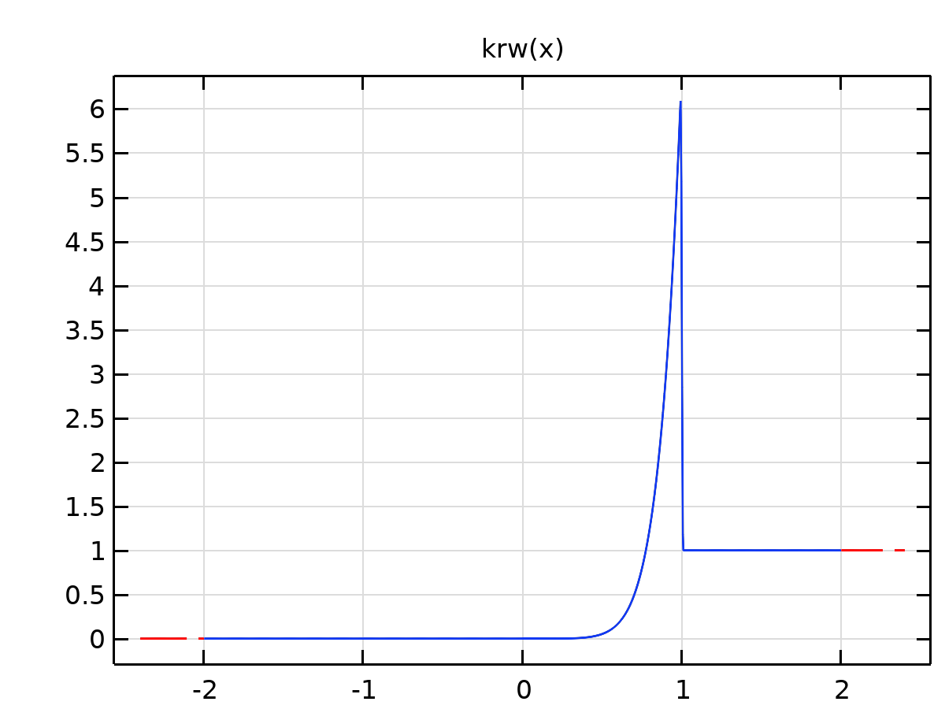

Piecewise 8

Definition

| **Description** | **Value** |
| --- | --- |
| Argument | x |
| Extrapolation | Constant |
| Smoothing | Continuous second derivative |
| Size of transition zone | 0.01 |

Definition

| **Start** | **End** | **Function** |
| --- | --- | --- |
| -2 | swc | 0 |
| swc | 1 | theta*krwhl(x)+(1-theta)*krwls(x) |
| 1 | 2 | 1 |

### Piecewise 9

|  |  |
| --- | --- |
| Function name | krohl |
| Function type | Piecewise |

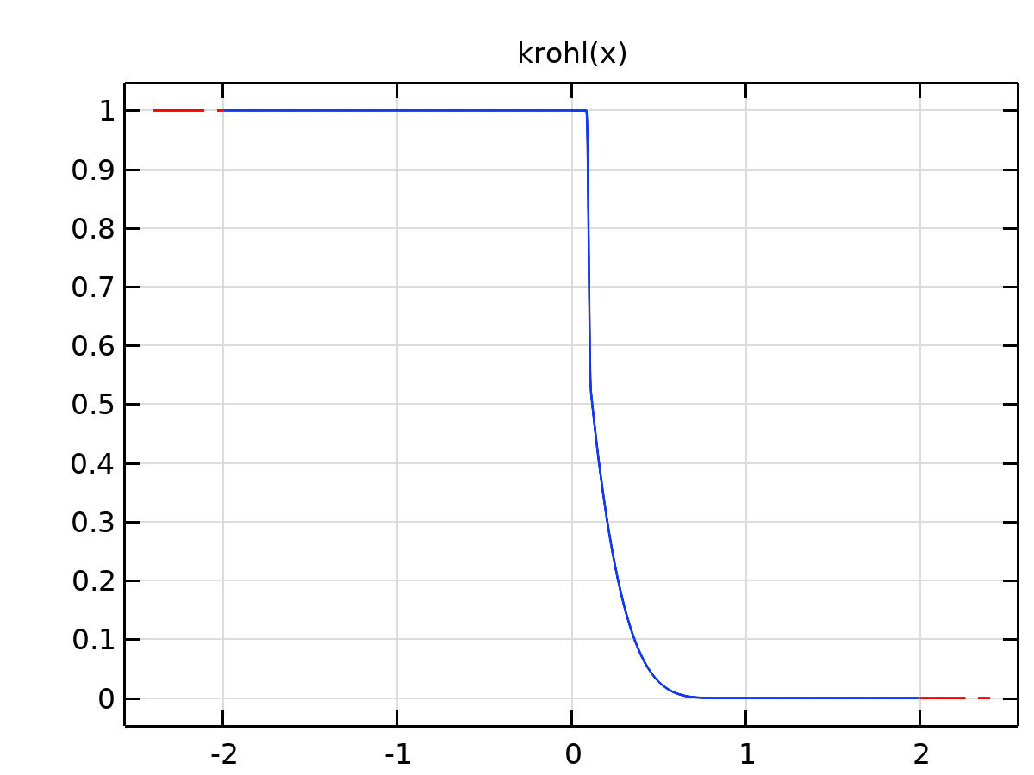

Piecewise 9

Definition

| **Description** | **Value** |
| --- | --- |
| Argument | x |
| Extrapolation | Constant |
| Smoothing | Continuous second derivative |
| Size of transition zone | 0.01 |

Definition

| **Start** | **End** | **Function** |
| --- | --- | --- |
| -2 | swc | 1 |
| swc | 0.9 | koh*(1-se(x))^noh |
| 0.9 | 2 | 0 |

### Piecewise 10

|  |  |
| --- | --- |
| Function name | krwhl |
| Function type | Piecewise |

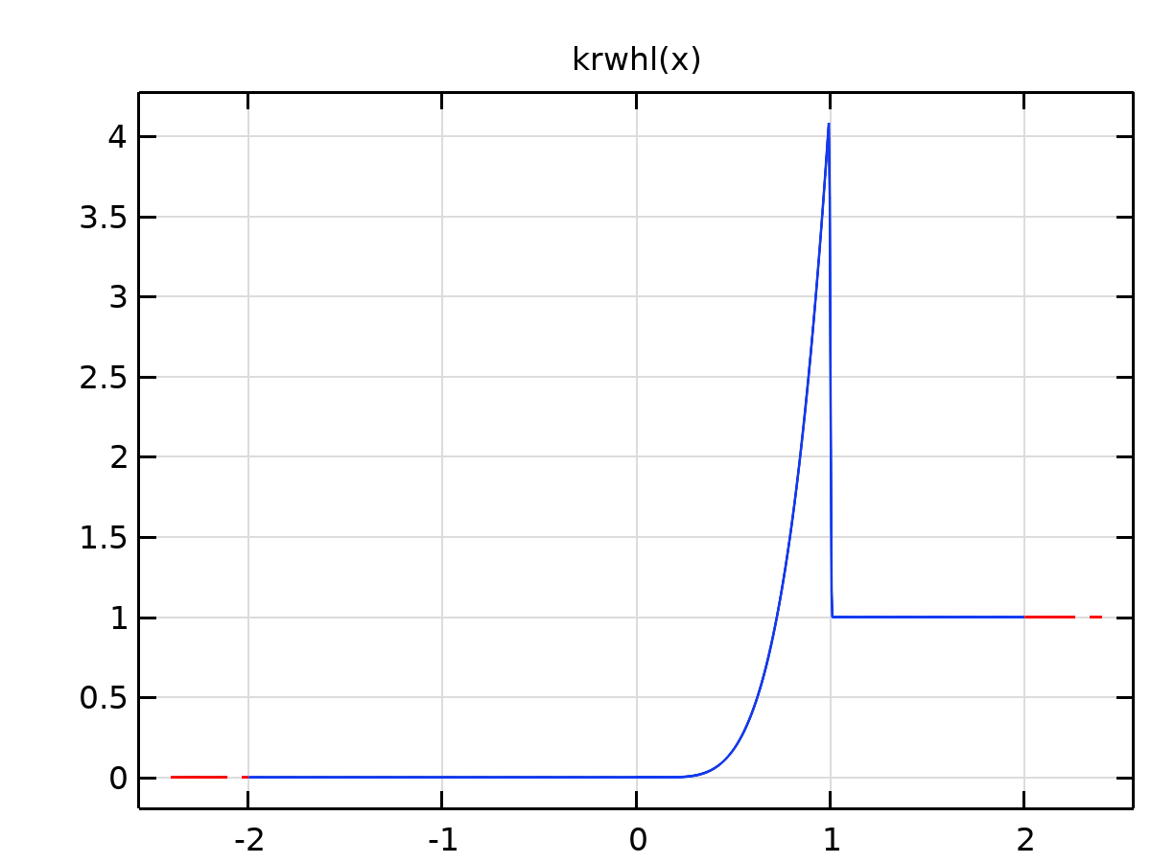

Piecewise 10

Definition

| **Description** | **Value** |
| --- | --- |
| Argument | x |
| Extrapolation | Constant |
| Smoothing | Continuous second derivative |
| Size of transition zone | 0.01 |
| Smooth at endpoints | On |

Definition

| **Start** | **End** | **Function** |
| --- | --- | --- |
| -2 | swc | 0 |
| swc | 1 | kwh*se(x)^nwh |
| 1 | 2 | 1 |

### Analytic 74

|  |  |
| --- | --- |
| Function name | gauss1 |
| Function type | Analytic |

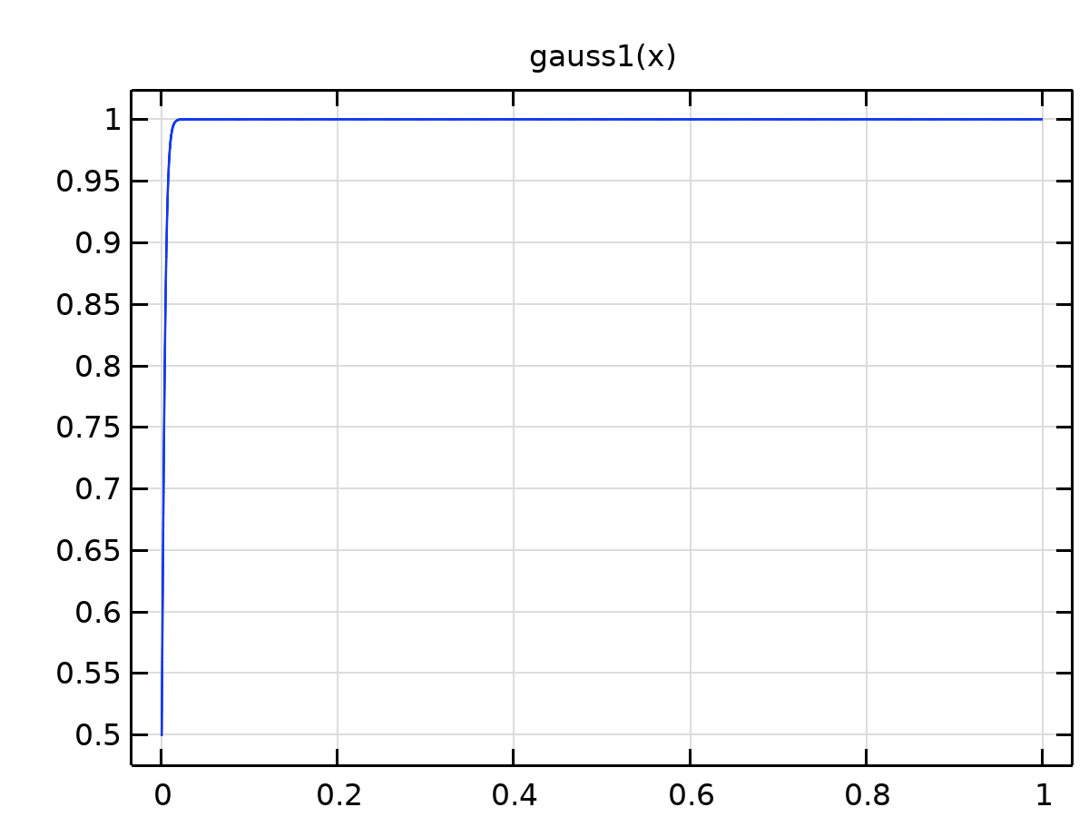

Analytic 74

Definition

| **Description** | **Value** |
| --- | --- |
| Expression | 0.5*(1 + tanh((x - 0.00001)/0.005)) |
| Arguments | x |

Units

| **Argument** | **Unit** |
| --- | --- |
| x |  |

### rhor5

|  |  |
| --- | --- |
| Function name | rhor5 |
| Function type | Analytic |

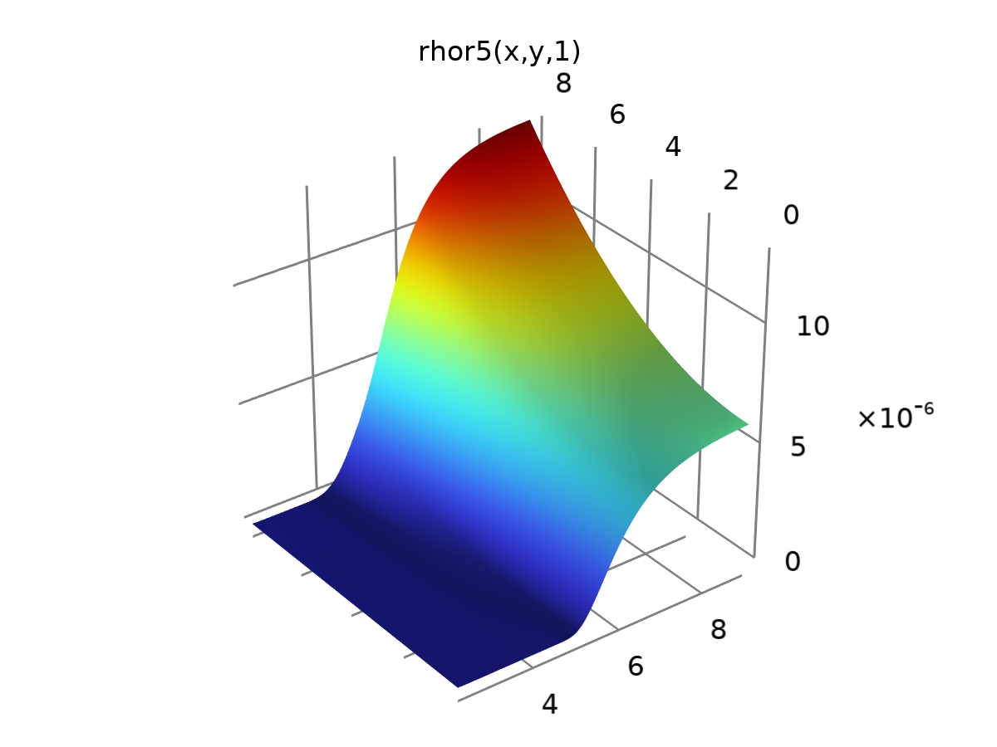

rhor5

Definition

| **Description** | **Value** |
| --- | --- |
| Expression | (0.01103*y^2*gauss(48.79/exp(0.8058*x)) + 0.6058*gauss(0.005821/z + 30.78/(x^2 + 0.1733*z*exp(0.8058*x) - 18.71)))*0.00001 |
| Arguments | {x, y, z} |

Units

| **Argument** | **Unit** |
| --- | --- |
| x |  |
| y |  |
| z |  |

### rhoo5

|  |  |
| --- | --- |
| Function name | rhoo5 |
| Function type | Analytic |

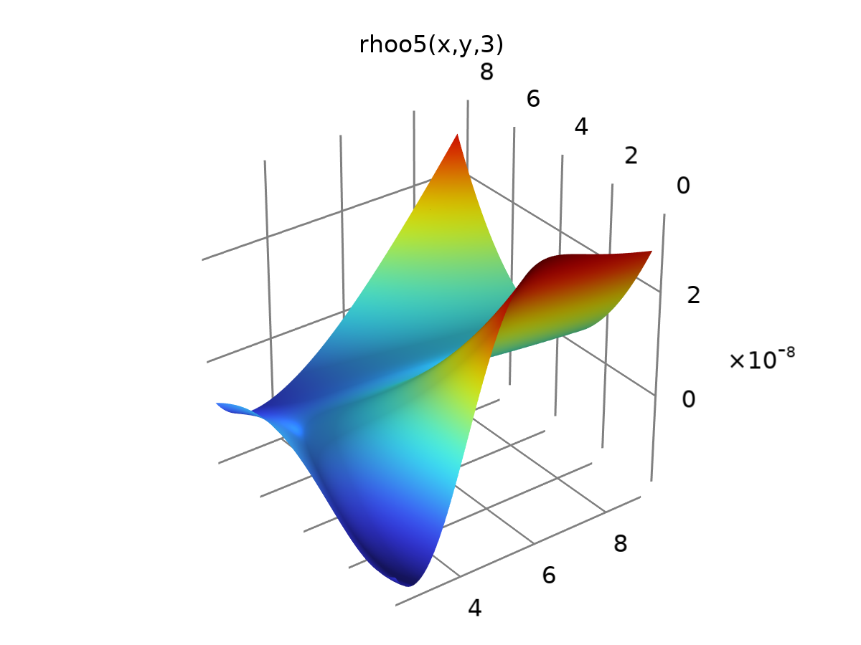

rhoo5

Definition

| **Description** | **Value** |
| --- | --- |
| Expression | (0.302 + 1.47/x + 0.001829*x*y^2 - 0.05994*z - 0.1314*y - 0.977*gauss(0.1798*y + 0.05398*x^2))*0.0000001 |
| Arguments | {x, y, z} |

Units

| **Argument** | **Unit** |
| --- | --- |
| x |  |
| y |  |
| z |  |

### rhow5

|  |  |
| --- | --- |
| Function name | rhow5 |
| Function type | Analytic |

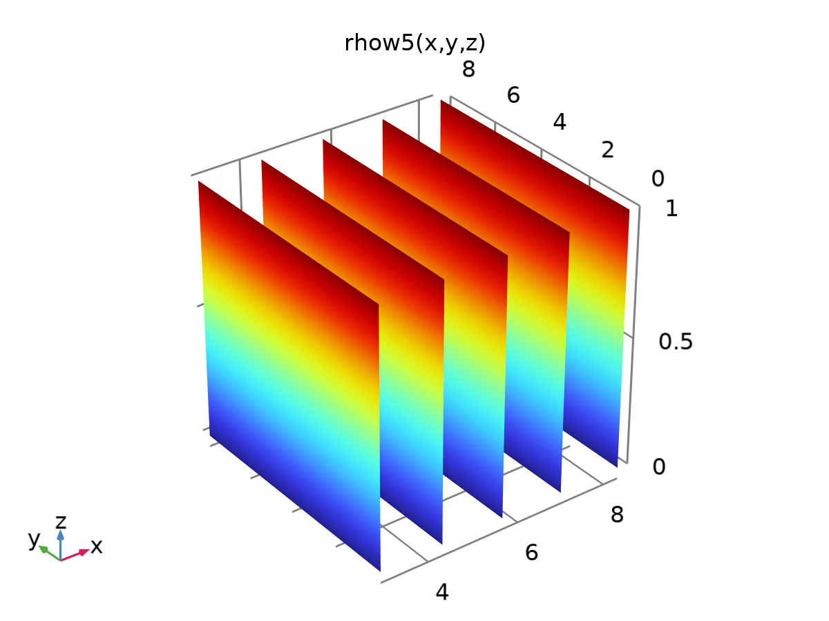

rhow5

Definition

| **Description** | **Value** |
| --- | --- |
| Expression | phi*z + 0.0000000000000000001*x + 0.000000000000000000000001*y |
| Arguments | {x, y, z} |

Units

| **Argument** | **Unit** |
| --- | --- |
| x |  |
| y |  |
| z |  |

### rho5

|  |  |
| --- | --- |
| Function name | rho5 |
| Function type | Analytic |

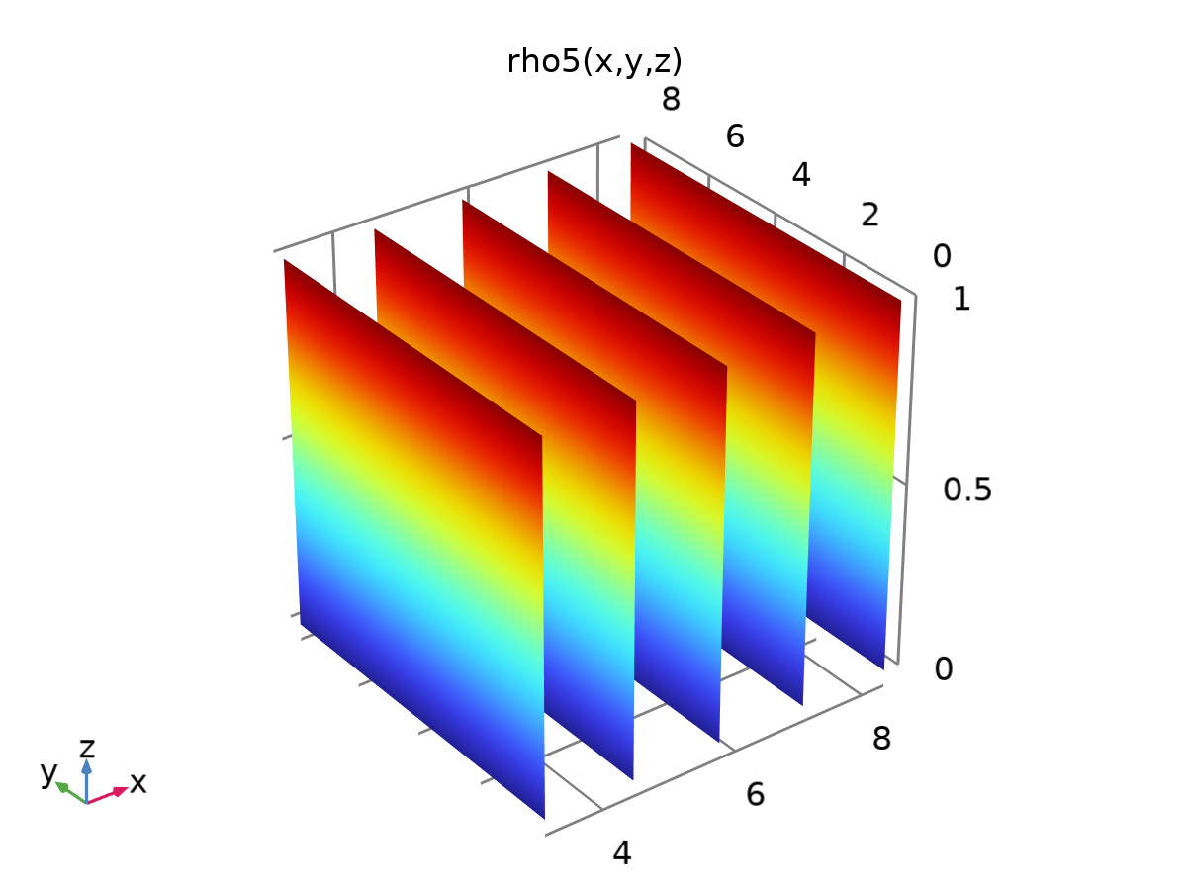

rho5

Definition

| **Description** | **Value** |
| --- | --- |
| Expression | phi*z - rhoo5(x, y, z) |
| Arguments | {x, y, z} |

Units

| **Argument** | **Unit** |
| --- | --- |
| x |  |
| y |  |
| z |  |

### Mgini

|  |  |
| --- | --- |
| Function name | Mgini |
| Function type | Analytic |

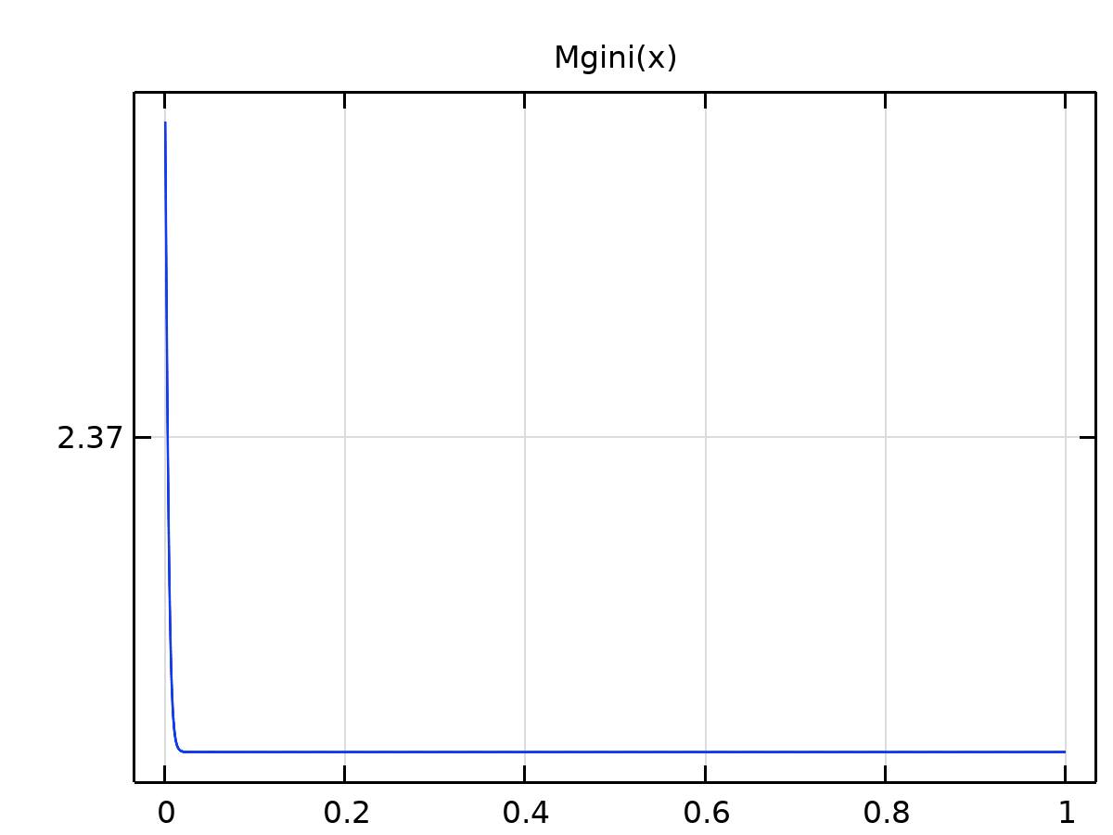

Mgini

Definition

| **Description** | **Value** |
| --- | --- |
| Expression | (2.37 + 0.000001*(1 - tann(x))*(mgh - mgl)) |
| Arguments | x |

Units

| **Argument** | **Unit** |
| --- | --- |
| x |  |

### rhor1.1.1.1

|  |  |
| --- | --- |
| Function name | rhor1z |
| Function type | Analytic |

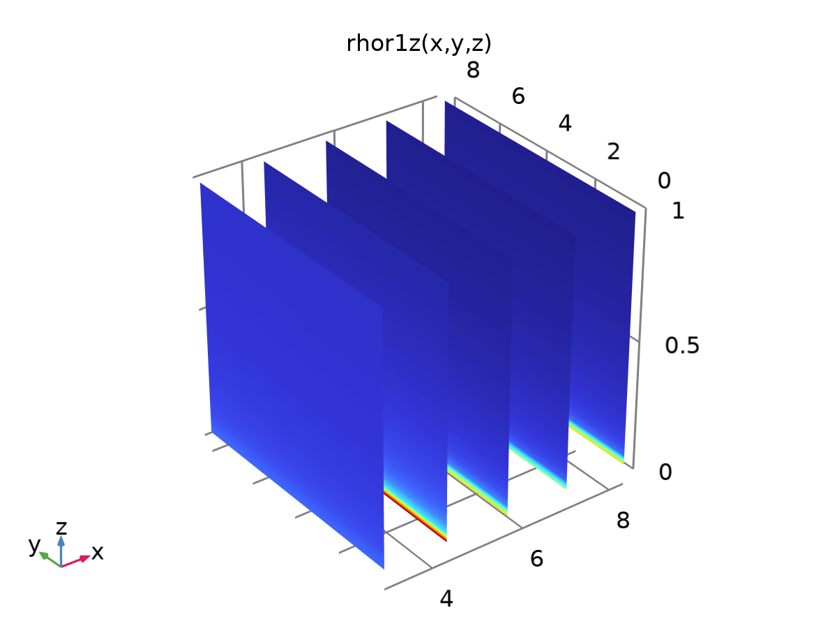

rhor1.1.1.1

Definition

| **Description** | **Value** |
| --- | --- |
| Expression | d(rhor1(x, y, z), z) |
| Arguments | {x, y, z} |

Units

| **Argument** | **Unit** |
| --- | --- |
| x |  |
| y |  |
| z |  |

### rhor1.1.1.1.1

|  |  |
| --- | --- |
| Function name | rhoo1z |
| Function type | Analytic |

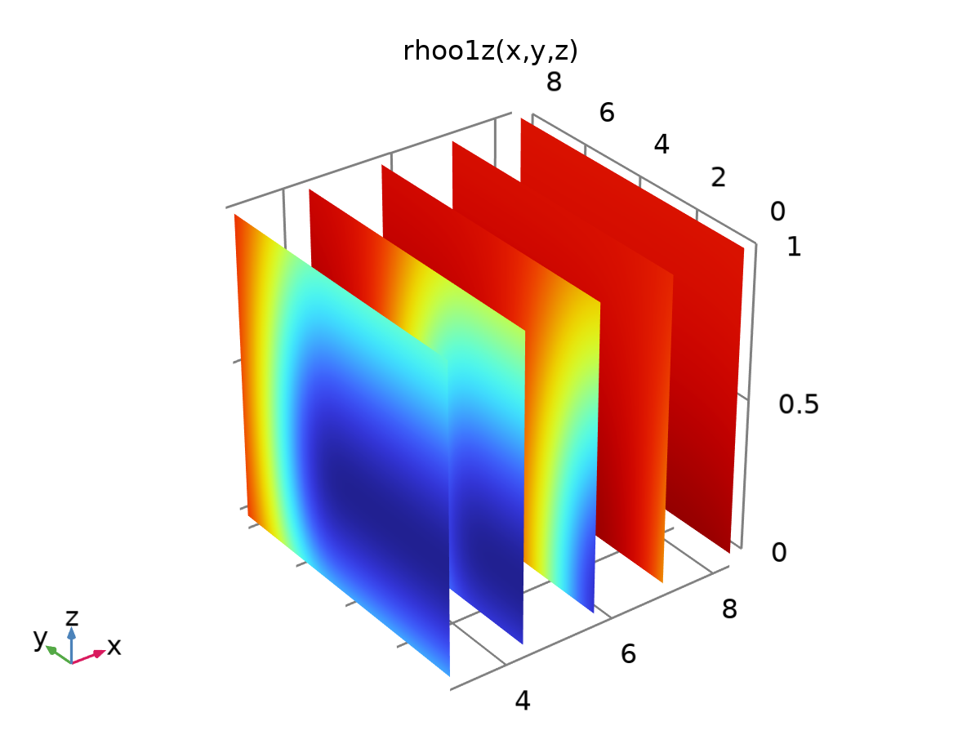

rhor1.1.1.1.1

Definition

| **Description** | **Value** |
| --- | --- |
| Expression | d(rhoo1(x, y, z), z) |
| Arguments | {x, y, z} |

Units

| **Argument** | **Unit** |
| --- | --- |
| x |  |
| y |  |
| z |  |

### rhor1.1.1.1.1.1

|  |  |
| --- | --- |
| Function name | rhow1z |
| Function type | Analytic |

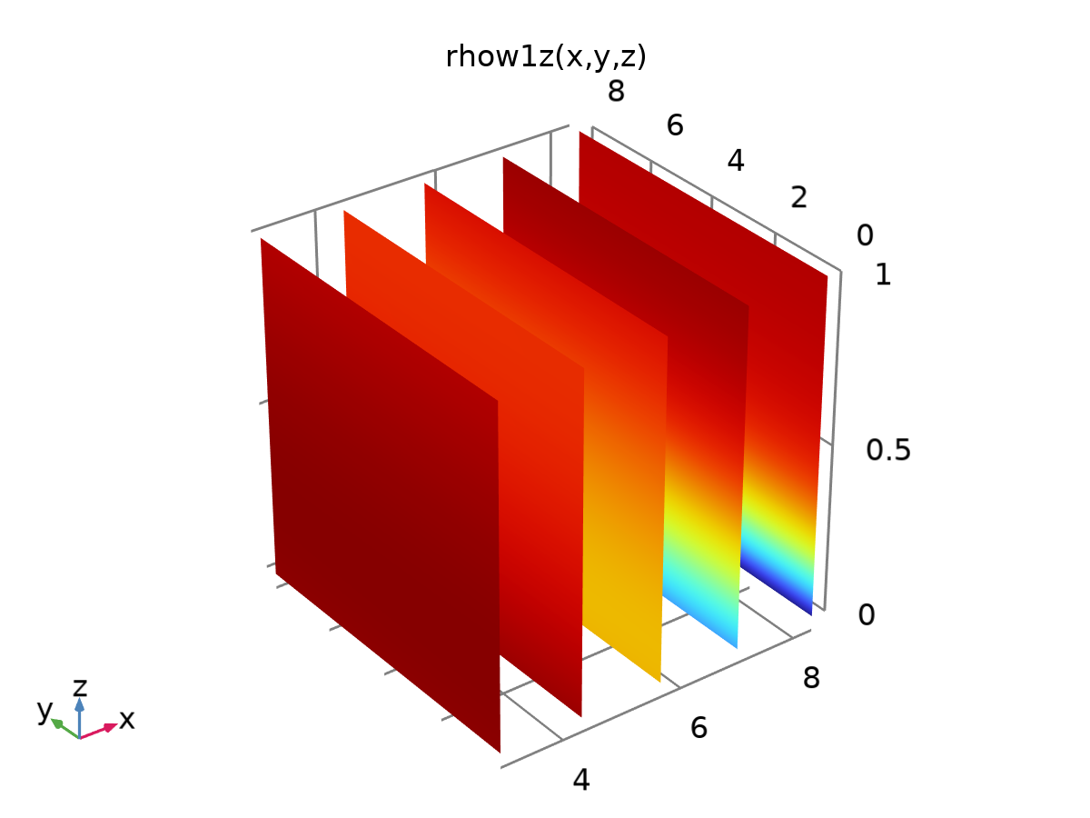

rhor1.1.1.1.1.1

Definition

| **Description** | **Value** |
| --- | --- |
| Expression | d(rhow1(x, y, z), z) |
| Arguments | {x, y, z} |

Units

| **Argument** | **Unit** |
| --- | --- |
| x |  |
| y |  |
| z |  |

### rhor4.1.1.1

|  |  |
| --- | --- |
| Function name | rhor4z |
| Function type | Analytic |

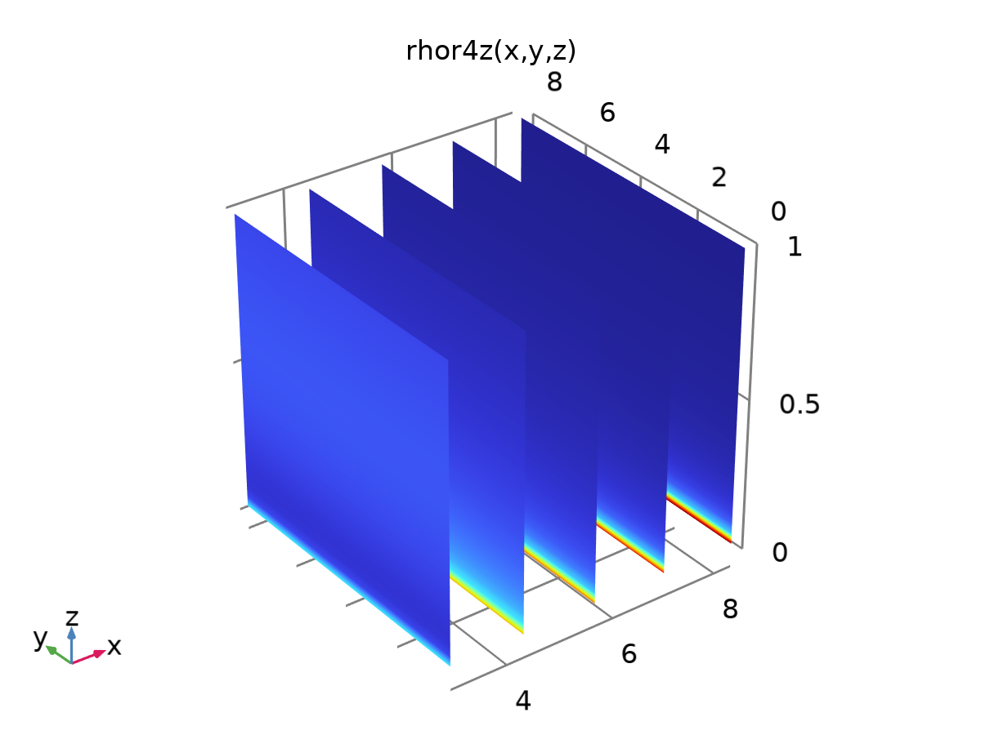

rhor4.1.1.1

Definition

| **Description** | **Value** |
| --- | --- |
| Expression | d(rhor4(x, y, z), z) |
| Arguments | {x, y, z} |

Units

| **Argument** | **Unit** |
| --- | --- |
| x |  |
| y |  |
| z |  |

### rhoo4.1

|  |  |
| --- | --- |
| Function name | rhoo4x |
| Function type | Analytic |

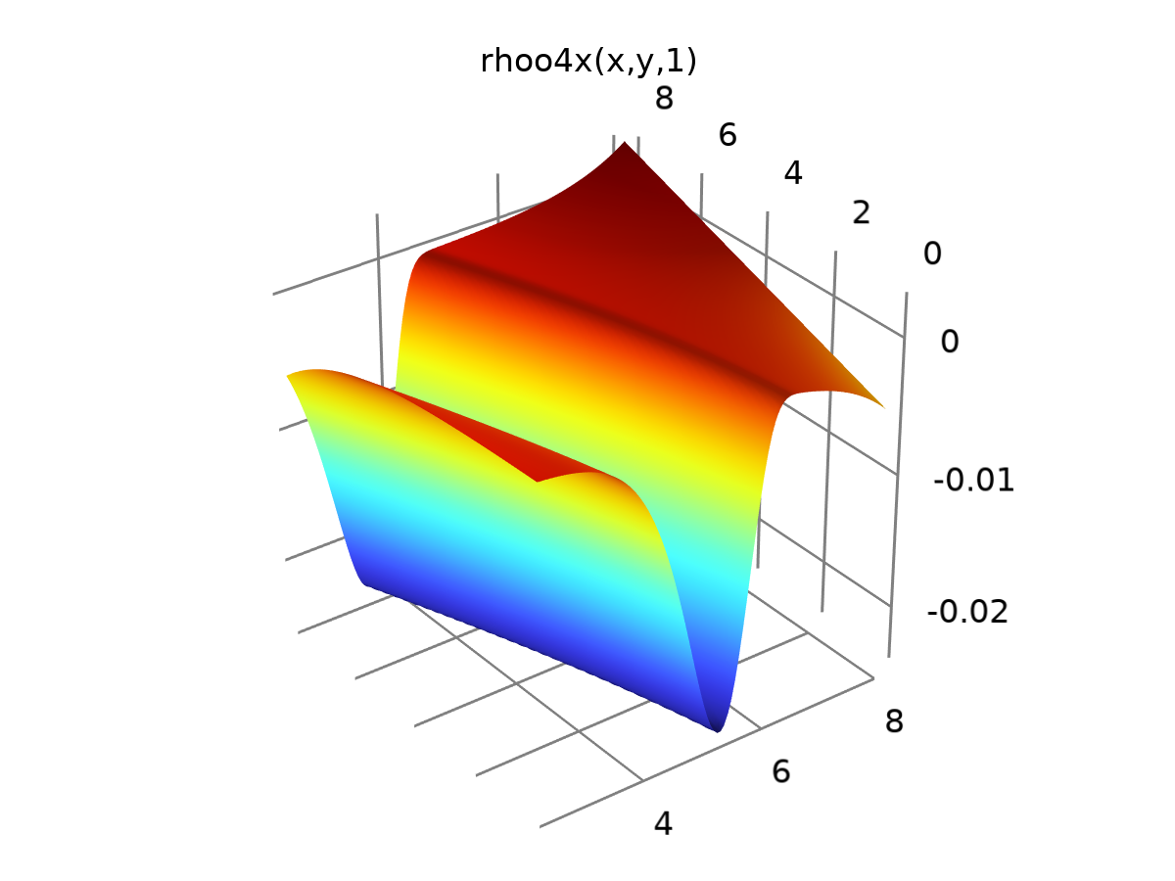

rhoo4.1

Definition

| **Description** | **Value** |
| --- | --- |
| Expression | d(rhoo4(x, y, z), x) |
| Arguments | {x, y, z} |

Units

| **Argument** | **Unit** |
| --- | --- |
| x |  |
| y |  |
| z |  |

### rhoo4.1.1

|  |  |
| --- | --- |
| Function name | rhoo4y |
| Function type | Analytic |

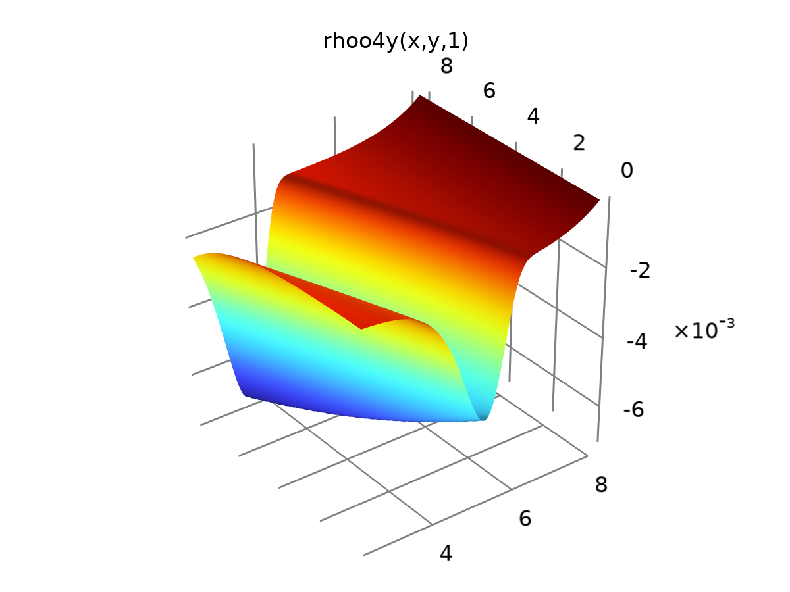

rhoo4.1.1

Definition

| **Description** | **Value** |
| --- | --- |
| Expression | d(rhoo4(x, y, z), y) |
| Arguments | {x, y, z} |

Units

| **Argument** | **Unit** |
| --- | --- |
| x |  |
| y |  |
| z |  |

### rhoo4.1.1.1

|  |  |
| --- | --- |
| Function name | rhoo4z |
| Function type | Analytic |

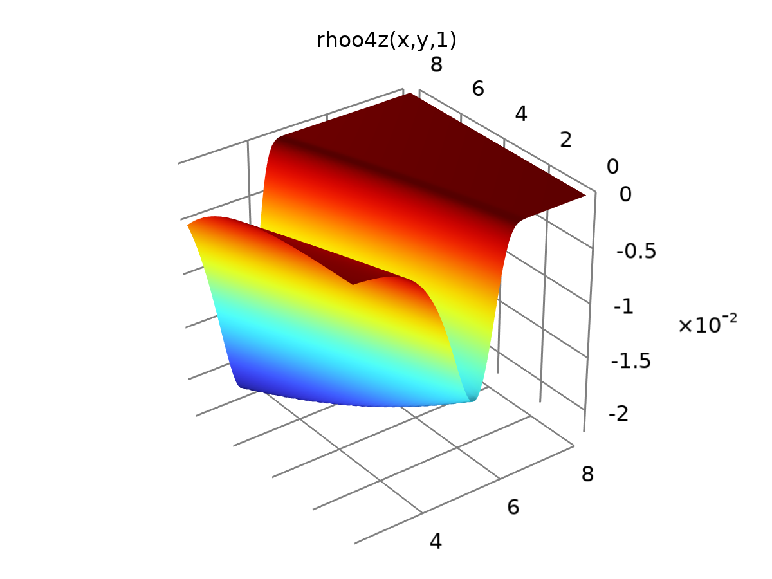

rhoo4.1.1.1

Definition

| **Description** | **Value** |
| --- | --- |
| Expression | d(rhoo4(x, y, z), z) |
| Arguments | {x, y, z} |

Units

| **Argument** | **Unit** |
| --- | --- |
| x |  |
| y |  |
| z |  |

### rhow4.1

|  |  |
| --- | --- |
| Function name | rhow4x |
| Function type | Analytic |

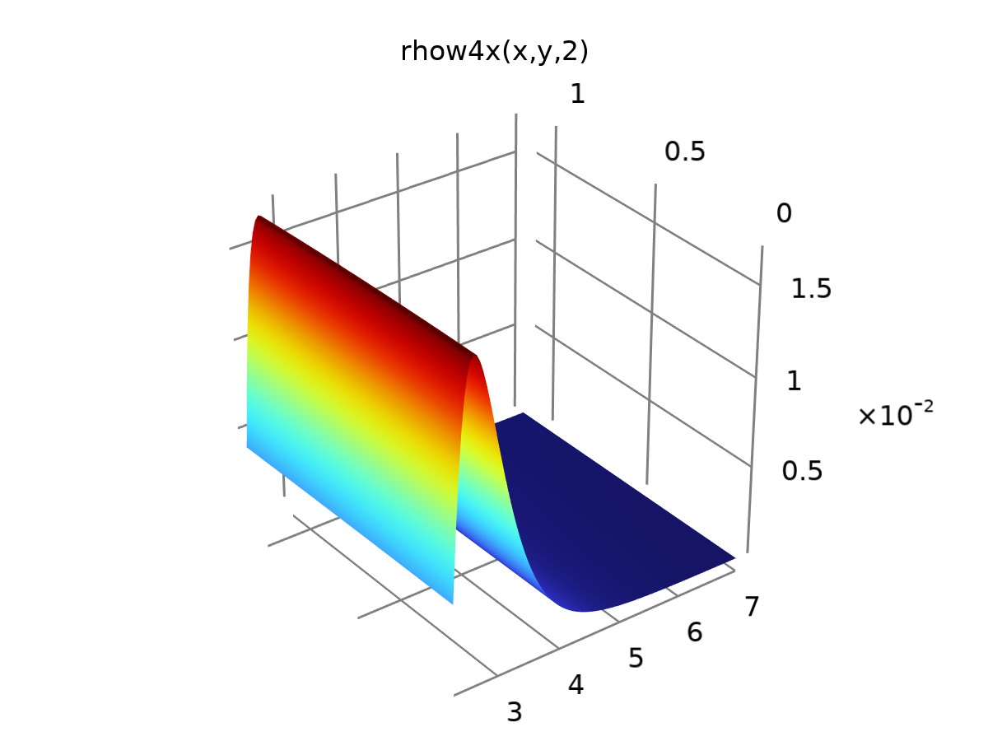

rhow4.1

Definition

| **Description** | **Value** |
| --- | --- |
| Expression | d(rhow4(x, y, z), x) |
| Arguments | {x, y, z} |

Units

| **Argument** | **Unit** |
| --- | --- |
| x |  |
| y |  |
| z |  |

### rhow4y

|  |  |
| --- | --- |
| Function name | rhow4y |
| Function type | Analytic |

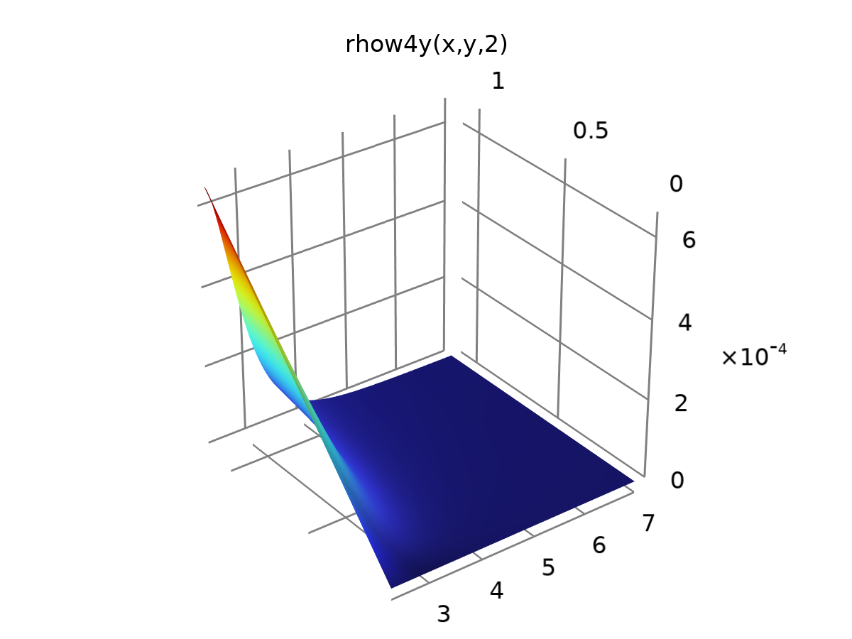

rhow4y

Definition

| **Description** | **Value** |
| --- | --- |
| Expression | d(rhow4(x, y, z), y) |
| Arguments | {x, y, z} |

Units

| **Argument** | **Unit** |
| --- | --- |
| x |  |
| y |  |
| z |  |

### rhow4y 1

|  |  |
| --- | --- |
| Function name | rhow4z |
| Function type | Analytic |

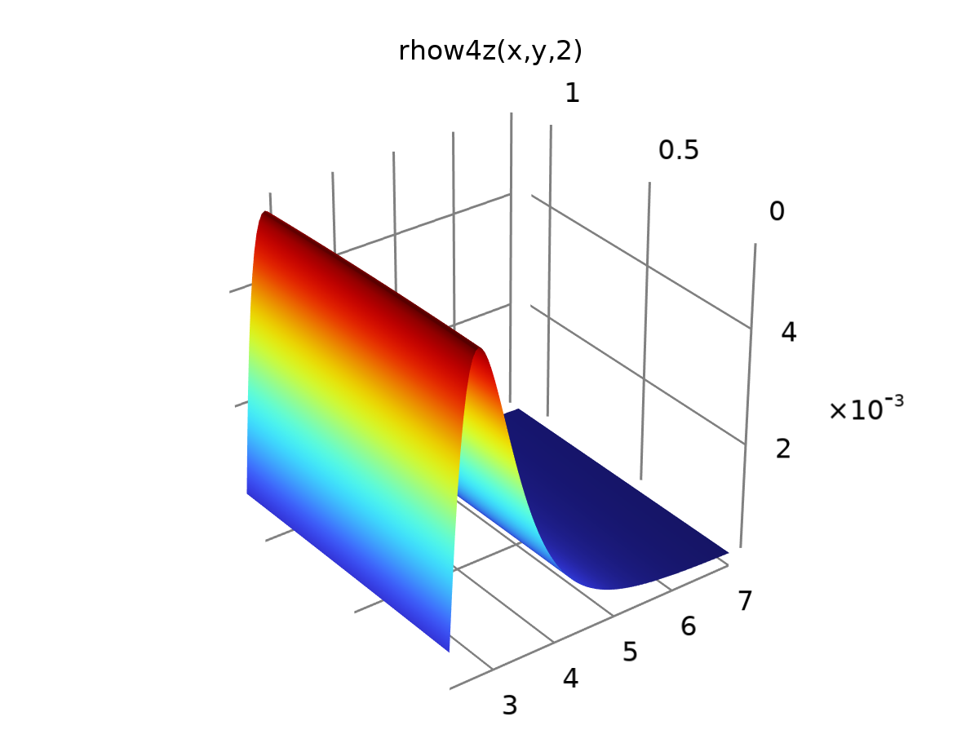

rhow4y 1

Definition

| **Description** | **Value** |
| --- | --- |
| Expression | d(rhow4(x, y, z), z) |
| Arguments | {x, y, z} |

Units

| **Argument** | **Unit** |
| --- | --- |
| x |  |
| y |  |
| z |  |

### rhow3.1

|  |  |
| --- | --- |
| Function name | rhow3x |
| Function type | Analytic |

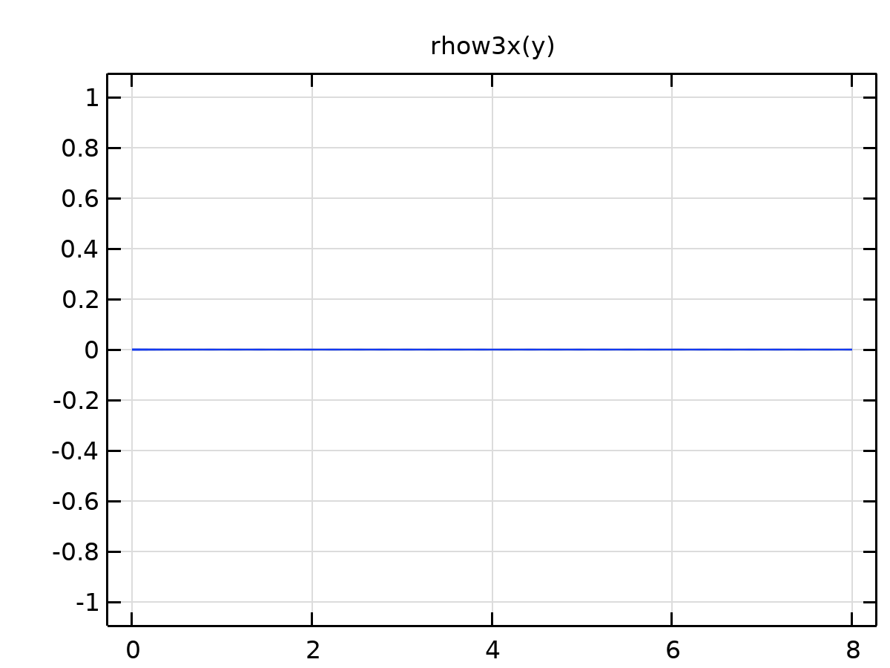

rhow3.1

Definition

| **Description** | **Value** |
| --- | --- |
| Expression | 0 |
| Arguments | y |

Units

| **Argument** | **Unit** |
| --- | --- |
| y |  |

### rhow3.1.1

|  |  |
| --- | --- |
| Function name | rhow3y |
| Function type | Analytic |

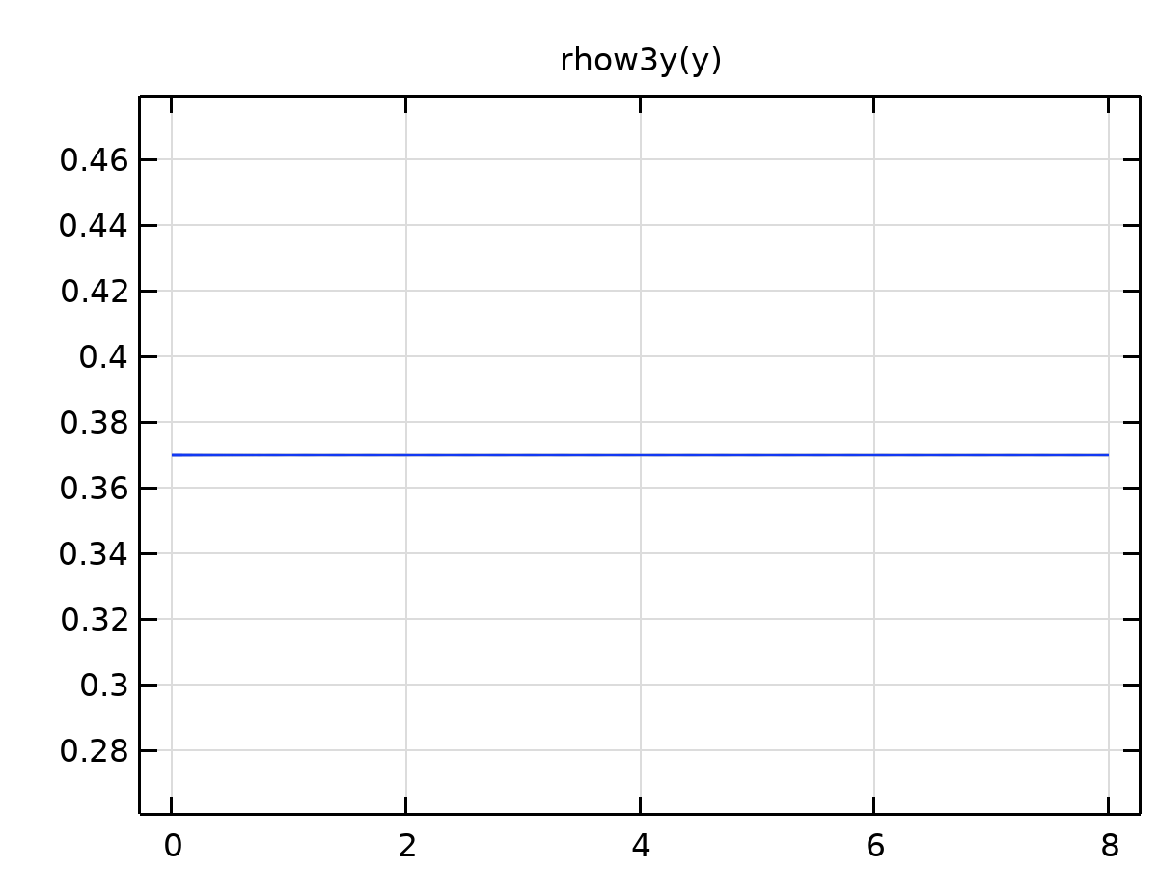

rhow3.1.1

Definition

| **Description** | **Value** |
| --- | --- |
| Expression | phi |
| Arguments | y |

Units

| **Argument** | **Unit** |
| --- | --- |
| y |  |

### rhow3.1.1.1

|  |  |
| --- | --- |
| Function name | rhow3z |
| Function type | Analytic |

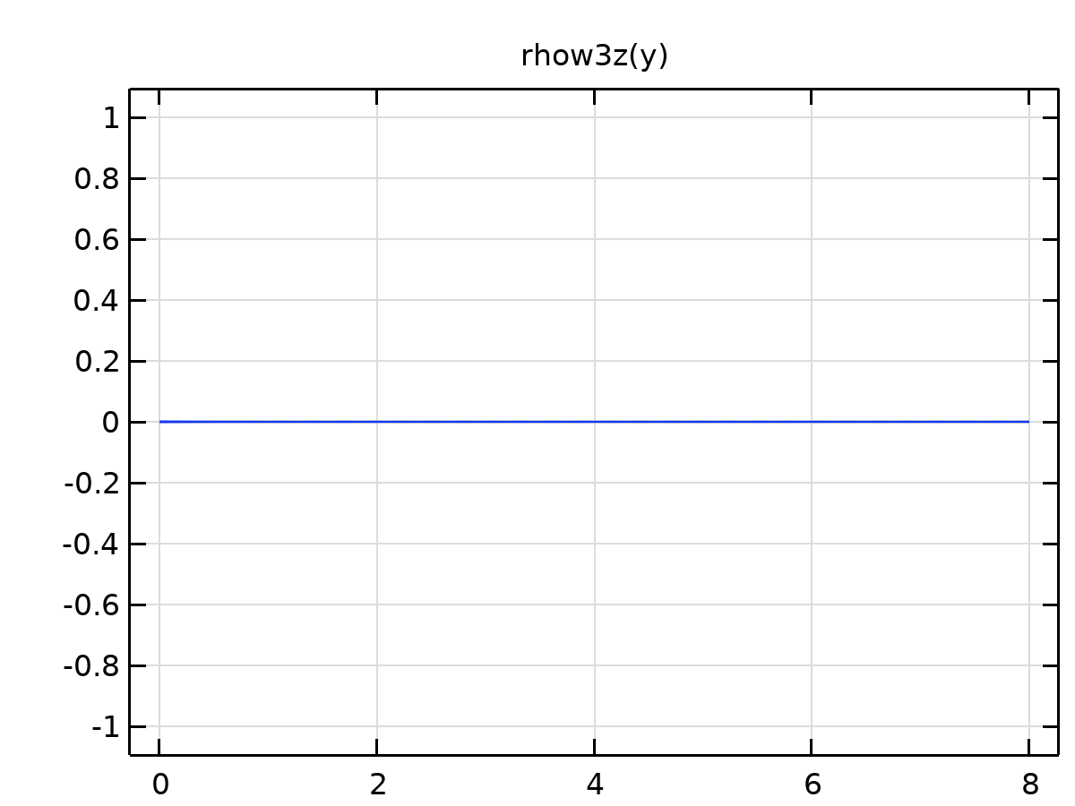

rhow3.1.1.1

Definition

| **Description** | **Value** |
| --- | --- |
| Expression | 0 |
| Arguments | y |

Units

| **Argument** | **Unit** |
| --- | --- |
| y |  |

### rhoo2.2

|  |  |
| --- | --- |
| Function name | rhoo2x |
| Function type | Analytic |

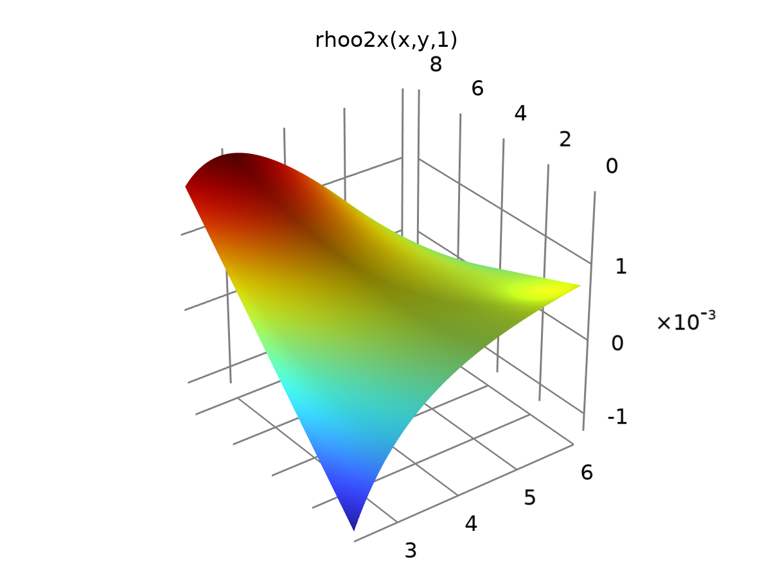

rhoo2.2

Definition

| **Description** | **Value** |
| --- | --- |
| Expression | d(rhoo2(x, y, z), x) |
| Arguments | {x, y, z} |

Units

| **Argument** | **Unit** |
| --- | --- |
| x |  |
| y |  |
| z |  |

### rhoo2.2.1

|  |  |
| --- | --- |
| Function name | rhoo2y |
| Function type | Analytic |

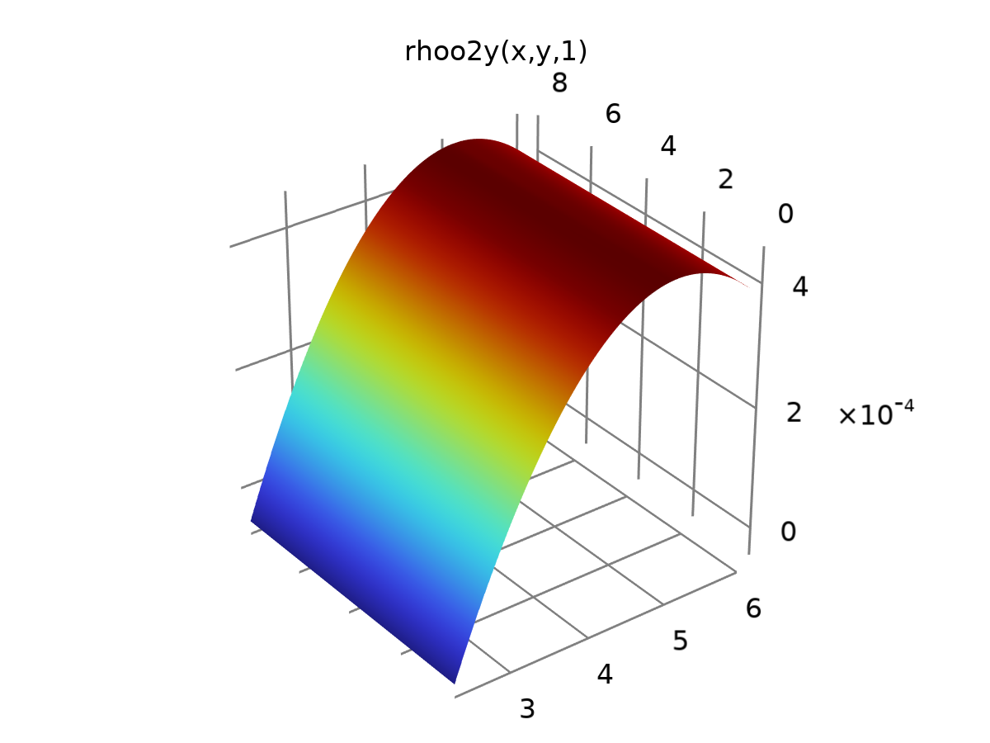

rhoo2.2.1

Definition

| **Description** | **Value** |
| --- | --- |
| Expression | d(rhoo2(x, y, z), y) |
| Arguments | {x, y, z} |

Units

| **Argument** | **Unit** |
| --- | --- |
| x |  |
| y |  |
| z |  |

### rhoo2.2.1.1

|  |  |
| --- | --- |
| Function name | rhoo2z |
| Function type | Analytic |

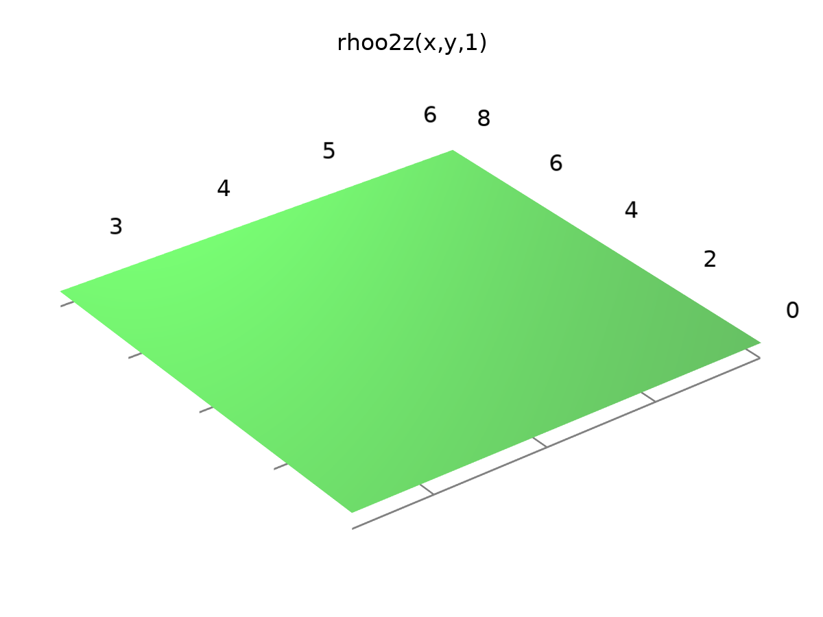

rhoo2.2.1.1

Definition

| **Description** | **Value** |
| --- | --- |
| Expression | d(rhoo2(x, y, z), z) |
| Arguments | {x, y, z} |

Units

| **Argument** | **Unit** |
| --- | --- |
| x |  |
| y |  |
| z |  |

### rhow5.1

|  |  |
| --- | --- |
| Function name | rhow5x |
| Function type | Analytic |

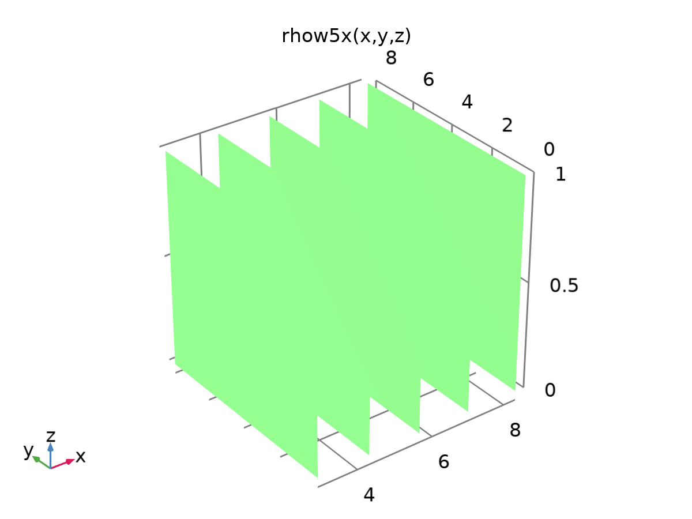

rhow5.1

Definition

| **Description** | **Value** |
| --- | --- |
| Expression | d(rhow5(x, y, z), x) |
| Arguments | {x, y, z} |

Units

| **Argument** | **Unit** |
| --- | --- |
| x |  |
| y |  |
| z |  |

### rhow5.1.1

|  |  |
| --- | --- |
| Function name | rhow5y |
| Function type | Analytic |

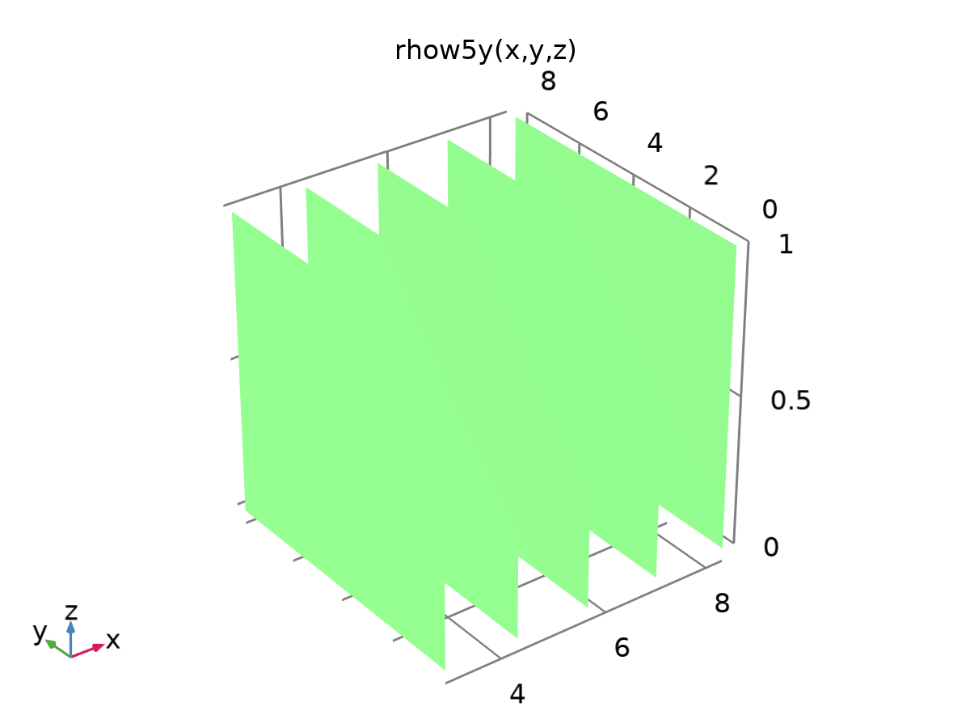

rhow5.1.1

Definition

| **Description** | **Value** |
| --- | --- |
| Expression | d(rhow5(x, y, z), y) |
| Arguments | {x, y, z} |

Units

| **Argument** | **Unit** |
| --- | --- |
| x |  |
| y |  |
| z |  |

### rhow5.1.1.1

|  |  |
| --- | --- |
| Function name | rhow5z |
| Function type | Analytic |

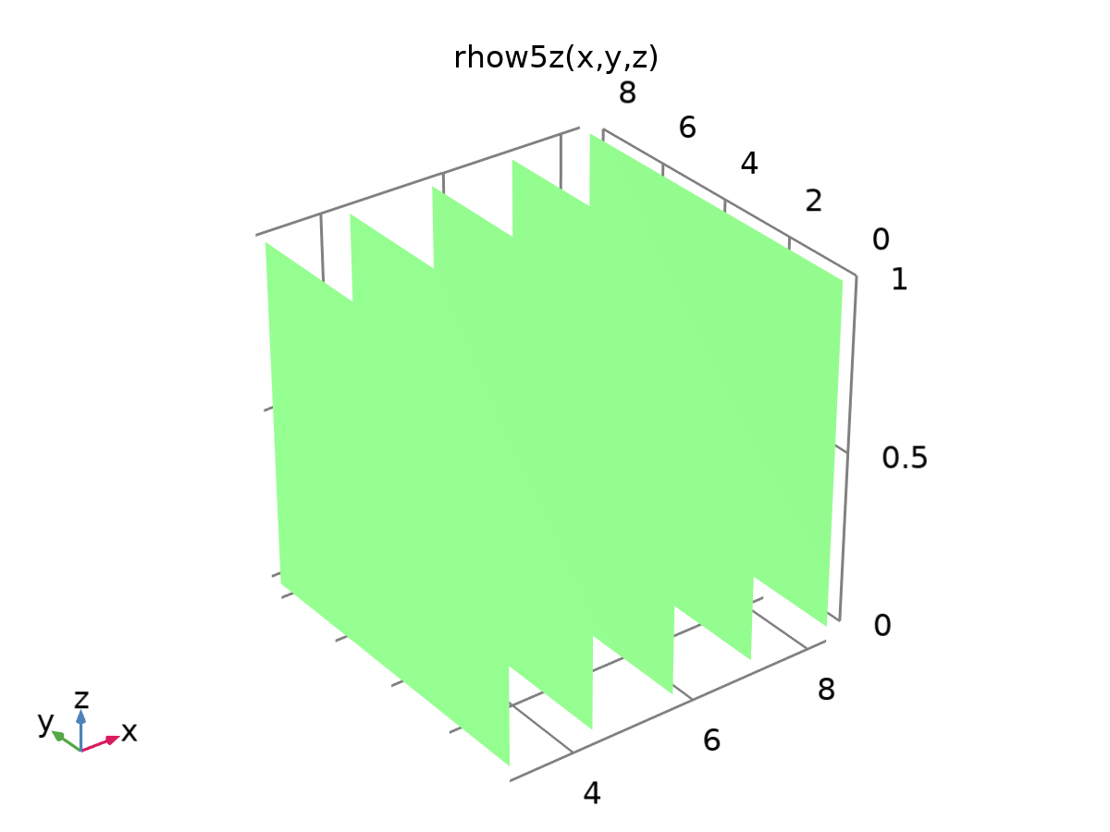

rhow5.1.1.1

Definition

| **Description** | **Value** |
| --- | --- |
| Expression | d(rhow5(x, y, z), z) |
| Arguments | {x, y, z} |

Units

| **Argument** | **Unit** |
| --- | --- |
| x |  |
| y |  |
| z |  |

### rhoo5.1

|  |  |
| --- | --- |
| Function name | rhoo5x |
| Function type | Analytic |

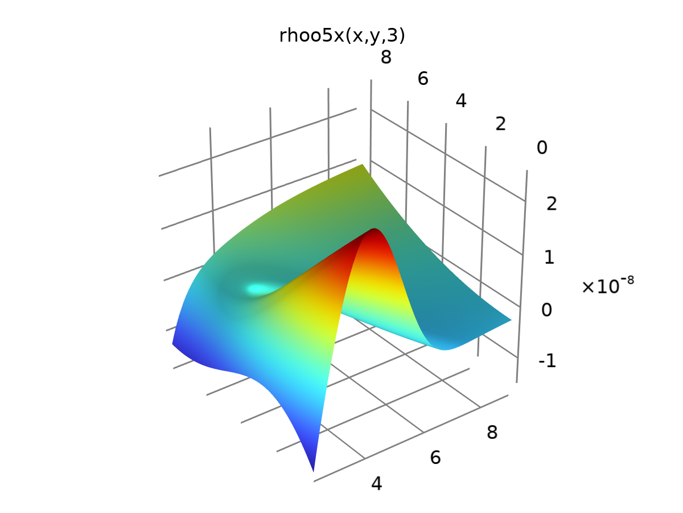

rhoo5.1

Definition

| **Description** | **Value** |
| --- | --- |
| Expression | d(rhoo5(x, y, z), x) |
| Arguments | {x, y, z} |

Units

| **Argument** | **Unit** |
| --- | --- |
| x |  |
| y |  |
| z |  |

### rhoo5.1.1

|  |  |
| --- | --- |
| Function name | rhoo5y |
| Function type | Analytic |

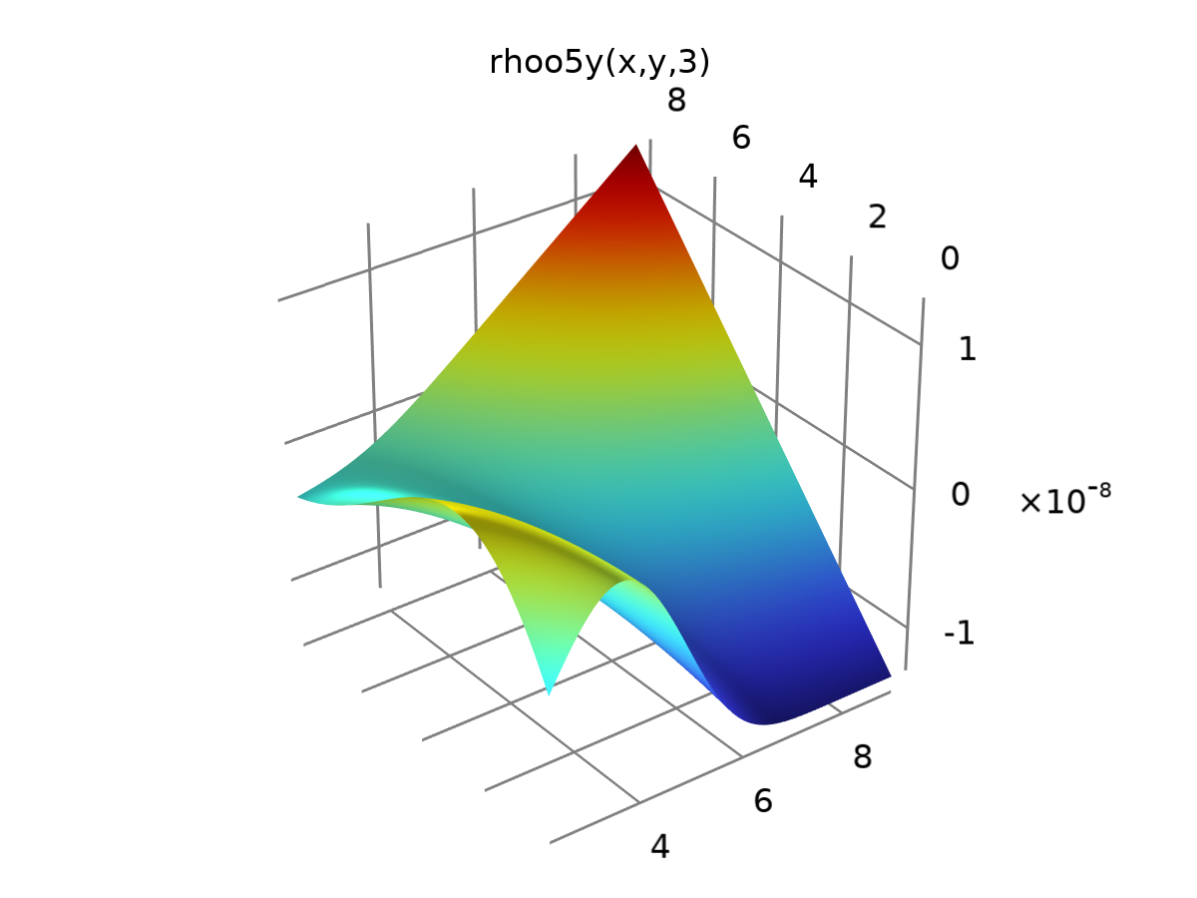

rhoo5.1.1

Definition

| **Description** | **Value** |
| --- | --- |
| Expression | d(rhoo5(x, y, z), y) |
| Arguments | {x, y, z} |

Units

| **Argument** | **Unit** |
| --- | --- |
| x |  |
| y |  |
| z |  |

### rhoo5.1.1.1

|  |  |
| --- | --- |
| Function name | rhoo5z |
| Function type | Analytic |

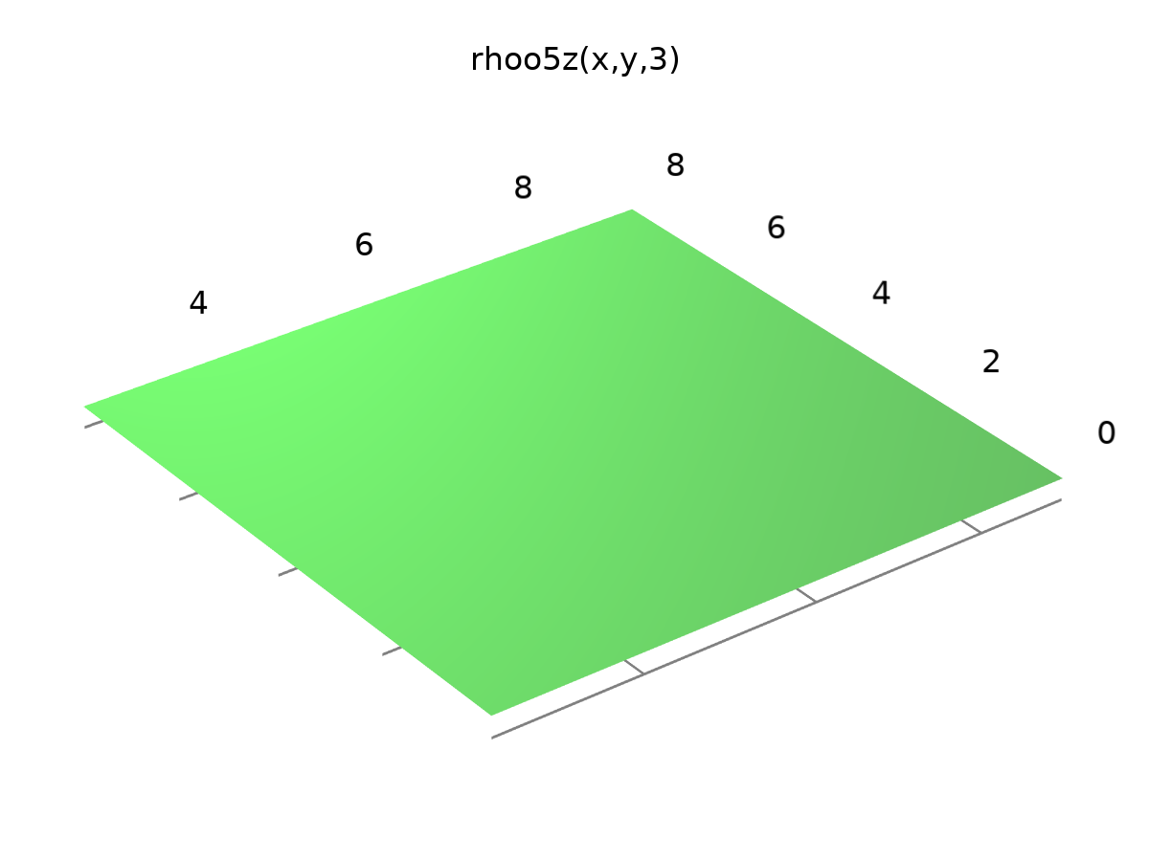

rhoo5.1.1.1

Definition

| **Description** | **Value** |
| --- | --- |
| Expression | d(rhoo5(x, y, z), z) |
| Arguments | {x, y, z} |

Units

| **Argument** | **Unit** |
| --- | --- |
| x |  |
| y |  |
| z |  |

### rhor5.1

|  |  |
| --- | --- |
| Function name | rhor5x |
| Function type | Analytic |

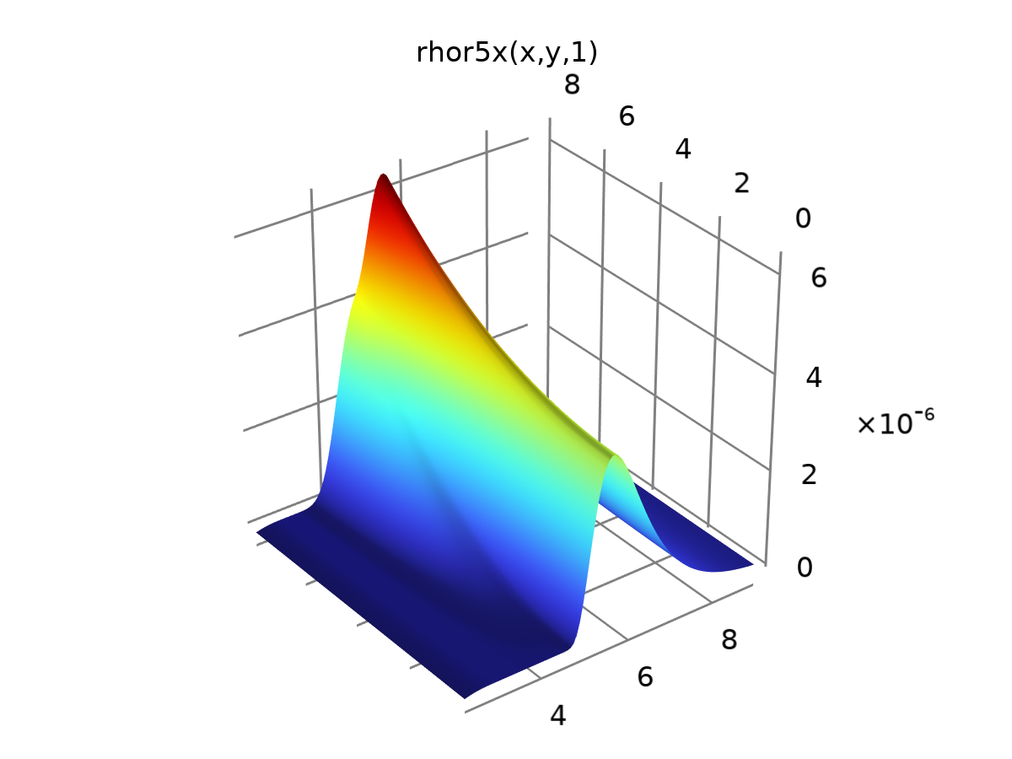

rhor5.1

Definition

| **Description** | **Value** |
| --- | --- |
| Expression | d(rhor5(x, y, z), x) |
| Arguments | {x, y, z} |

Units

| **Argument** | **Unit** |
| --- | --- |
| x |  |
| y |  |
| z |  |

### rhor5.1.1

|  |  |
| --- | --- |
| Function name | rhor5y |
| Function type | Analytic |

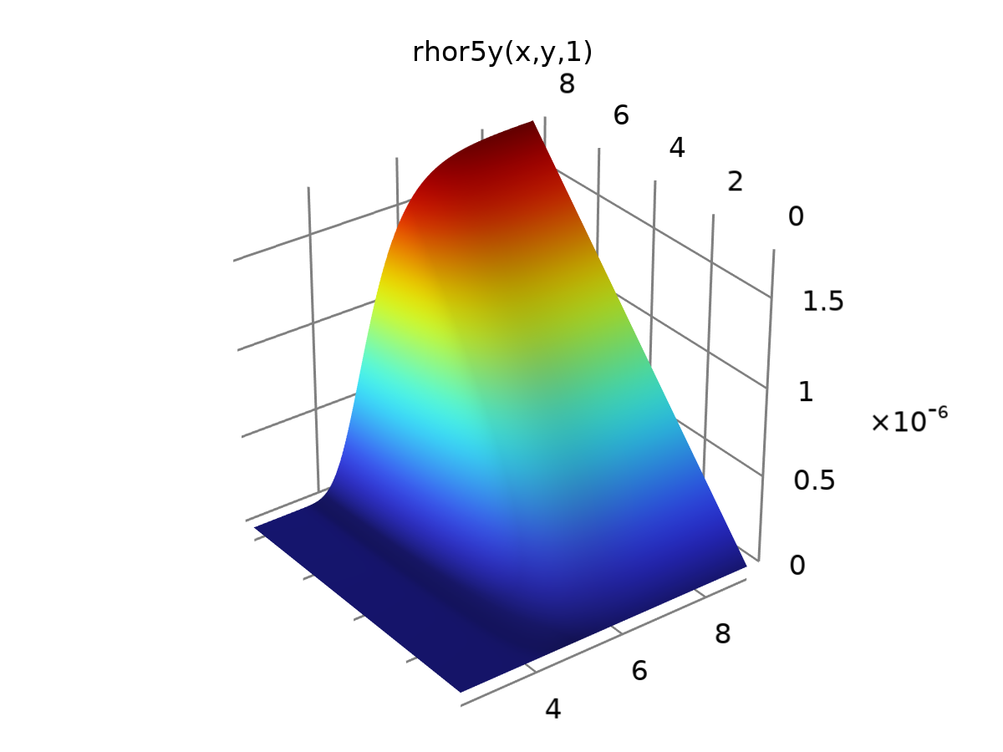

rhor5.1.1

Definition

| **Description** | **Value** |
| --- | --- |
| Expression | d(rhor5(x, y, z), y) |
| Arguments | {x, y, z} |

Units

| **Argument** | **Unit** |
| --- | --- |
| x |  |
| y |  |
| z |  |

### rhor5.1.1.1

|  |  |
| --- | --- |
| Function name | rhor5z |
| Function type | Analytic |

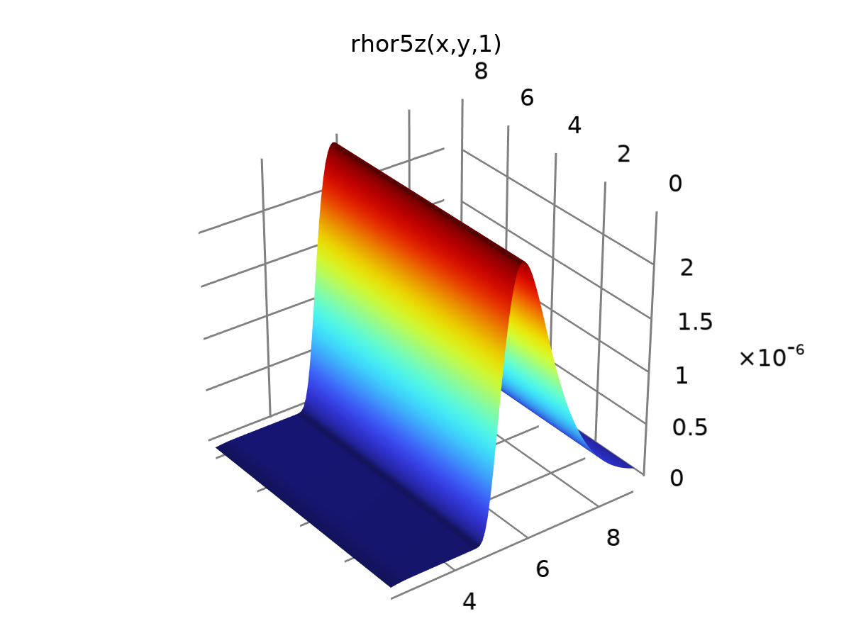

rhor5.1.1.1

Definition

| **Description** | **Value** |
| --- | --- |
| Expression | d(rhor5(x, y, z), z) |
| Arguments | {x, y, z} |

Units

| **Argument** | **Unit** |
| --- | --- |
| x |  |
| y |  |
| z |  |

### tbp

|  |  |
| --- | --- |
| Function name | tbp |
| Function type | Analytic |

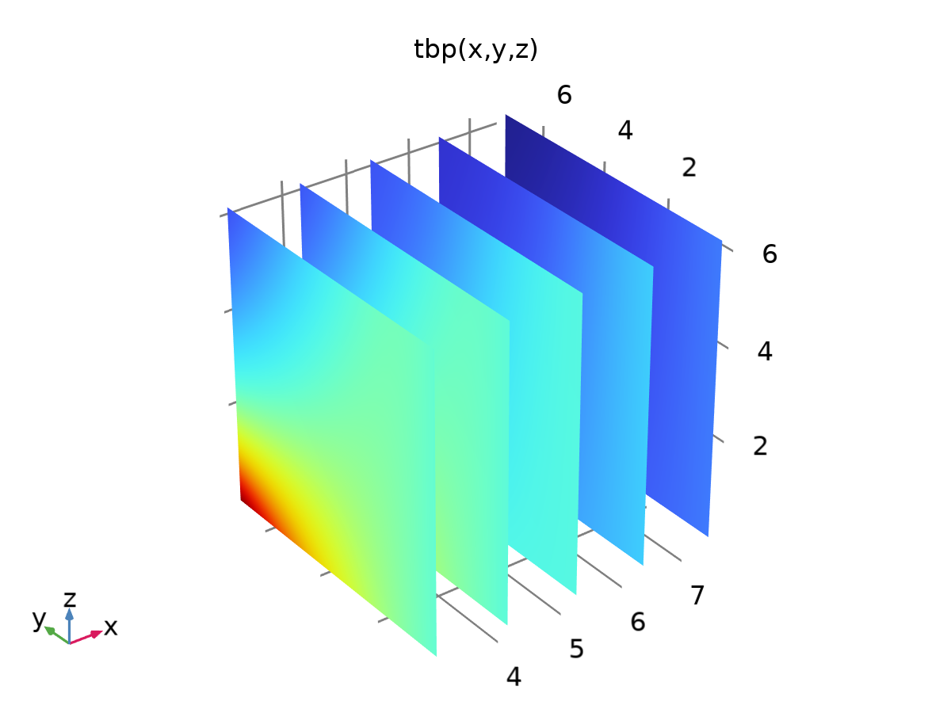

tbp

Definition

| **Description** | **Value** |
| --- | --- |
| Expression | 1.115 * exp(-0.142 * x - 0.007638 * y^2 * z - 0.1348 * y * sin(1.115 + x + 0.007638 * y^2)) - 0.01984 * x * sin(4.673 + 1.249 * x) |
| Arguments | {x, y, z} |

Units

| **Argument** | **Unit** |
| --- | --- |
| x |  |
| y |  |
| z |  |

### tbp 1

|  |  |
| --- | --- |
| Function name | tbpx |
| Function type | Analytic |

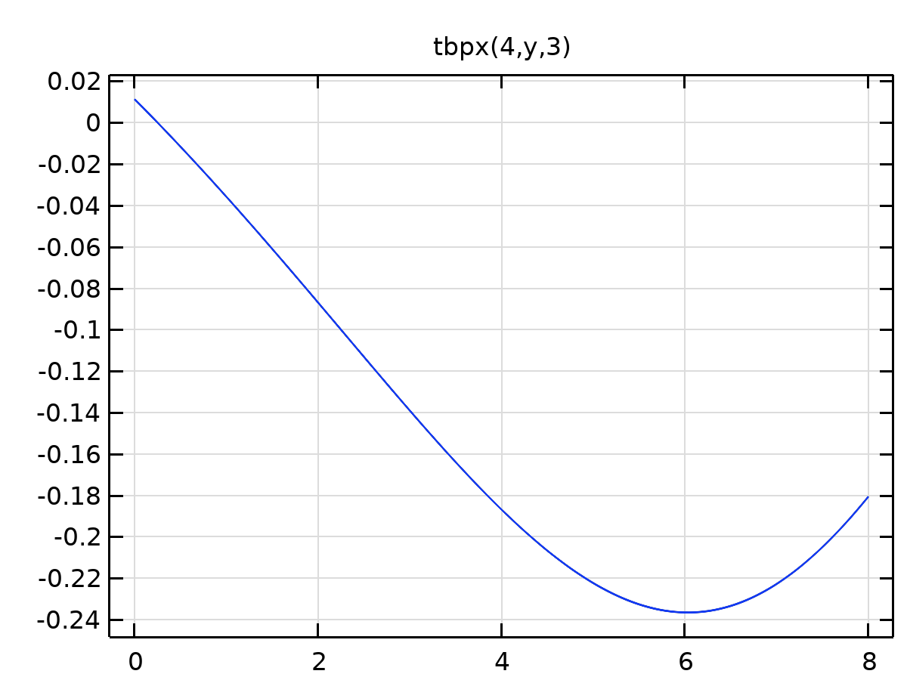

tbp 1

Definition

| **Description** | **Value** |
| --- | --- |
| Expression | d(tbp(x, y, z), x) |
| Arguments | {x, y, z} |

Units

| **Argument** | **Unit** |
| --- | --- |
| x |  |
| y |  |
| z |  |

### tbp 1.1

|  |  |
| --- | --- |
| Function name | tbpz |
| Function type | Analytic |

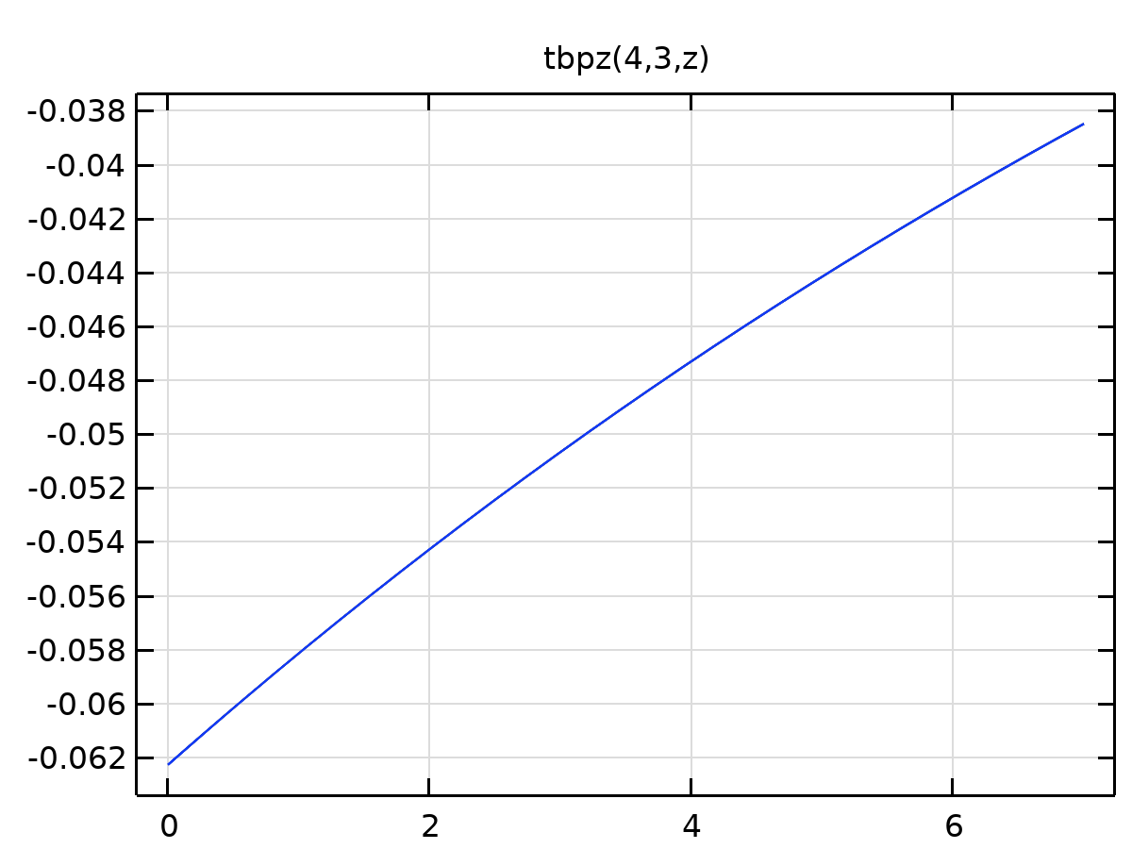

tbp 1.1

Definition

| **Description** | **Value** |
| --- | --- |
| Expression | d(tbp(x, y, z), z) |
| Arguments | {x, y, z} |

Units

| **Argument** | **Unit** |
| --- | --- |
| x |  |
| y |  |
| z |  |

### tbp 2

|  |  |
| --- | --- |
| Function name | tbp108 |
| Function type | Analytic |

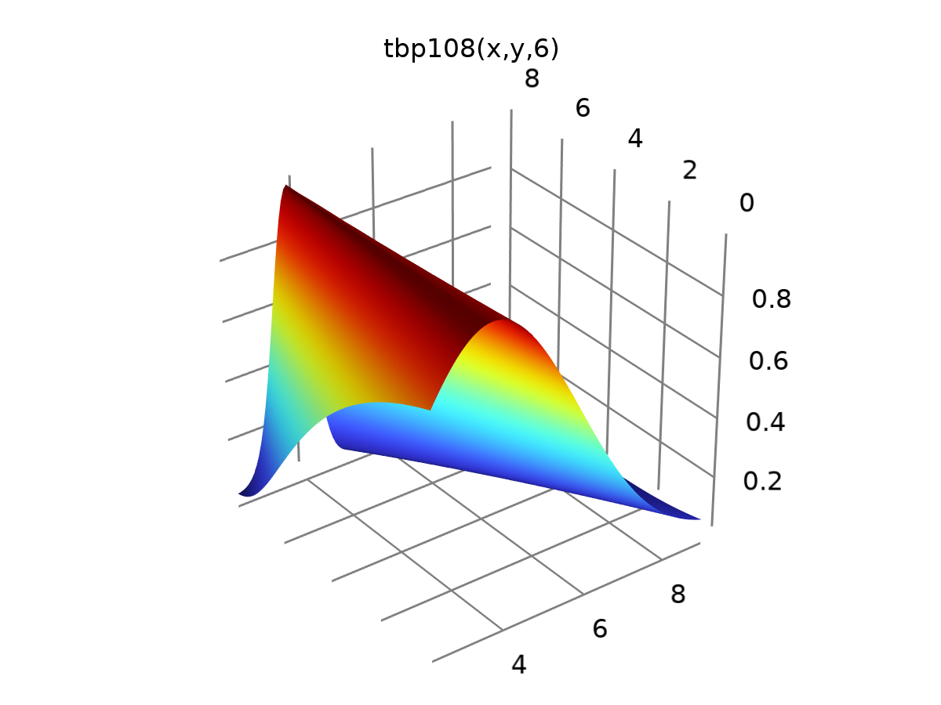

tbp 2

Definition

| **Description** | **Value** |
| --- | --- |
| Expression | 0.03101 + z*gauss(z + 0.3626*x + 0.2968*y) + 0.966*gauss((x - 3.717)/(0.2968*y - 2.963)) - 5.358*gauss(9.107/x - 1.784)*gauss(z + 0.3626*x + 0.2968*y) |
| Arguments | {x, y, z} |

Units

| **Argument** | **Unit** |
| --- | --- |
| x |  |
| y |  |
| z |  |

### tbpnew

|  |  |
| --- | --- |
| Function name | tbpnew |
| Function type | Analytic |

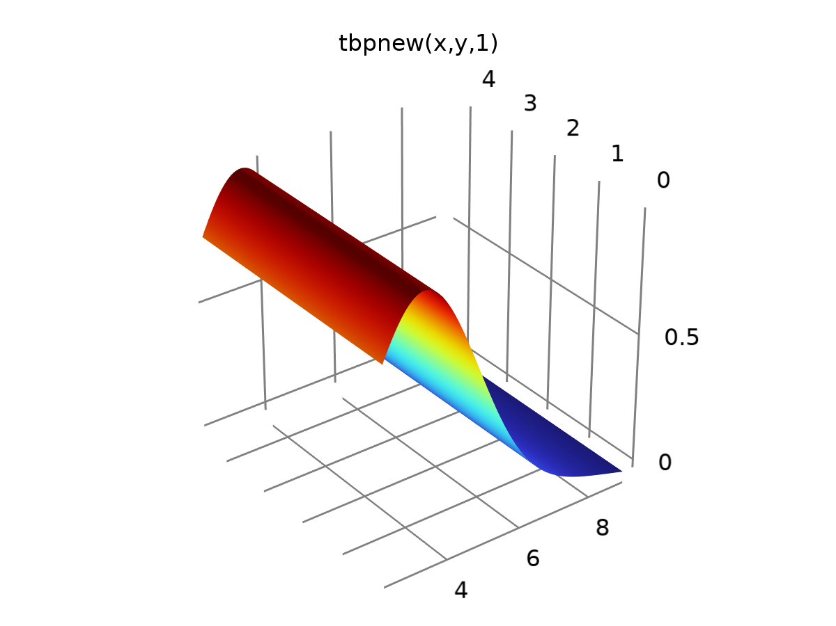

tbpnew

Definition

| **Description** | **Value** |
| --- | --- |
| Expression | 0.1556 + 0.8549*gauss(2.197*z - 0.206*x - 0.2928*x*z - 0.4998*z^2) - 0.002343*x^2 |
| Arguments | {x, y, z} |

Units

| **Argument** | **Unit** |
| --- | --- |
| x |  |
| y |  |
| z |  |

### tbp95

|  |  |
| --- | --- |
| Function name | tbp95 |
| Function type | Analytic |

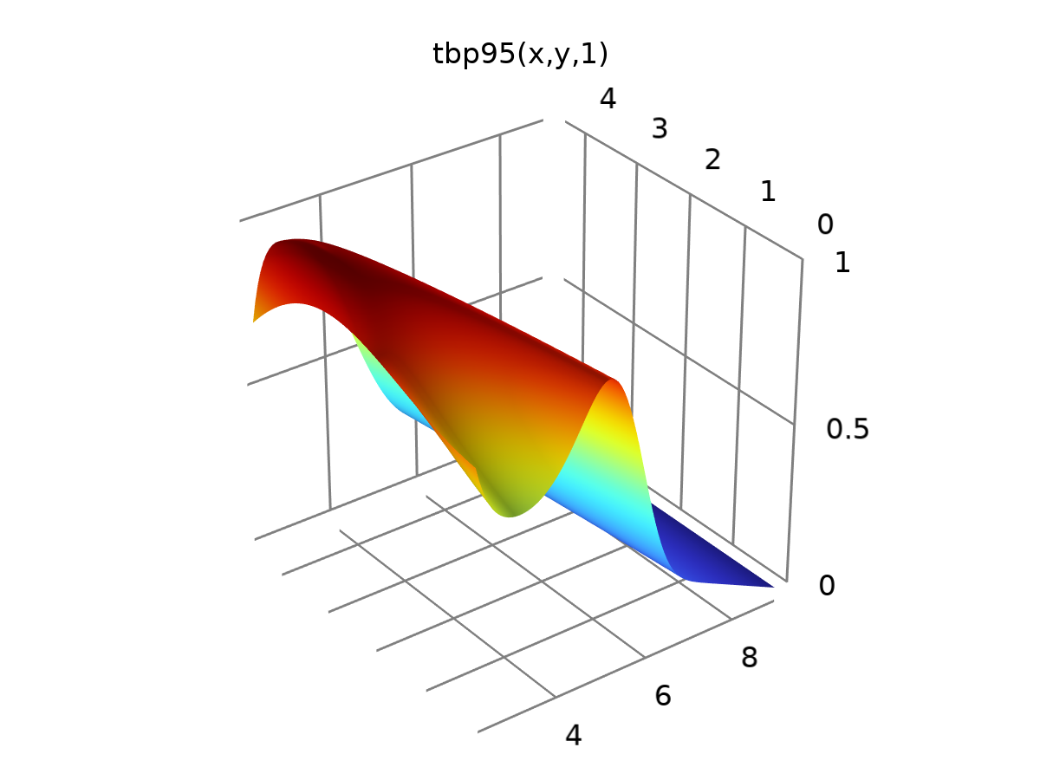

tbp95

Definition

| **Description** | **Value** |
| --- | --- |
| Expression | 0.311 + 0.311*z + 10.81*exp(-((x)^2)/(2*(0.7861)^2)) + 0.5959*exp(-((0.292*y + 0.1522*x^2 - 0.7861*x)^2)/(2*0.5959^2)) - 0.06937*x*z - 7.104*y*exp(-((x)^2)/(2*(0.7861)^2)) |
| Arguments | {x, y, z} |

Units

| **Argument** | **Unit** |
| --- | --- |
| x |  |
| y |  |
| z |  |

### tbp95.1

|  |  |
| --- | --- |
| Function name | tbp111 |
| Function type | Analytic |

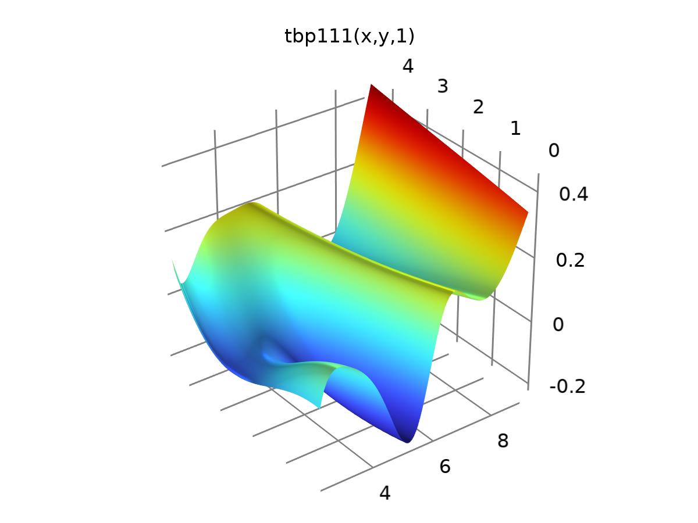

tbp95.1

Definition

| **Description** | **Value** |
| --- | --- |
| Expression | tbp(x, y, z) - tbp95(x, y, z) |
| Arguments | {x, y, z} |

Units

| **Argument** | **Unit** |
| --- | --- |
| x |  |
| y |  |
| z |  |

### tbp95.1.1

|  |  |
| --- | --- |
| Function name | tbp112 |
| Function type | Analytic |

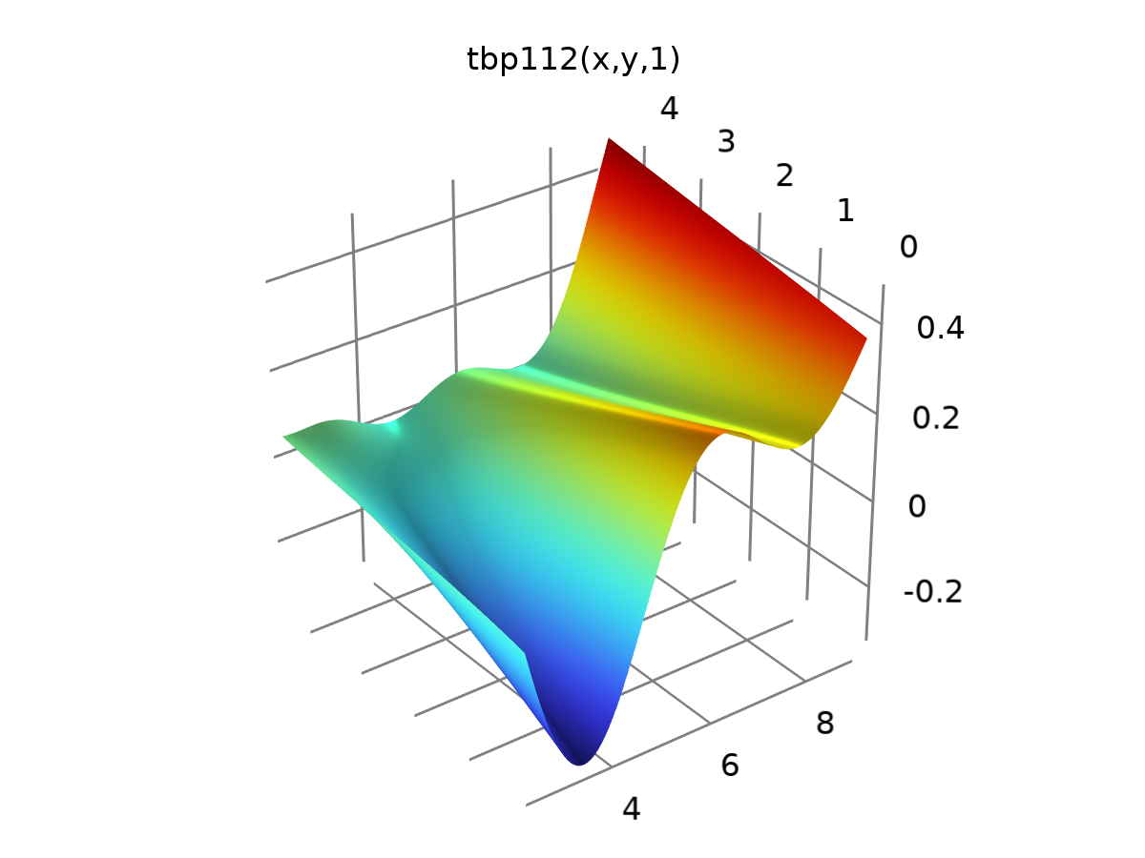

tbp95.1.1

Definition

| **Description** | **Value** |
| --- | --- |
| Expression | tbp(x, y, z) - tbpnew(x, y, z) |
| Arguments | {x, y, z} |

Units

| **Argument** | **Unit** |
| --- | --- |
| x |  |
| y |  |
| z |  |

# Component 1

|  |  |
| --- | --- |
| Date | Jan 20, 2016, 8:18:39 AM |

Settings

| **Description** | **Value** |
| --- | --- |
| Unit system | Same as global system (SI) |
| Geometry shape function | Automatic |

Spatial frame coordinates

| **First** | **Second** | **Third** |
| --- | --- | --- |
| x | y | z |

Material frame coordinates

| **First** | **Second** | **Third** |
| --- | --- | --- |
| X | Y | Z |

Geometry frame coordinates

| **First** | **Second** | **Third** |
| --- | --- | --- |
| Xg | Yg | Zg |

Mesh frame coordinates

| **First** | **Second** | **Third** |
| --- | --- | --- |
| Xm | Ym | Zm |

## Geometry 1

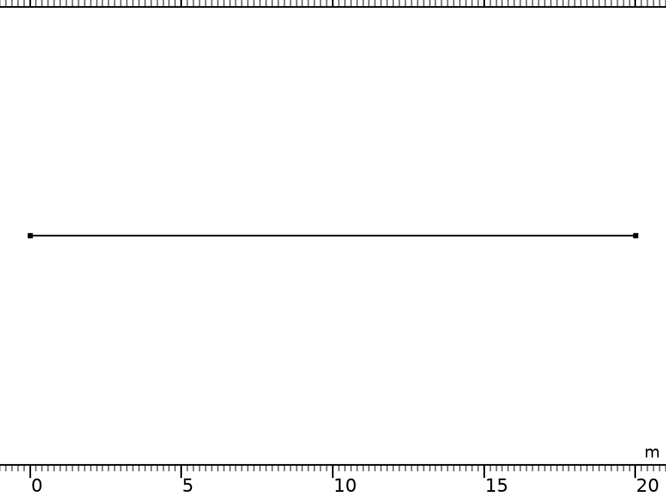

Geometry 1

Units

|  |  |
| --- | --- |
| Length unit | m |
| Angular unit | deg |

Geometry statistics

| **Description** | **Value** |
| --- | --- |
| Space dimension | 1 |
| Number of domains | 1 |
| Number of boundaries | 2 |

### Interval 1 (i1)

Interval

| **Coordinates (m)** |
| --- |
| 0 |
| 20 |

Information

| **Description** | **Value** |
| --- | --- |
| Last build time | < 1 second |
| Built with | COMSOL 6.2.0.278 (glnxa64), Dec 17, 2023, 3:35:00 PM |

### Form Union (fin)

Information

| **Description** | **Value** |
| --- | --- |
| Details | {Formed union of 1 solid object., Union has 1 domain and 2 boundaries.} |
| Last build time | < 1 second |
| Built with | COMSOL 6.2.0.278 (glnxa64), Dec 17, 2023, 3:35:00 PM |

## Weak Form PDE

Used products

|  |
| --- |
| COMSOL Multiphysics |

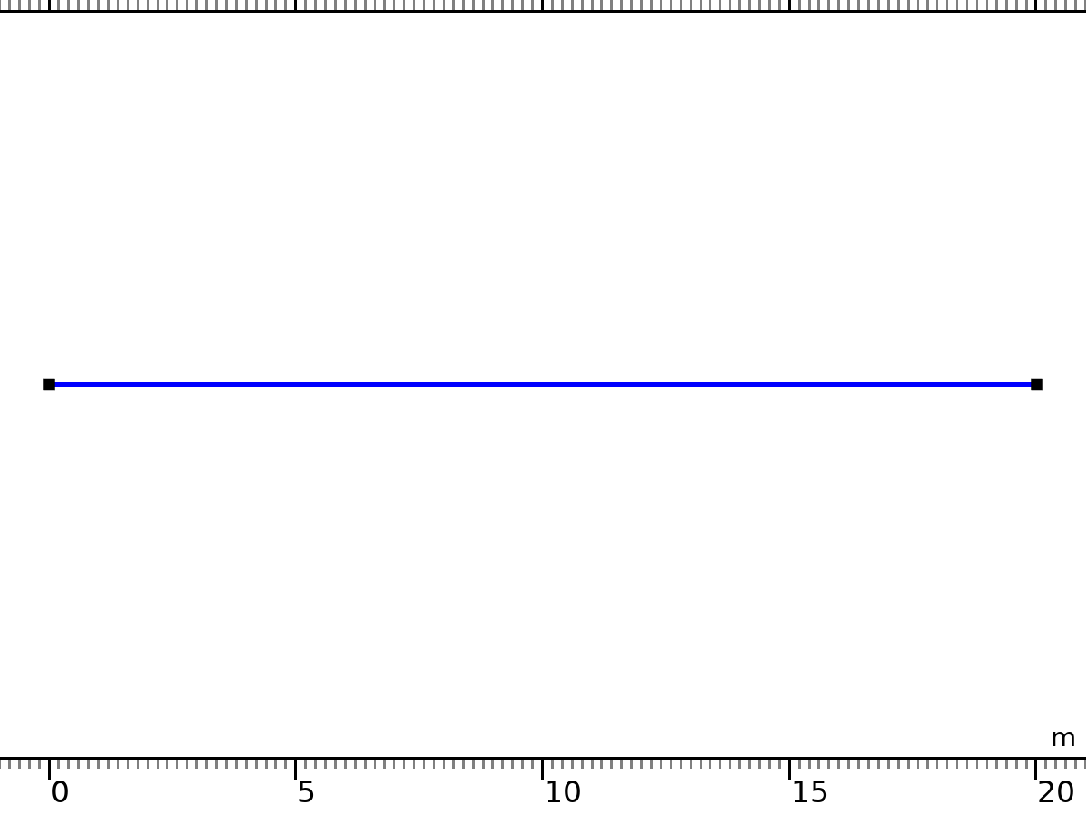

Weak Form PDE

Selection

|  |  |
| --- | --- |
| Geometric entity level | Domain |
| Selection | Geometry geom1: Dimension 1: All domains |

Equations

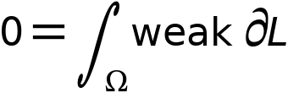

### Interface Settings

#### Discretization

Settings

| **Description** | **Value** |
| --- | --- |
| Shape function type | Lagrange |
| Element order | Quadratic |

Settings

| **Description** | **Value** |
| --- | --- |
| Equation form | Time domain |

#### Units

| **Dependent variable quantity** | **Unit** |
| --- | --- |
| dimensionless |

| **Source term quantity** | **Unit** |
| --- | --- |
| none |

### Variables

| **Name** | **Expression** | **Unit** | **Description** | **Selection** | **Details** |
| --- | --- | --- | --- | --- | --- |
| w.nx | nx |  | Normal vector, x-component | Boundaries 1–2 | Meta |
| w.ny | root.ny |  | Normal vector, y-component | Boundaries 1–2 | Meta |
| w.nz | root.nz |  | Normal vector, z-component | Boundaries 1–2 | Meta |
| w.nxmesh | nxmesh |  | Normal vector (mesh), x-component | Boundaries 1–2 | Meta |
| w.nymesh | root.nymesh |  | Normal vector (mesh), y-component | Boundaries 1–2 | Meta |
| w.nzmesh | root.nzmesh |  | Normal vector (mesh), z-component | Boundaries 1–2 | Meta |
| w.omega | 2*pi*w.freq | rad/s | Angular frequency | Global |  |
| w.freq | freq | Hz | Frequency | Global |  |
| w.iomega | w.omega*i | rad/s | Complex angular frequency | Global |  |

### Weak Form PDE 1



Weak Form PDE 1

Selection

|  |  |
| --- | --- |
| Geometric entity level | Domain |
| Selection | Geometry geom1: Dimension 1: All domains |

Equations



Settings

| **Description** | **Value** |
| --- | --- |
| Weak expressions | {(rho1(ph2, cl3, mg4)*s4t + d(rhow1(ph2, cl3, mg4), t)*s4 + d(rhoo1(ph2, cl3, mg4), t)*(1 - s4) + d(rhor1(ph2, cl3, mg4), t))*test(ph2) - ((u4/phi)*(rhow1(ph2, cl3, mg4)*fw(s4) + rhoo1(ph2, cl3, mg4)*(1 - fw(s4))))*test(ph2x) + difsw1*(rho1(ph2, cl3, mg4)*s4x + d(rhoo1(ph2, cl3, mg4), x)*(1 - s4) + d(rhor1(ph2, cl3, mg4), x) + s4*d(rhow1(ph2, cl3, mg4), x))*test(ph2x), d((1 - s4)*rhoo2(ph2, cl3, mg4), t)*test(cl3) - (u4/phi)*(1 - fw(s4))*rhoo2(ph2, cl3, mg4)*test(cl3x) + difsw1*d((1 - s4)*rhoo2(ph2, cl3, mg4), x)*test(cl3x) + phi*d(s4*cl3, t)*test(cl3) - fw(s4)*cl3*u4*test(cl3x) + phi*(difsw1*cl3*d(s4, x) + difsw1*s4*d(cl3, x))*test(cl3x), (rho4(ph2, cl3, mg4)*s4t + d(rhow4(ph2, cl3, mg4), t)*s4 + d(rhoo4(ph2, cl3, mg4), t)*(1 - s4) + d(rhor4(ph2, cl3, mg4), t))*test(s4) - ((u4/phi)*(rhow4(ph2, cl3, mg4)*fw(s4) + rhoo4(ph2, cl3, mg4)*(1 - fw(s4))))*test(s4x) + difsw1*(rho4(ph2, cl3, mg4)*s4x + d(rhoo4(ph2, cl3, mg4), x)*(1 - s4) + d(rhor4(ph2, cl3, mg4), x) + s4*d(rhow4(ph2, cl3, mg4), x))*test(s4x), (rho5(ph2, cl3, mg4)*s4t + phi*mg4t*s4 + d(rhoo5(ph2, cl3, mg4), t)*(1 - s4) + d(rhor5(ph2, cl3, mg4), t))*test(mg4) - ((u4/phi)*(phi*mg4*fw(s4) + rhoo4(ph2, cl3, mg4)*(1 - fw(s4))))*test(mg4x) + difsw1*(rho5(ph2, cl3, mg4)*s4x + d(rhoo5(ph2, cl3, mg4), x)*(1 - s4) + d(rhor5(ph2, cl3, mg4), x) + s4*d(rhow5(ph2, cl3, mg4), x))*test(mg4x)} |

#### Shape functions

| **Name** | **Shape function** | **Unit** | **Description** | **Shape frame** | **Selection** |
| --- | --- | --- | --- | --- | --- |
| ph2 | Lagrange (Quadratic) | 1 | Dependent variable ph2 | Material | Domain 1 |
| cl3 | Lagrange (Quadratic) | 1 | Dependent variable cl3 | Material | Domain 1 |
| s4 | Lagrange (Quadratic) | 1 | Dependent variable s4 | Material | Domain 1 |
| mg4 | Lagrange (Quadratic) | 1 | Dependent variable mg4 | Material | Domain 1 |

#### Weak Expressions

| **Weak expression** | **Integration order** | **Integration frame** | **Selection** |
| --- | --- | --- | --- |
| (rho1(ph2,cl3,mg4)*s4t+d(rhow1(ph2,cl3,mg4),t)*s4+d(rhoo1(ph2,cl3,mg4),t)*(1-s4)+d(rhor1(ph2,cl3,mg4),t))*test(ph2)-u4*(rhow1(ph2,cl3,mg4)*fw(s4)+rhoo1(ph2,cl3,mg4)*(1-fw(s4)))*test(ph2x)/phi+difsw1*(rho1(ph2,cl3,mg4)*s4x+d(rhoo1(ph2,cl3,mg4),x)*(1-s4)+d(rhor1(ph2,cl3,mg4),x)+s4*d(rhow1(ph2,cl3,mg4),x))*test(ph2x) | 4 | Material | Domain 1 |
| d((1-s4)*rhoo2(ph2,cl3,mg4),t)*test(cl3)-u4*(1-fw(s4))*rhoo2(ph2,cl3,mg4)*test(cl3x)/phi+difsw1*d((1-s4)*rhoo2(ph2,cl3,mg4),x)*test(cl3x)+phi*d(s4*cl3,t)*test(cl3)-fw(s4)*cl3*u4*test(cl3x)+phi*difsw1*(cl3*d(s4,x)+s4*d(cl3,x))*test(cl3x) | 4 | Material | Domain 1 |
| (rho4(ph2,cl3,mg4)*s4t+d(rhow4(ph2,cl3,mg4),t)*s4+d(rhoo4(ph2,cl3,mg4),t)*(1-s4)+d(rhor4(ph2,cl3,mg4),t))*test(s4)-u4*(rhow4(ph2,cl3,mg4)*fw(s4)+rhoo4(ph2,cl3,mg4)*(1-fw(s4)))*test(s4x)/phi+difsw1*(rho4(ph2,cl3,mg4)*s4x+d(rhoo4(ph2,cl3,mg4),x)*(1-s4)+d(rhor4(ph2,cl3,mg4),x)+s4*d(rhow4(ph2,cl3,mg4),x))*test(s4x) | 4 | Material | Domain 1 |
| (rho5(ph2,cl3,mg4)*s4t+phi*mg4t*s4+d(rhoo5(ph2,cl3,mg4),t)*(1-s4)+d(rhor5(ph2,cl3,mg4),t))*test(mg4)-u4*(phi*mg4*fw(s4)+rhoo4(ph2,cl3,mg4)*(1-fw(s4)))*test(mg4x)/phi+difsw1*(rho5(ph2,cl3,mg4)*s4x+d(rhoo5(ph2,cl3,mg4),x)*(1-s4)+d(rhor5(ph2,cl3,mg4),x)+s4*d(rhow5(ph2,cl3,mg4),x))*test(mg4x) | 4 | Material | Domain 1 |

### Zero Flux 1

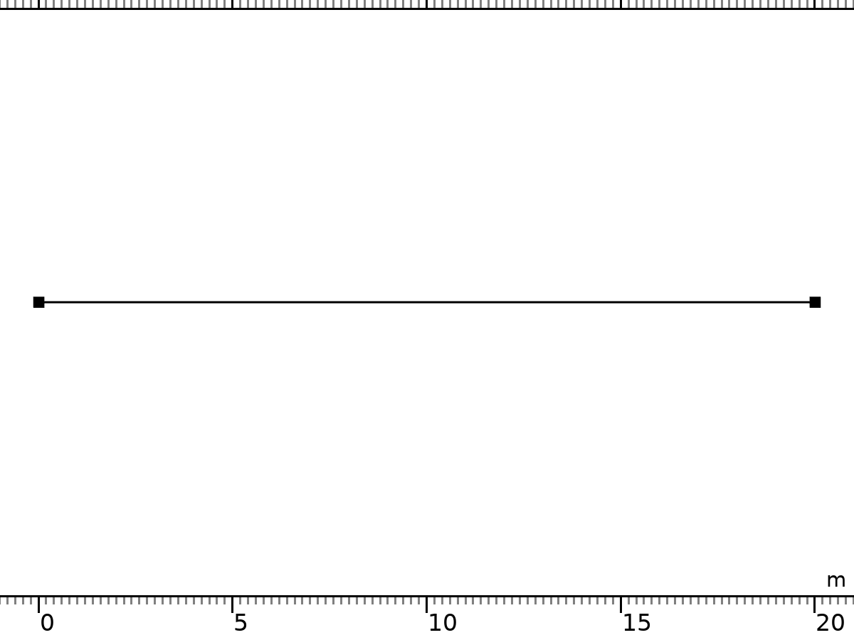

Zero Flux 1

Selection

|  |  |
| --- | --- |
| Geometric entity level | Boundary |
| Selection | Geometry geom1: Dimension 0: All boundaries |

Equations



### Initial Values 1



Initial Values 1

Selection

|  |  |
| --- | --- |
| Geometric entity level | Domain |
| Selection | Geometry geom1: Dimension 1: All domains |

Settings

| **Description** | **Value** | **Unit** |
| --- | --- | --- |
| Initial value for s4 | sini(x) | 1 |
| Initial time derivative of s4 | 0 | 1/s |
| Initial time derivative of cl3 | 0 | 1/s |
| Initial time derivative of mg4 | 0 | 1/s |
| Initial value for ph2 | pHini(x) | 1 |
| Initial value for cl3 | Clini(x) | 1 |
| Initial value for mg4 | Mgini(x) | 1 |
| Initial time derivative of ph2 | 0 | 1/s |

### Dirichlet Boundary Condition 1

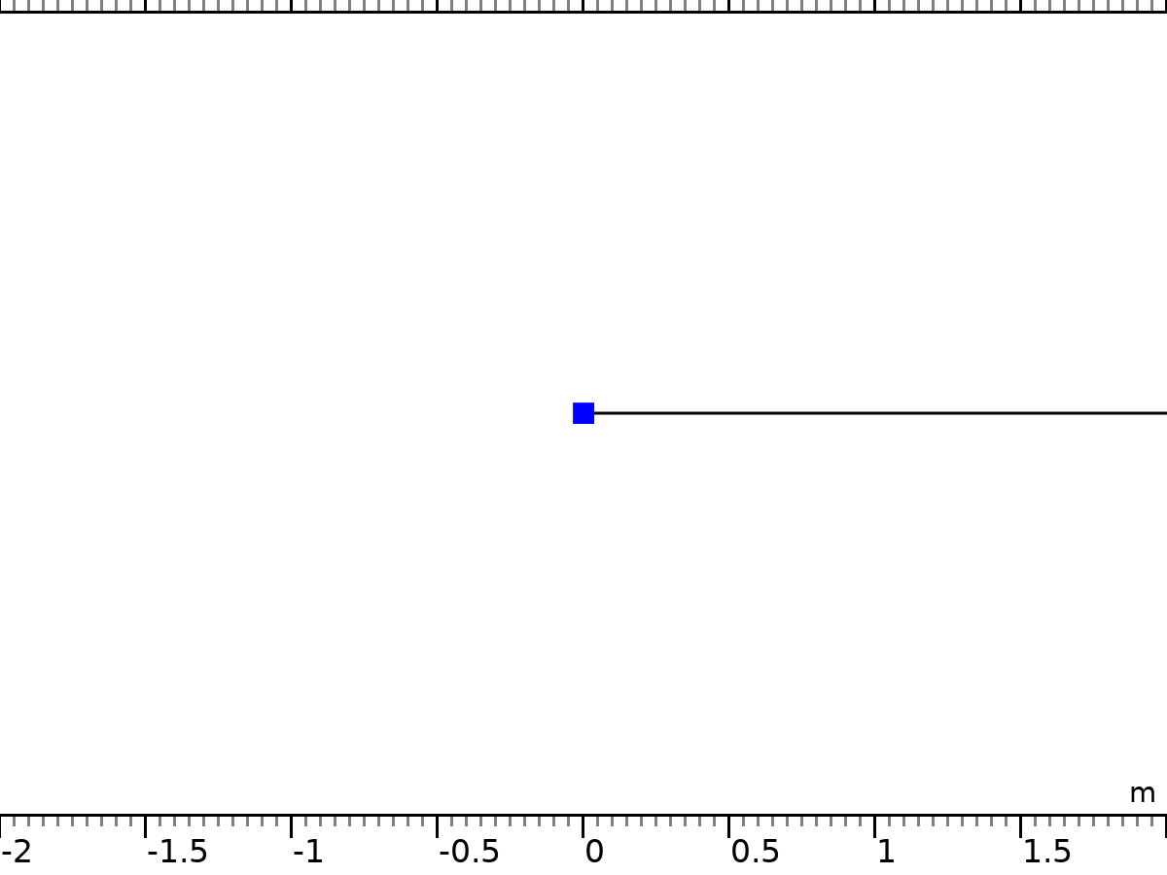

Dirichlet Boundary Condition 1

Selection

|  |  |
| --- | --- |
| Geometric entity level | Boundary |
| Selection | Geometry geom1: Dimension 0: Boundary 1 |

Equations



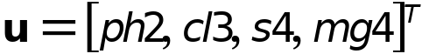

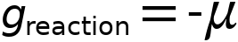

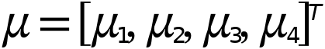

Settings

| **Description** | **Value** |
| --- | --- |
| Value on boundary | {pHbound, Clbound, 1 - sor - swc, mgh - mgl} |
| Prescribed value of ph2 | On |
| Prescribed value of cl3 | On |
| Prescribed value of s4 | On |
| Prescribed value of mg4 | On |

#### Constraints

| **Constraint** | **Constraint force** | **Shape function** | **Selection** | **Details** |
| --- | --- | --- | --- | --- |
| pHbound-ph2 | -test(ph2) | Lagrange (Quadratic) | Boundary 1 | Elemental |
| Clbound-cl3 | -test(cl3) | Lagrange (Quadratic) | Boundary 1 | Elemental |
| 1-sor-swc-s4 | -test(s4) | Lagrange (Quadratic) | Boundary 1 | Elemental |
| mgh-mgl-mg4 | -test(mg4) | Lagrange (Quadratic) | Boundary 1 | Elemental |

### Flux/Source 2

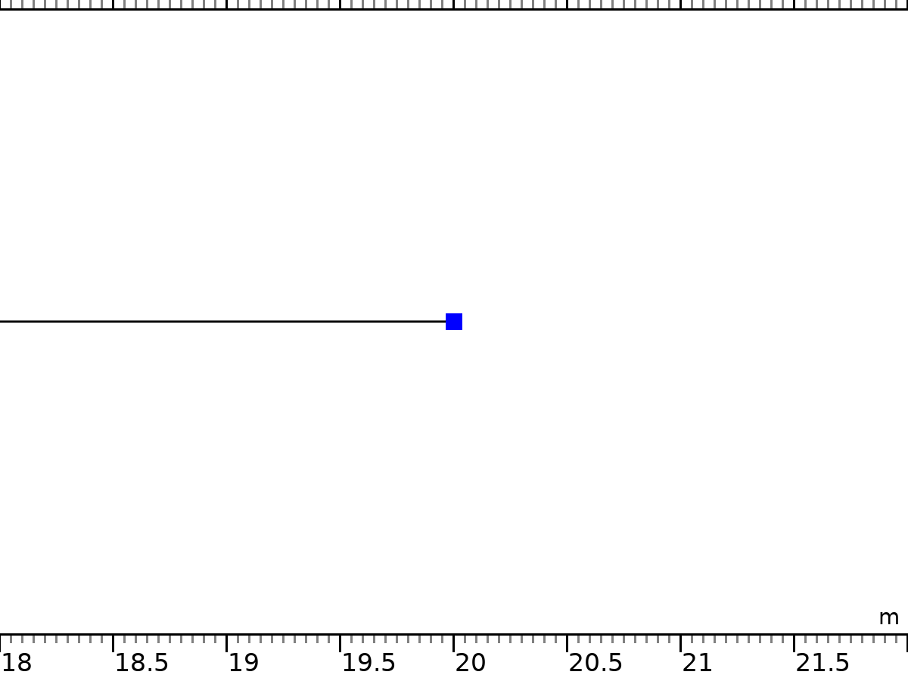

Flux/Source 2

Selection

|  |  |
| --- | --- |
| Geometric entity level | Boundary |
| Selection | Geometry geom1: Dimension 0: Boundary 2 |

Equations



Settings

| **Description** | **Value** | **Unit** |
| --- | --- | --- |
| Boundary absorption/impedance term | 0 | 1/m |
| Boundary flux/source | {u4*(rhow1(ph2, cl3, mg4)*fw(s4) + rhoo1(ph2, cl3, mg4)*(1 - fw(s4)))/phi, u4*((1 - fw(s4))*rhoo2(ph2, cl3, mg4) + phi*fw(s4)*cl3)/phi, u4*(rhow4(ph2, cl3, mg4)*fw(s4) + rhoo4(ph2, cl3, mg4)*(1 - fw(s4)))/phi, u4*(rhow5(ph2, cl3, mg4)*fw(s4) + rhoo5(ph2, cl3, mg4)*(1 - fw(s4)))/phi} | 1/m |

#### Variables

| **Name** | **Expression** | **Unit** | **Description** | **Selection** | **Details** |
| --- | --- | --- | --- | --- | --- |
| w.g_ph2 | u4*(rhow1(ph2,cl3,mg4)*fw(s4)+rhoo1(ph2,cl3,mg4)*(1-fw(s4)))/phi | 1/m | Boundary flux/source | Boundary 2 | + operation |
| w.g_cl3 | u4*((1-fw(s4))*rhoo2(ph2,cl3,mg4)+phi*fw(s4)*cl3)/phi | 1/m | Boundary flux/source | Boundary 2 | + operation |
| w.g_s4 | u4*(rhow4(ph2,cl3,mg4)*fw(s4)+rhoo4(ph2,cl3,mg4)*(1-fw(s4)))/phi | 1/m | Boundary flux/source | Boundary 2 | + operation |
| w.g_mg4 | u4*(rhow5(ph2,cl3,mg4)*fw(s4)+rhoo5(ph2,cl3,mg4)*(1-fw(s4)))/phi | 1/m | Boundary flux/source | Boundary 2 | + operation |

## Mesh 1

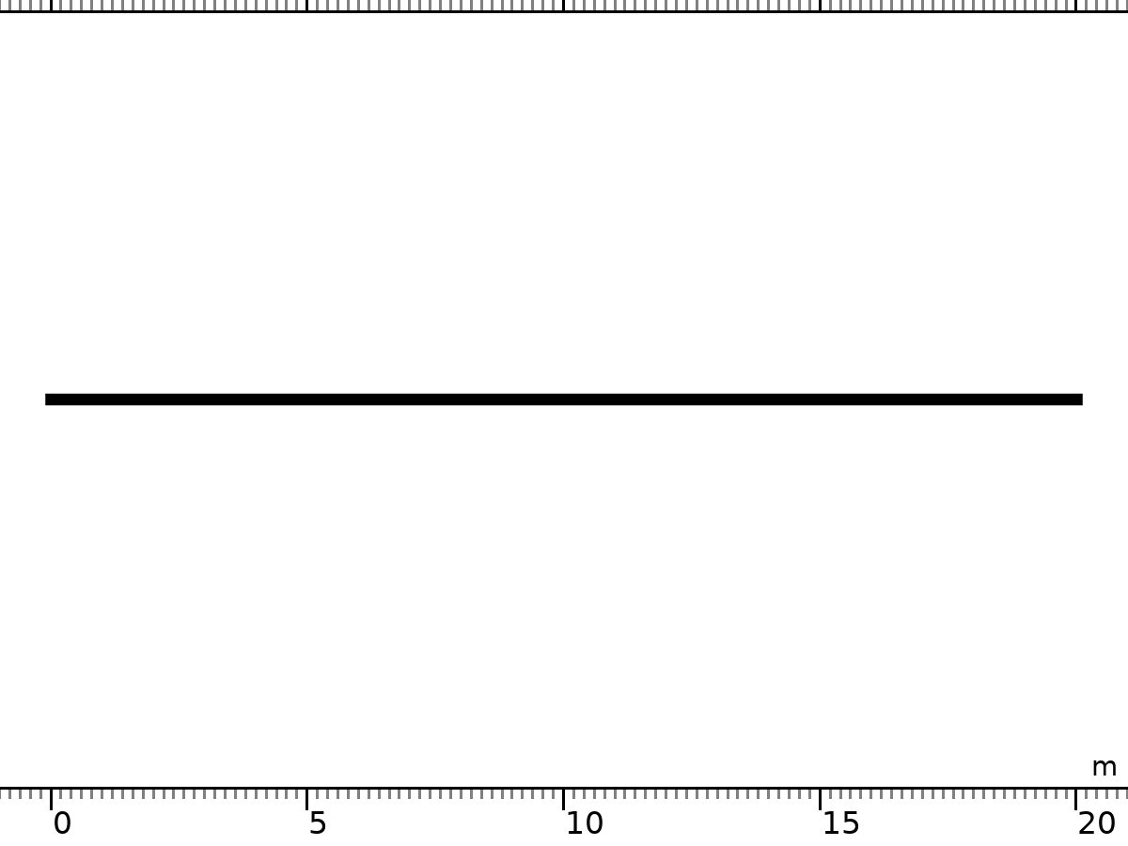

Mesh 1

Mesh statistics

| **Description** | **Value** |
| --- | --- |
| Status | Complete mesh |
| Mesh vertices | 1001 |
| Edge elements | 1000 |
| Vertex elements | 2 |
| Number of elements | 1000 |
| Minimum element quality | 1 |
| Average element quality | 1 |
| Element length ratio | 1 |
| Mesh length | 20 m |

### Size (size)

Settings

| **Description** | **Value** |
| --- | --- |
| Maximum element size | 0.02 |
| Minimum element size | 2E-4 |
| Curvature factor | 0.2 |
| Predefined size | Extremely fine |
| Custom element size | Custom |

### Edge 1 (edg1)

Selection

|  |  |
| --- | --- |
| Geometric entity level | Domain |
| Selection | Remaining |

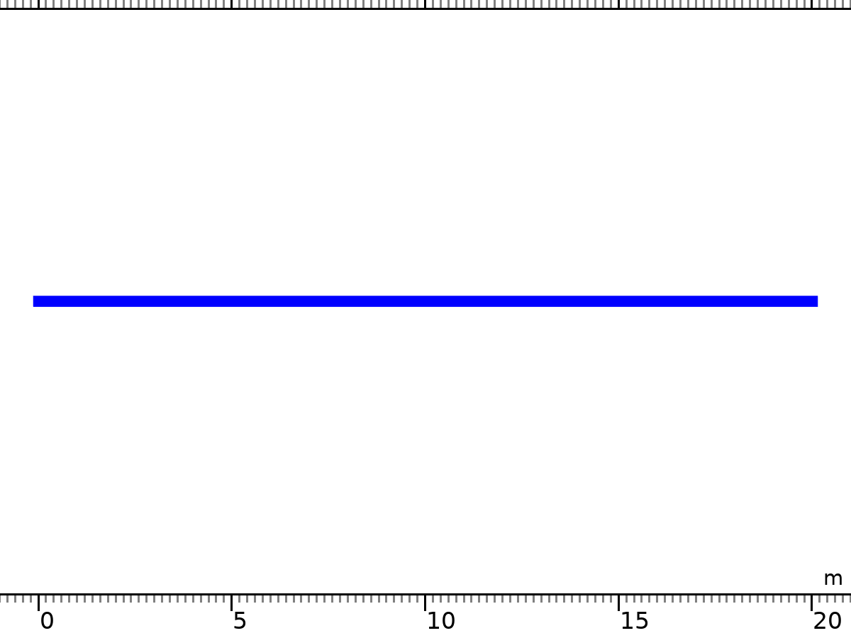

Edge 1

Information

| **Description** | **Value** |
| --- | --- |
| Last build time | < 1 second |
| Built with | COMSOL 6.2.0.339 (glnxa64), Oct 13, 2024, 11:06:38 AM |

# Study 1

Computation information

|  |  |
| --- | --- |
| Computation time | 3 h 29 min 52 s |

## Time Dependent

| **Times** | **Unit** |
| --- | --- |
| range(0,300,30000) | s |

Study settings

| **Description** | **Value** |
| --- | --- |
| Include geometric nonlinearity | Off |

Study settings

| **Description** | **Value** |
| --- | --- |
| Output times | {0, 300, 600, 900, 1200, 1500, 1800, 2100, 2400, 2700, 3000, 3300, 3600, 3900, 4200, 4500, 4800, 5100, 5400, 5700, 6000, 6300, 6600, 6900, 7200, 7500, 7800, 8100, 8400, 8700, 9000, 9300, 9600, 9900, 10200, 10500, 10800, 11100, 11400, 11700, 12000, 12300, 12600, 12900, 13200, 13500, 13800, 14100, 14400, 14700, 15000, 15300, 15600, 15900, 16200, 16500, 16800, 17100, 17400, 17700, 18000, 18300, 18600, 18900, 19200, 19500, 19800, 20100, 20400, 20700, 21000, 21300, 21600, 21900, 22200, 22500, 22800, 23100, 23400, 23700, 24000, 24300, 24600, 24900, 25200, 25500, 25800, 26100, 26400, 26700, 27000, 27300, 27600, 27900, 28200, 28500, 28800, 29100, 29400, 29700, 30000} |
| Tolerance | User controlled |

Physics and variables selection

| **Physics interface** | **Solve for** | **Equation form** |
| --- | --- | --- |
| Weak Form PDE (w) | On | Time dependent |

Values of dependent variables

| **Description** | **Value** |
| --- | --- |
| Settings | User controlled |

Store in output

| **Interface** | **Output** | **Selection** |
| --- | --- | --- |
| Weak Form PDE (w) | Physics controlled |  |

Mesh selection

| **Component** | **Mesh** |
| --- | --- |
| Component 1 | Mesh 1 |

## Solver Configurations

### Solution 1

#### Compile Equations: Time Dependent (st1)

Study and step

| **Description** | **Value** |
| --- | --- |
| Use study | Study 1 |
| Use study step | Time Dependent |

Log

<---- Compile Equations: Time Dependent in Study 1/Solution 1 (sol1) -----------

Started at Apr 19, 2025, 8:20:43 PM.

Geometry shape function: Quadratic Lagrange

Running on 12th Gen Intel(R) Core(TM) i5-12500H.

Using 1 socket with 8 cores in total on G15-5520.

Available memory: 31.78 GB.

Time: 0 s.

Physical memory: 1.57 GB

Virtual memory: 13.59 GB

Ended at Apr 19, 2025, 8:20:44 PM.

----- Compile Equations: Time Dependent in Study 1/Solution 1 (sol1) ---------->

#### Dependent Variables 1 (v1)

General

| **Description** | **Value** |
| --- | --- |
| Defined by study step | Step 1: Time Dependent |

Scaling

| **Description** | **Value** |
| --- | --- |
| Method | None |

Residual scaling

| **Description** | **Value** |
| --- | --- |
| Method | Manual |

Initial value calculation constants

| **Constant name** | **Initial value source** |
| --- | --- |
| t | {range(0,300,30000)}[s] |
| timestep | 30[s] |

Log

<---- Dependent Variables 1 in Study 1/Solution 1 (sol1) -----------------------

Started at Apr 19, 2025, 8:20:44 PM.

Solution time: 0 s.

Physical memory: 1.57 GB

Virtual memory: 13.59 GB

Ended at Apr 19, 2025, 8:20:44 PM.

----- Dependent Variables 1 in Study 1/Solution 1 (sol1) ---------------------->

##### Dependent Variable Cl3 (comp1.cl3) (comp1_cl3)

General

| **Description** | **Value** |
| --- | --- |
| Field components | comp1.cl3 |

##### Dependent Variable Ph2 (comp1.ph2) (comp1_ph2)

General

| **Description** | **Value** |
| --- | --- |
| Field components | comp1.ph2 |

##### Dependent Variable S4 (comp1.s4) (comp1_s4)

General

| **Description** | **Value** |
| --- | --- |
| Field components | comp1.s4 |

##### Dependent Variable Mg4 (comp1.mg4) (comp1_mg4)

General

| **Description** | **Value** |
| --- | --- |
| Field components | comp1.mg4 |

#### Time-Dependent Solver 1 (t1)

General

| **Description** | **Value** |
| --- | --- |
| Defined by study step | Step 1: Time Dependent |
| Output times | {0, 300, 600, 900, 1200, 1500, 1800, 2100, 2400, 2700, 3000, 3300, 3600, 3900, 4200, 4500, 4800, 5100, 5400, 5700, 6000, 6300, 6600, 6900, 7200, 7500, 7800, 8100, 8400, 8700, 9000, 9300, 9600, 9900, 10200, 10500, 10800, 11100, 11400, 11700, 12000, 12300, 12600, 12900, 13200, 13500, 13800, 14100, 14400, 14700, 15000, 15300, 15600, 15900, 16200, 16500, 16800, 17100, 17400, 17700, 18000, 18300, 18600, 18900, 19200, 19500, 19800, 20100, 20400, 20700, 21000, 21300, 21600, 21900, 22200, 22500, 22800, 23100, 23400, 23700, 24000, 24300, 24600, 24900, 25200, 25500, 25800, 26100, 26400, 26700, 27000, 27300, 27600, 27900, 28200, 28500, 28800, 29100, 29400, 29700, 30000} |

Absolute tolerance

| **Field** | **Method** | **Tolerance method** | **Tolerance factor** | **Derivative tolerance method** | **Time derivative factor** | **Tolerance** | **Tolerance for time derivatives** |
| --- | --- | --- | --- | --- | --- | --- | --- |
| Dependent Variable Cl3 (comp1.cl3) | Use global | Factor | 0.1 | Automatic | 1 | 0.001 | 0.001 |
| Dependent Variable Ph2 (comp1.ph2) | Use global | Factor | 0.1 | Automatic | 1 | 0.001 | 0.001 |
| Dependent Variable S4 (comp1.s4) | Use global | Factor | 0.1 | Automatic | 1 | 0.001 | 0.001 |
| Dependent Variable Mg4 (comp1.mg4) | Use global | Factor | 0.1 | Automatic | 1 | 0.001 | 0.001 |

Time stepping

| **Description** | **Value** |
| --- | --- |
| Maximum step constraint | Expression |
| Minimum BDF order | 2 |
| Singular mass matrix | Yes |

Results while solving

| **Description** | **Value** |
| --- | --- |
| Plot | On |
| Plot group | 1D Plot Group 1 |
| Probes | Manual |

Log

299675       29968         0.1     562794    9 562794     2     0      0  4.8e-16  1.4e-15

299676       29968         0.1     562796    9 562796     2     0      0  6.9e-16  2.5e-15

299677       29968         0.1     562797    9 562797     2     0      0  7.2e-16  2.2e-15

299678       29968         0.1     562799    9 562799     2     0      0  4.9e-16  1.5e-15

299679       29968         0.1     562800    9 562800     2     0      0  5.4e-16  1.4e-15

299680       29968         0.1     562802    9 562802     2     0      0  3.6e-16  1.2e-15

299681       29968         0.1     562804    9 562804     2     0      0  7.6e-16  2.3e-15

299682       29968         0.1     562805    9 562805     2     0      0  7.5e-16    2e-15

299683       29968         0.1     562807    9 562807     2     0      0  9.1e-16  3.4e-15

299684       29968         0.1     562808    9 562808     2     0      0  5.9e-16  2.3e-15

299685       29969         0.1     562810    9 562810     2     0      0  6.1e-16  1.5e-15

299686       29969         0.1     562811    9 562811     2     0      0  5.1e-16  1.2e-15

299687       29969         0.1     562813    9 562813     2     0      0  4.9e-16  8.3e-16

299688       29969         0.1     562815    9 562815     2     0      0  4.8e-16  1.7e-15

299689       29969         0.1     562816    9 562816     2     0      0  6.1e-16  2.6e-15

299690       29969         0.1     562818    9 562818     2     0      0  6.1e-16  1.9e-15

299691       29969         0.1     562819    9 562819     2     0      0  5.9e-16  1.8e-15

299692       29969         0.1     562821    9 562821     2     0      0  4.5e-16  1.1e-15

299693       29969         0.1     562823    9 562823     2     0      0  6.3e-16  1.9e-15

299694       29969         0.1     562824    9 562824     2     0      0  5.6e-16  1.5e-15

299695       29970         0.1     562826    9 562826     2     0      0  5.6e-16  1.8e-15

299696       29970         0.1     562827    9 562827     2     0      0  4.1e-16  1.1e-15

299697       29970         0.1     562829    9 562829     2     0      0  7.1e-16  9.8e-16

299698       29970         0.1     562831    9 562831     2     0      0  7.2e-16  2.4e-15

299699       29970         0.1     562832    9 562832     2     0      0  6.9e-16  1.7e-15

299700       29970         0.1     562834    9 562834     2     0      0  6.7e-16  3.8e-15

299701       29970         0.1     562835    9 562835     2     0      0  5.5e-16  1.6e-15

299702       29970         0.1     562837    9 562837     2     0      0    6e-16  1.6e-15

299703       29970         0.1     562838    9 562838     2     0      0  5.4e-16  1.5e-15

299704       29970         0.1     562840    9 562840     2     0      0  4.9e-16  1.4e-15

299705       29971         0.1     562842    9 562842     2     0      0  5.6e-16  1.8e-15

299706       29971         0.1     562843    9 562843     2     0      0  5.3e-16  1.7e-15

299707       29971         0.1     562845    9 562845     2     0      0  5.1e-16  1.2e-15

299708       29971         0.1     562846    9 562846     2     0      0  5.5e-16  2.1e-15

299709       29971         0.1     562848    9 562848     2     0      0    6e-16  1.5e-15

299710       29971         0.1     562850    9 562850     2     0      0  4.6e-16  9.7e-16

299711       29971         0.1     562851    9 562851     2     0      0    5e-16  1.3e-15

299712       29971         0.1     562853    9 562853     2     0      0  5.6e-16  1.2e-15

299713       29971         0.1     562855    9 562855     2     0      0  4.8e-16  1.8e-15

299714       29971         0.1     562856    9 562856     2     0      0  5.7e-16  1.7e-15

299715       29972         0.1     562858    9 562858     2     0      0  5.5e-16  1.3e-15

299716       29972         0.1     562859    9 562859     2     0      0  5.3e-16    2e-15

299717       29972         0.1     562861    9 562861     2     0      0  5.9e-16  1.2e-15

299718       29972         0.1     562863    9 562863     2     0      0  6.2e-16  3.2e-15

299719       29972         0.1     562864    9 562864     2     0      0  6.6e-16  1.8e-15

299720       29972         0.1     562866    9 562866     2     0      0  5.1e-16  1.7e-15

299721       29972         0.1     562868    9 562868     2     0      0  5.6e-16  1.7e-15

299722       29972         0.1     562869    9 562869     2     0      0  4.9e-16  2.1e-15

299723       29972         0.1     562871    9 562871     2     0      0  4.1e-16  8.8e-16

299724       29972         0.1     562872    9 562872     2     0      0  5.2e-16  1.4e-15

299725       29973         0.1     562874    9 562874     2     0      0  6.4e-16  2.6e-15

299726       29973         0.1     562876    9 562876     2     0      0  6.7e-16  1.7e-15

299727       29973         0.1     562877    9 562877     2     0      0  5.6e-16  1.9e-15

299728       29973         0.1     562879    9 562879     2     0      0  5.6e-16  1.7e-15

299729       29973         0.1     562881    9 562881     2     0      0  5.7e-16  2.6e-15

299730       29973         0.1     562882    9 562882     2     0      0  5.8e-16  2.3e-15

299731       29973         0.1     562884    9 562884     2     0      0  5.3e-16  1.4e-15

299732       29973         0.1     562885    9 562885     2     0      0  6.5e-16  2.9e-15

299733       29973         0.1     562887    9 562887     2     0      0  6.9e-16  1.9e-15

299734       29973         0.1     562889    9 562889     2     0      0  6.4e-16  1.5e-15

299735       29974         0.1     562890    9 562890     2     0      0  5.1e-16  2.4e-15

299736       29974         0.1     562892    9 562892     2     0      0  5.3e-16  1.7e-15

299737       29974         0.1     562894    9 562894     2     0      0  6.8e-16  1.8e-15

299738       29974         0.1     562895    9 562895     2     0      0  5.4e-16  3.1e-15

299739       29974         0.1     562897    9 562897     2     0      0  5.4e-16  3.6e-15

299740       29974         0.1     562898    9 562898     2     0      0  4.7e-16  2.7e-15

299741       29974         0.1     562900    9 562900     2     0      0  5.9e-16  1.8e-15

299742       29974         0.1     562901    9 562901     2     0      0  4.1e-16  1.5e-15

299743       29974         0.1     562903    9 562903     2     0      0  5.3e-16  2.1e-15

299744       29974         0.1     562905    9 562905     2     0      0  4.7e-16  1.5e-15

299745       29975         0.1     562907    9 562907     2     0      0  4.4e-16    2e-15

299746       29975         0.1     562908    9 562908     2     0      0  5.1e-16  1.8e-15

299747       29975         0.1     562910    9 562910     2     0      0  3.8e-16  1.8e-15

299748       29975         0.1     562911    9 562911     2     0      0  5.4e-16  2.3e-15

299749       29975         0.1     562913    9 562913     2     0      0  4.9e-16  1.6e-15

299750       29975         0.1     562914    9 562914     2     0      0  4.3e-16  1.8e-15

299751       29975         0.1     562916    9 562916     2     0      0  5.3e-16  1.8e-15

299752       29975         0.1     562918    9 562918     2     0      0  4.4e-16  1.5e-15

299753       29975         0.1     562919    9 562919     2     0      0  7.5e-16  2.3e-15

299754       29975         0.1     562921    9 562921     2     0      0    9e-16    2e-15

299755       29976         0.1     562922    9 562922     2     0      0  5.8e-16  1.6e-15

299756       29976         0.1     562924    9 562924     2     0      0  7.1e-16  1.3e-15

299757       29976         0.1     562925    9 562925     2     0      0  8.1e-16  2.5e-15

299758       29976         0.1     562927    9 562927     2     0      0  8.9e-16  1.5e-15

299759       29976         0.1     562928    9 562928     2     0      0  4.8e-16  1.3e-15

299760       29976         0.1     562930    9 562930     2     0      0  4.4e-16  8.9e-16

299761       29976         0.1     562932    9 562932     2     0      0  6.2e-16  1.5e-15

299762       29976         0.1     562933    9 562933     2     0      0    7e-16  1.8e-15

299763       29976         0.1     562935    9 562935     2     0      0  7.2e-16  1.5e-15

299764       29976         0.1     562936    9 562936     2     0      0  6.4e-16  2.2e-15

299765       29977         0.1     562938    9 562938     2     0      0  5.9e-16  1.2e-15

299766       29977         0.1     562940    9 562940     2     0      0  6.1e-16  1.8e-15

299767       29977         0.1     562941    9 562941     2     0      0  5.7e-16  2.7e-15

299768       29977         0.1     562943    9 562943     2     0      0  4.4e-16  1.2e-15

299769       29977         0.1     562944    9 562944     2     0      0  4.8e-16    2e-15

299770       29977         0.1     562946    9 562946     2     0      0  7.1e-16  1.4e-15

299771       29977         0.1     562948    9 562948     2     0      0  5.8e-16  1.6e-15

299772       29977         0.1     562949    9 562949     2     0      0  6.7e-16  2.4e-15

299773       29977         0.1     562951    9 562951     2     0      0  4.4e-16  1.6e-15

299774       29977         0.1     562953    9 562953     2     0      0  8.5e-16    2e-15

299775       29978         0.1     562954    9 562954     2     0      0  5.6e-16  2.2e-15

299776       29978         0.1     562956    9 562956     2     0      0  6.6e-16  2.1e-15

299777       29978         0.1     562957    9 562957     2     0      0  3.8e-16  2.5e-15

299778       29978         0.1     562959    9 562959     2     0      0  3.6e-16  1.2e-15

299779       29978         0.1     562960    9 562960     2     0      0  4.4e-16  8.9e-16

299780       29978         0.1     562962    9 562962     2     0      0  5.1e-16  1.4e-15

299781       29978         0.1     562964    9 562964     2     0      0    5e-16    1e-15

299782       29978         0.1     562965    9 562965     2     0      0  6.1e-16  2.6e-15

299783       29978         0.1     562967    9 562967     2     0      0  4.8e-16  8.8e-16

299784       29978         0.1     562969    9 562969     2     0      0  4.4e-16  1.2e-15

299785       29979         0.1     562970    9 562970     2     0      0  3.8e-16  1.4e-15

299786       29979         0.1     562972    9 562972     2     0      0  6.2e-16  6.8e-16

299787       29979         0.1     562974    9 562974     2     0      0  4.2e-16  1.7e-15

299788       29979         0.1     562975    9 562975     2     0      0  5.3e-16  1.3e-15

299789       29979         0.1     562977    9 562977     2     0      0  3.2e-16  9.1e-16

299790       29979         0.1     562978    9 562978     2     0      0  7.3e-16    2e-15

299791       29979         0.1     562980    9 562980     2     0      0  5.7e-16  1.2e-15

299792       29979         0.1     562981    9 562981     2     0      0  9.3e-16    2e-15

299793       29979         0.1     562983    9 562983     2     0      0    1e-15  2.1e-15

299794       29979         0.1     562984    9 562984     2     0      0  6.6e-16  1.5e-15

299795       29980         0.1     562986    9 562986     2     0      0  8.4e-16  1.8e-15

299796       29980         0.1     562987    9 562987     2     0      0  4.8e-16  2.6e-15

299797       29980         0.1     562989    9 562989     2     0      0  4.8e-16  2.7e-15

299798       29980         0.1     562991    9 562991     2     0      0  5.6e-16  1.8e-15

299799       29980         0.1     562992    9 562992     2     0      0  5.3e-16    2e-15

299800       29980         0.1     562994    9 562994     2     0      0  4.8e-16    3e-15

299801       29980         0.1     562995    9 562995     2     0      0    5e-16  1.5e-15

299802       29980         0.1     562997    9 562997     2     0      0  5.1e-16  1.6e-15

299803       29980         0.1     562999    9 562999     2     0      0  4.2e-16  2.7e-15

299804       29980         0.1     563000    9 563000     2     0      0  4.1e-16  1.5e-15

299805       29981         0.1     563002    9 563002     2     0      0  5.1e-16  2.2e-15

299806       29981         0.1     563003    9 563003     2     0      0  5.2e-16  1.9e-15

299807       29981         0.1     563005    9 563005     2     0      0  6.3e-16  2.1e-15

299808       29981         0.1     563007    9 563007     2     0      0  4.2e-16  2.2e-15

299809       29981         0.1     563008    9 563008     2     0      0  6.7e-16  1.8e-15

299810       29981         0.1     563010    9 563010     2     0      0  6.2e-16    3e-15

299811       29981         0.1     563011    9 563011     2     0      0  5.5e-16  2.2e-15

299812       29981         0.1     563013    9 563013     2     0      0  5.6e-16  1.8e-15

299813       29981         0.1     563015    9 563015     2     0      0  5.9e-16  1.7e-15

299814       29981         0.1     563016    9 563016     2     0      0  5.8e-16  2.1e-15

299815       29982         0.1     563018    9 563018     2     0      0  3.8e-16  1.4e-15

299816       29982         0.1     563019    9 563019     2     0      0  4.9e-16  1.6e-15

299817       29982         0.1     563021    9 563021     2     0      0  6.9e-16  1.8e-15

299818       29982         0.1     563023    9 563023     2     0      0  4.3e-16  2.4e-15

299819       29982         0.1     563024    9 563024     2     0      0  5.9e-16  1.7e-15

299820       29982         0.1     563026    9 563026     2     0      0  4.8e-16  1.9e-15

299821       29982         0.1     563028    9 563028     2     0      0  7.1e-16  2.1e-15

299822       29982         0.1     563029    9 563029     2     0      0  6.9e-16  1.7e-15

299823       29982         0.1     563031    9 563031     2     0      0  4.9e-16  1.6e-15

299824       29982         0.1     563032    9 563032     2     0      0  6.8e-16  1.6e-15

299825       29983         0.1     563034    9 563034     2     0      0  7.1e-16  2.1e-15

299826       29983         0.1     563036    9 563036     2     0      0  4.7e-16  1.4e-15

299827       29983         0.1     563037    9 563037     2     0      0  4.6e-16  1.8e-15

299828       29983         0.1     563039    9 563039     2     0      0  7.5e-16  1.8e-15

299829       29983         0.1     563041    9 563041     2     0      0  7.8e-16  1.9e-15

299830       29983         0.1     563042    9 563042     2     0      0  7.9e-16  1.7e-15

299831       29983         0.1     563044    9 563044     2     0      0  8.9e-16    1e-15

299832       29983         0.1     563045    9 563045     2     0      0    7e-16  1.7e-15

299833       29983         0.1     563047    9 563047     2     0      0  8.2e-16  2.2e-15

299834       29983         0.1     563048    9 563048     2     0      0  5.1e-16  1.4e-15

299835       29984         0.1     563050    9 563050     2     0      0    5e-16  8.6e-16

299836       29984         0.1     563052    9 563052     2     0      0  5.7e-16  1.3e-15

299837       29984         0.1     563053    9 563053     2     0      0  6.2e-16  1.7e-15

299838       29984         0.1     563055    9 563055     2     0      0  5.4e-16    2e-15

299839       29984         0.1     563056    9 563056     2     0      0    8e-16  2.5e-15

299840       29984         0.1     563058    9 563058     2     0      0  9.3e-16    2e-15

299841       29984         0.1     563060    9 563060     2     0      0  7.2e-16  2.4e-15

299842       29984         0.1     563061    9 563061     2     0      0  4.7e-16  1.2e-15

299843       29984         0.1     563063    9 563063     2     0      0  8.3e-16  2.1e-15

299844       29984         0.1     563065    9 563065     2     0      0  6.6e-16  1.5e-15

299845       29985         0.1     563066    9 563066     2     0      0  7.5e-16  2.3e-15

299846       29985         0.1     563068    9 563068     2     0      0  8.5e-16  1.6e-15

299847       29985         0.1     563069    9 563069     2     0      0  5.7e-16  1.8e-15

299848       29985         0.1     563071    9 563071     2     0      0  6.7e-16  1.5e-15

299849       29985         0.1     563073    9 563073     2     0      0  6.1e-16  1.5e-15

299850       29985         0.1     563074    9 563074     2     0      0  6.2e-16  1.5e-15

299851       29985         0.1     563076    9 563076     2     0      0  5.4e-16  1.2e-15

299852       29985         0.1     563077    9 563077     2     0      0  6.8e-16  1.5e-15

299853       29985         0.1     563079    9 563079     2     0      0  7.4e-16  2.2e-15

299854       29985         0.1     563081    9 563081     2     0      0  4.4e-16  1.1e-15

299855       29986         0.1     563082    9 563082     2     0      0  5.7e-16  1.1e-15

299856       29986         0.1     563084    9 563084     2     0      0  3.1e-16  6.2e-16

299857       29986         0.1     563086    9 563086     2     0      0  7.2e-16  1.4e-15

299858       29986         0.1     563087    9 563087     2     0      0  8.6e-16  1.8e-15

299859       29986         0.1     563089    9 563089     2     0      0  8.9e-16  1.7e-15

299860       29986         0.1     563090    9 563090     2     0      0  6.9e-16  2.7e-15

299861       29986         0.1     563092    9 563092     2     0      0  6.4e-16  1.4e-15

299862       29986         0.1     563093    9 563093     2     0      0  5.6e-16  2.1e-15

299863       29986         0.1     563095    9 563095     2     0      0  7.9e-16  1.7e-15

299864       29986         0.1     563097    9 563097     2     0      0    4e-16    1e-15

299865       29987         0.1     563098    9 563098     2     0      0  5.7e-16  1.5e-15

299866       29987         0.1     563100    9 563100     2     0      0  7.5e-16  1.5e-15

299867       29987         0.1     563102    9 563102     2     0      0  6.4e-16  1.3e-15

299868       29987         0.1     563103    9 563103     2     0      0  7.6e-16  1.9e-15

299869       29987         0.1     563105    9 563105     2     0      0  9.8e-16  2.7e-15

299870       29987         0.1     563106    9 563106     2     0      0  5.6e-16  2.3e-15

299871       29987         0.1     563108    9 563108     2     0      0  7.5e-16  1.8e-15

299872       29987         0.1     563109    9 563109     2     0      0  6.3e-16  1.9e-15

299873       29987         0.1     563111    9 563111     2     0      0  5.2e-16  8.7e-16

299874       29987         0.1     563113    9 563113     2     0      0  4.8e-16  1.2e-15

299875       29988         0.1     563114    9 563114     2     0      0  6.5e-16  1.7e-15

299876       29988         0.1     563116    9 563116     2     0      0  5.5e-16  9.2e-16

299877       29988         0.1     563117    9 563117     2     0      0  6.3e-16  2.3e-15

299878       29988         0.1     563119    9 563119     2     0      0    6e-16    2e-15

299879       29988         0.1     563121    9 563121     2     0      0  3.7e-16    1e-15

299880       29988         0.1     563122    9 563122     2     0      0  4.7e-16  1.7e-15

299881       29988         0.1     563124    9 563124     2     0      0  4.2e-16  8.8e-16

299882       29988         0.1     563126    9 563126     2     0      0  7.1e-16  2.8e-15

299883       29988         0.1     563127    9 563127     2     0      0  6.4e-16    2e-15

299884       29988         0.1     563129    9 563129     2     0      0  7.3e-16  2.4e-15

299885       29989         0.1     563130    9 563130     2     0      0  6.4e-16  3.3e-15

299886       29989         0.1     563132    9 563132     2     0      0  8.1e-16  1.9e-15

299887       29989         0.1     563134    9 563134     2     0      0  5.2e-16  1.4e-15

299888       29989         0.1     563135    9 563135     2     0      0  5.6e-16  1.8e-15

299889       29989         0.1     563137    9 563137     2     0      0    5e-16    1e-15

299890       29989         0.1     563138    9 563138     2     0      0  5.7e-16  2.8e-15

299891       29989         0.1     563140    9 563140     2     0      0  5.9e-16  1.5e-15

299892       29989         0.1     563142    9 563142     2     0      0  3.4e-16  1.2e-15

299893       29989         0.1     563143    9 563143     2     0      0    5e-16  1.2e-15

299894       29989         0.1     563145    9 563145     2     0      0  2.5e-16  7.3e-16

299895       29990         0.1     563147    9 563147     2     0      0  5.4e-16  2.2e-15

299896       29990         0.1     563148    9 563148     2     0      0  7.7e-16  2.2e-15

299897       29990         0.1     563150    9 563150     2     0      0  7.1e-16  2.8e-15

299898       29990         0.1     563151    9 563151     2     0      0  4.8e-16  1.6e-15

299899       29990         0.1     563153    9 563153     2     0      0  4.5e-16  1.2e-15

299900       29990         0.1     563155    9 563155     2     0      0  6.6e-16  2.5e-15

299901       29990         0.1     563156    9 563156     2     0      0  6.5e-16  3.1e-15

299902       29990         0.1     563158    9 563158     2     0      0  7.1e-16  1.9e-15

299903       29990         0.1     563159    9 563159     2     0      0  4.9e-16  1.4e-15

299904       29990         0.1     563161    9 563161     2     0      0  5.3e-16  1.3e-15

299905       29991         0.1     563162    9 563162     2     0      0  5.3e-16  1.3e-15

299906       29991         0.1     563164    9 563164     2     0      0  6.3e-16  1.3e-15

299907       29991         0.1     563166    9 563166     2     0      0  4.9e-16  1.3e-15

299908       29991         0.1     563167    9 563167     2     0      0  6.1e-16  2.1e-15

299909       29991         0.1     563169    9 563169     2     0      0  4.9e-16  1.7e-15

299910       29991         0.1     563170    9 563170     2     0      0  6.6e-16  2.2e-15

299911       29991         0.1     563172    9 563172     2     0      0  5.3e-16  1.1e-15

299912       29991         0.1     563174    9 563174     2     0      0  6.2e-16  1.2e-15

299913       29991         0.1     563175    9 563175     2     0      0  5.2e-16  2.5e-15

299914       29991         0.1     563177    9 563177     2     0      0  5.6e-16  1.4e-15

299915       29992         0.1     563178    9 563178     2     0      0  4.9e-16  1.7e-15

299916       29992         0.1     563180    9 563180     2     0      0  2.9e-16  9.5e-16

299917       29992         0.1     563182    9 563182     2     0      0  5.5e-16  1.4e-15

299918       29992         0.1     563183    9 563183     2     0      0  6.6e-16  2.3e-15

299919       29992         0.1     563185    9 563185     2     0      0  7.5e-16  2.2e-15

299920       29992         0.1     563186    9 563186     2     0      0  6.2e-16  1.7e-15

299921       29992         0.1     563188    9 563188     2     0      0    4e-16  1.3e-15

299922       29992         0.1     563190    9 563190     2     0      0  7.6e-16  2.9e-15

299923       29992         0.1     563191    9 563191     2     0      0  6.8e-16  2.1e-15

299924       29992         0.1     563193    9 563193     2     0      0  7.5e-16  2.1e-15

299925       29993         0.1     563194    9 563194     2     0      0  5.5e-16  2.2e-15

299926       29993         0.1     563196    9 563196     2     0      0  4.4e-16  1.2e-15

299927       29993         0.1     563197    9 563197     2     0      0  4.9e-16  1.4e-15

299928       29993         0.1     563199    9 563199     2     0      0  3.2e-16  7.2e-16

299929       29993         0.1     563201    9 563201     2     0      0  4.7e-16  1.1e-15

299930       29993         0.1     563202    9 563202     2     0      0  3.8e-16  1.3e-15

299931       29993         0.1     563204    9 563204     2     0      0    3e-16  8.9e-16

299932       29993         0.1     563206    9 563206     2     0      0  5.1e-16  1.4e-15

299933       29993         0.1     563207    9 563207     2     0      0  5.1e-16    2e-15

299934       29993         0.1     563209    9 563209     2     0      0  3.8e-16  1.5e-15

299935       29994         0.1     563211    9 563211     2     0      0  7.5e-16  1.6e-15

299936       29994         0.1     563212    9 563212     2     0      0  3.1e-16  8.7e-16

299937       29994         0.1     563214    9 563214     2     0      0  2.8e-16  8.1e-16

299938       29994         0.1     563215    9 563215     2     0      0  4.1e-16  1.2e-15

299939       29994         0.1     563217    9 563217     2     0      0  6.4e-16  1.3e-15

299940       29994         0.1     563219    9 563219     2     0      0    6e-16  1.9e-15

299941       29994         0.1     563220    9 563220     2     0      0  4.2e-16  1.5e-15

299942       29994         0.1     563222    9 563222     2     0      0    8e-16  1.9e-15

299943       29994         0.1     563224    9 563224     2     0      0  7.5e-16  1.8e-15

299944       29994         0.1     563225    9 563225     2     0      0  4.7e-16    1e-15

299945       29995         0.1     563227    9 563227     2     0      0  4.2e-16  1.3e-15

299946       29995         0.1     563228    9 563228     2     0      0  4.8e-16  1.4e-15

299947       29995         0.1     563230    9 563230     2     0      0  3.1e-16  1.1e-15

299948       29995         0.1     563232    9 563232     2     0      0  6.4e-16  1.7e-15

299949       29995         0.1     563233    9 563233     2     0      0  5.1e-16  1.7e-15

299950       29995         0.1     563235    9 563235     2     0      0  6.3e-16  2.4e-15

299951       29995         0.1     563237    9 563237     2     0      0  5.7e-16  1.7e-15

299952       29995         0.1     563238    9 563238     2     0      0  4.8e-16  1.2e-15

299953       29995         0.1     563240    9 563240     2     0      0  7.8e-16  1.9e-15

299954       29995         0.1     563241    9 563241     2     0      0  4.2e-16  1.7e-15

299955       29996         0.1     563243    9 563243     2     0      0  4.3e-16  1.2e-15

299956       29996         0.1     563245    9 563245     2     0      0    4e-16  1.5e-15

299957       29996         0.1     563246    9 563246     2     0      0  4.4e-16  1.3e-15

299958       29996         0.1     563248    9 563248     2     0      0  4.3e-16  1.8e-15

299959       29996         0.1     563250    9 563250     2     0      0  4.3e-16  1.6e-15

299960       29996         0.1     563251    9 563251     2     0      0  4.8e-16  1.6e-15

299961       29996         0.1     563253    9 563253     2     0      0  3.3e-16  1.2e-15

299962       29996         0.1     563254    9 563254     2     0      0  4.7e-16  1.8e-15

299963       29996         0.1     563256    9 563256     2     0      0  3.8e-16  1.5e-15

299964       29996         0.1     563257    9 563257     2     0      0  6.3e-16  1.3e-15

299965       29997         0.1     563259    9 563259     2     0      0  6.3e-16  1.7e-15

299966       29997         0.1     563261    9 563261     2     0      0  4.6e-16  1.4e-15

299967       29997         0.1     563262    9 563262     2     0      0  4.3e-16  2.3e-15

299968       29997         0.1     563264    9 563264     2     0      0  3.7e-16  1.5e-15

299969       29997         0.1     563265    9 563265     2     0      0  6.1e-16  1.6e-15

299970       29997         0.1     563267    9 563267     2     0      0  5.3e-16    2e-15

299971       29997         0.1     563269    9 563269     2     0      0  4.6e-16  1.8e-15

299972       29997         0.1     563270    9 563270     2     0      0  6.1e-16  2.3e-15

299973       29997         0.1     563272    9 563272     2     0      0  4.4e-16  2.8e-15

299974       29997         0.1     563273    9 563273     2     0      0  5.3e-16  1.7e-15

299975       29998         0.1     563275    9 563275     2     0      0  4.3e-16  2.5e-15

299976       29998         0.1     563277    9 563277     2     0      0  5.3e-16  1.9e-15

299977       29998         0.1     563278    9 563278     2     0      0  4.1e-16  1.8e-15

299978       29998         0.1     563280    9 563280     2     0      0  3.7e-16  2.2e-15

299979       29998         0.1     563281    9 563281     2     0      0  5.1e-16  3.2e-15

299980       29998         0.1     563283    9 563283     2     0      0  5.3e-16    2e-15

299981       29998         0.1     563285    9 563285     2     0      0  5.9e-16  1.9e-15

299982       29998         0.1     563286    9 563286     2     0      0  4.7e-16  2.1e-15

299983       29998         0.1     563288    9 563288     2     0      0  6.1e-16  1.9e-15

299984       29998         0.1     563289    9 563289     2     0      0  6.3e-16  2.2e-15

299985       29999         0.1     563291    9 563291     2     0      0  5.8e-16  1.4e-15

299986       29999         0.1     563292    9 563292     2     0      0  5.5e-16  1.5e-15

299987       29999         0.1     563294    9 563294     2     0      0  4.8e-16  1.1e-15

299988       29999         0.1     563296    9 563296     2     0      0  3.7e-16  8.7e-16

299989       29999         0.1     563297    9 563297     2     0      0  4.7e-16  1.4e-15

299990       29999         0.1     563299    9 563299     2     0      0  4.7e-16  8.7e-16

299991       29999         0.1     563301    9 563301     2     0      0  4.3e-16  1.6e-15

299992       29999         0.1     563302    9 563302     2     0      0  4.9e-16    2e-15

299993       29999         0.1     563304    9 563304     2     0      0  5.1e-16  1.2e-15

299994       29999         0.1     563305    9 563305     2     0      0  7.8e-16  3.2e-15

299995       30000         0.1     563307    9 563307     2     0      0  7.1e-16  3.4e-15

299996       30000         0.1     563308    9 563308     2     0      0  5.4e-16  2.7e-15

299997       30000         0.1     563310    9 563310     2     0      0  4.2e-16  1.5e-15

299998       30000         0.1     563311    9 563311     2     0      0  4.6e-16  1.6e-15

299999       30000         0.1     563313    9 563313     2     0      0  3.8e-16  1.4e-15

   -       30000           - out

300000       30000         0.1     563315    9 563315     2     0      0    5e-16  1.8e-15

Time-stepping completed.

Solution time: 12592 s. (3 hours, 29 minutes, 52 seconds)

Physical memory: 1.74 GB

Virtual memory: 13.78 GB

Ended at Apr 19, 2025, 11:50:35 PM.

----- Time-Dependent Solver 1 in Study 1/Solution 1 (sol1) -------------------->

##### Fully Coupled 1 (fc1)

General

| **Description** | **Value** |
| --- | --- |
| Linear solver | Direct |

Method and termination

| **Description** | **Value** |
| --- | --- |
| Damping factor | 1.1 |
| Limit on nonlinear convergence rate | On |
| Maximum number of iterations | 10 |
| Stabilization and acceleration | Anderson acceleration |

# Results

## Data Sets

### Study 1/Solution 1

Solution

| **Description** | **Value** |
| --- | --- |
| Solution | Solution 1 (sol1) |
| Component | Component 1 (comp1) |

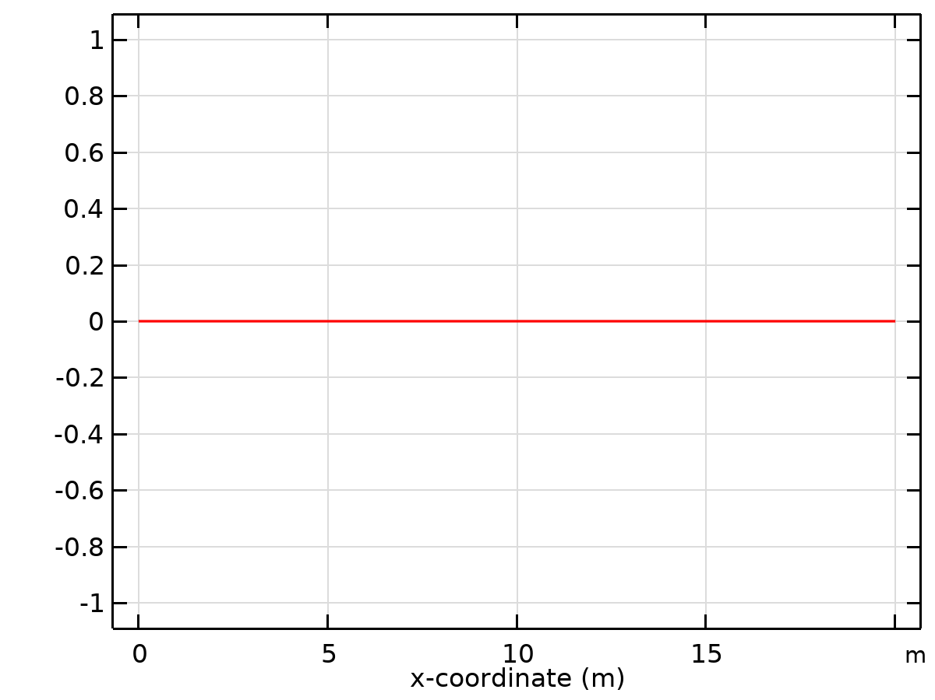

Dataset: Study 1/Solution 1

### Grid 1D 1

Data

| **Description** | **Value** |
| --- | --- |
| Function | All |
| Refresh |  |

Parameter bounds

| **Description** | **Value** |
| --- | --- |
| Name | x |
| Minimum | -2.4 |
| Maximum | 2.4 |

Grid

| **Description** | **Value** |
| --- | --- |
| Resolution | 10000 |
| Point distribution | Mixed uniform/exponential |

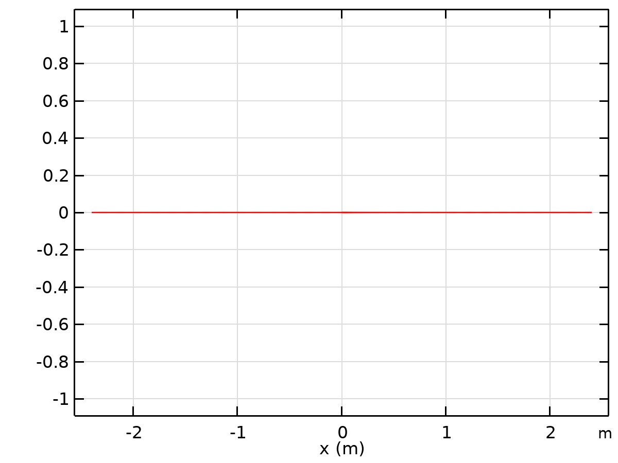

Dataset: Grid 1D 1

### Grid 1D 1a

Data

| **Description** | **Value** |
| --- | --- |
| Function | All |
| Refresh |  |

Parameter bounds

| **Description** | **Value** |
| --- | --- |
| Name | x |
| Minimum | -2 |
| Maximum | 2 |

Grid

| **Description** | **Value** |
| --- | --- |
| Resolution | 10000 |
| Point distribution | Mixed uniform/exponential |

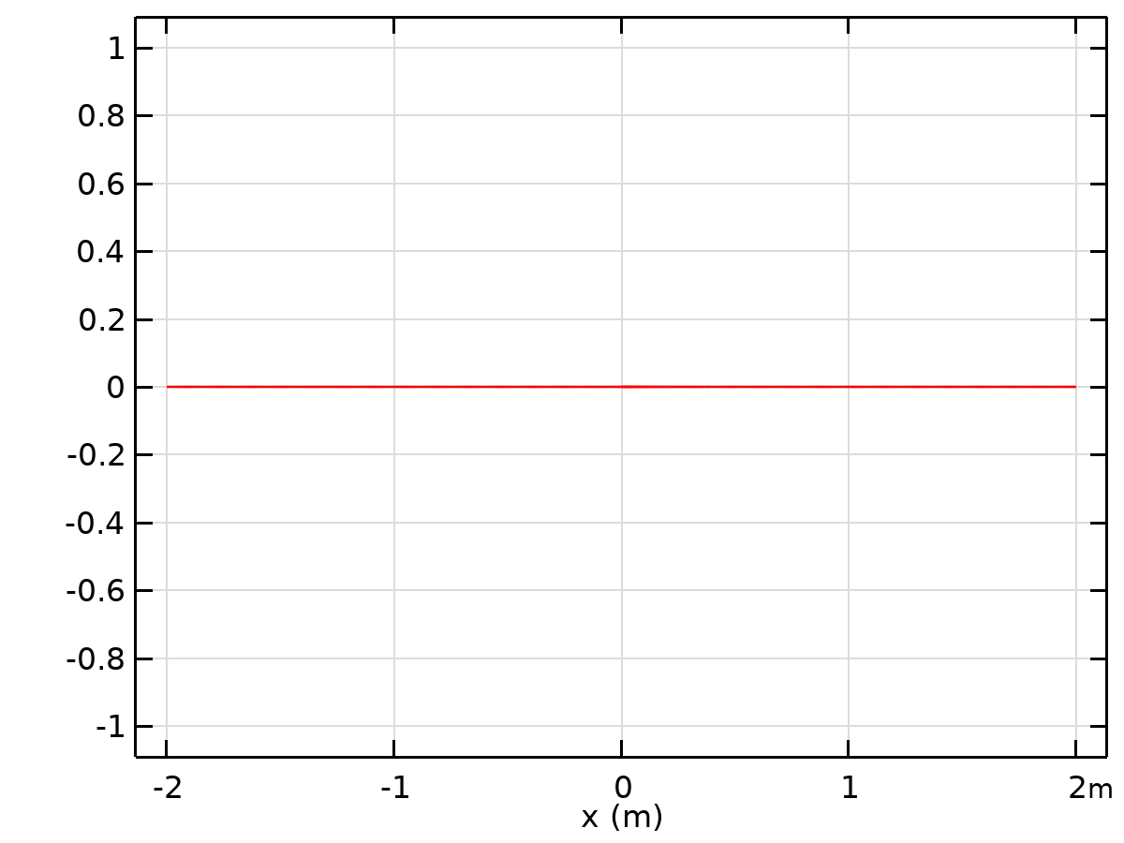

Dataset: Grid 1D 1a

### Grid 1D 2

Data

| **Description** | **Value** |
| --- | --- |
| Function | All |
| Refresh |  |

Parameter bounds

| **Description** | **Value** |
| --- | --- |
| Name | x |
| Minimum | -2 |
| Maximum | 2 |

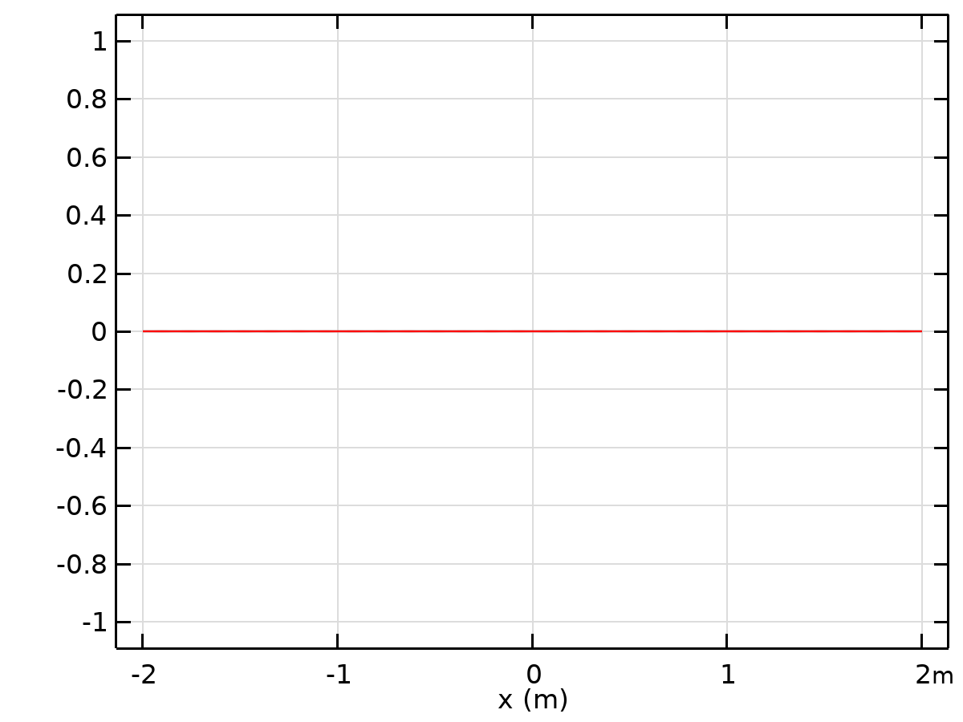

Dataset: Grid 1D 2

### Grid 2D 1

Data

| **Description** | **Value** |
| --- | --- |
| Function | rhow4 (rhow4) |
| Refresh |  |

Parameter bounds

| **Description** | **Value** |
| --- | --- |
| Name | x |
| Minimum | 2.3 |
| Maximum | 7 |
| Name | y |
| Minimum | 0 |
| Maximum | 1.1 |

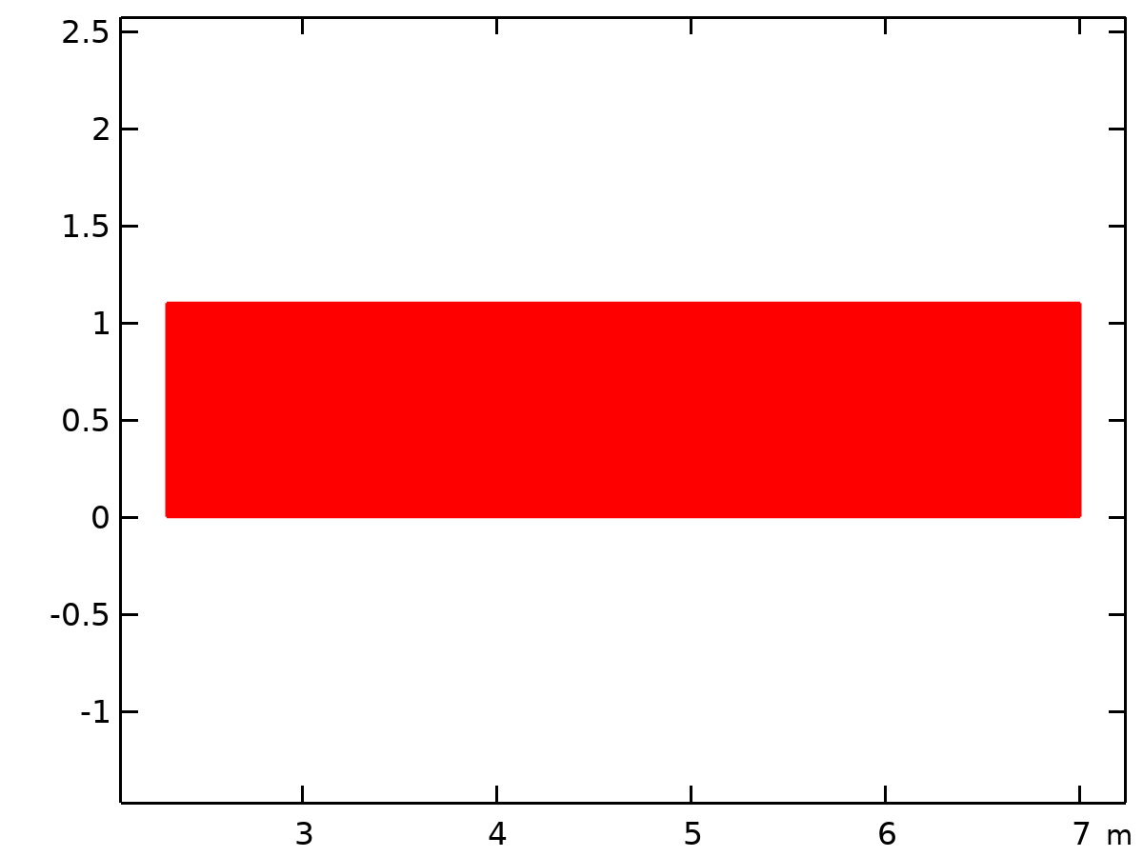

Dataset: Grid 2D 1

### Grid 1D 1b

Data

| **Description** | **Value** |
| --- | --- |
| Function | All |
| Refresh |  |

Parameter bounds

| **Description** | **Value** |
| --- | --- |
| Name | x |
| Minimum | -2.4 |
| Maximum | 2.4 |

Grid

| **Description** | **Value** |
| --- | --- |
| Resolution | 10000 |
| Point distribution | Mixed uniform/exponential |



Dataset: Grid 1D 1b

### Grid 1D 1c

Data

| **Description** | **Value** |
| --- | --- |
| Function | All |
| Refresh |  |

Parameter bounds

| **Description** | **Value** |
| --- | --- |
| Name | x |
| Minimum | -2.4 |
| Maximum | 2.4 |

Grid

| **Description** | **Value** |
| --- | --- |
| Resolution | 10000 |
| Point distribution | Mixed uniform/exponential |



Dataset: Grid 1D 1c

### Grid 1D 1d

Data

| **Description** | **Value** |
| --- | --- |
| Function | All |
| Refresh |  |

Parameter bounds

| **Description** | **Value** |
| --- | --- |
| Name | x |
| Minimum | -2.4 |
| Maximum | 2.4 |

Grid

| **Description** | **Value** |
| --- | --- |
| Resolution | 10000 |
| Point distribution | Mixed uniform/exponential |



Dataset: Grid 1D 1d

### Grid 1D 2a

Data

| **Description** | **Value** |
| --- | --- |
| Function | All |
| Refresh |  |

Parameter bounds

| **Description** | **Value** |
| --- | --- |
| Name | x |
| Minimum | -2.4 |
| Maximum | 2.4 |

Grid

| **Description** | **Value** |
| --- | --- |
| Resolution | 10000 |
| Point distribution | Mixed uniform/exponential |



Dataset: Grid 1D 2a

### Grid 1D 1e

Data

| **Description** | **Value** |
| --- | --- |
| Function | All |
| Refresh |  |

Parameter bounds

| **Description** | **Value** |
| --- | --- |
| Name | x |
| Minimum | -2.4 |
| Maximum | 2.4 |

Grid

| **Description** | **Value** |
| --- | --- |
| Resolution | 10000 |
| Point distribution | Mixed uniform/exponential |



Dataset: Grid 1D 1e

### Grid 1D 3

Data

| **Description** | **Value** |
| --- | --- |
| Function | All |
| Refresh |  |

Parameter bounds

| **Description** | **Value** |
| --- | --- |
| Name | x |
| Minimum | -2.4 |
| Maximum | 2.4 |

Grid

| **Description** | **Value** |
| --- | --- |
| Resolution | 10000 |
| Point distribution | Mixed uniform/exponential |



Dataset: Grid 1D 3

### Grid 1D 2b

Data

| **Description** | **Value** |
| --- | --- |
| Function | All |
| Refresh |  |

Parameter bounds

| **Description** | **Value** |
| --- | --- |
| Name | x |
| Minimum | -2.4 |
| Maximum | 2.4 |

Grid

| **Description** | **Value** |
| --- | --- |
| Resolution | 10000 |
| Point distribution | Mixed uniform/exponential |



Dataset: Grid 1D 2b

### Grid 1D 1f

Data

| **Description** | **Value** |
| --- | --- |
| Function | All |
| Refresh |  |

Parameter bounds

| **Description** | **Value** |
| --- | --- |
| Name | x |
| Minimum | -2.4 |
| Maximum | 2.4 |

Grid

| **Description** | **Value** |
| --- | --- |
| Resolution | 10000 |
| Point distribution | Mixed uniform/exponential |



Dataset: Grid 1D 1f

### Grid 1D 3a

Data

| **Description** | **Value** |
| --- | --- |
| Function | All |
| Refresh |  |

Parameter bounds

| **Description** | **Value** |
| --- | --- |
| Name | x |
| Minimum | -2.4 |
| Maximum | 2.4 |

Grid

| **Description** | **Value** |
| --- | --- |
| Resolution | 10000 |
| Point distribution | Mixed uniform/exponential |



Dataset: Grid 1D 3a

### Grid 1D 2c

Data

| **Description** | **Value** |
| --- | --- |
| Function | All |
| Refresh |  |

Parameter bounds

| **Description** | **Value** |
| --- | --- |
| Name | x |
| Minimum | -2.4 |
| Maximum | 2.4 |

Grid

| **Description** | **Value** |
| --- | --- |
| Resolution | 10000 |
| Point distribution | Mixed uniform/exponential |



Dataset: Grid 1D 2c

### Grid 1D 4

Data

| **Description** | **Value** |
| --- | --- |
| Function | All |
| Refresh |  |

Parameter bounds

| **Description** | **Value** |
| --- | --- |
| Name | x |
| Minimum | -2.4 |
| Maximum | 2.4 |

Grid

| **Description** | **Value** |
| --- | --- |
| Resolution | 10000 |
| Point distribution | Mixed uniform/exponential |



Dataset: Grid 1D 4

### Grid 1D 1g

Data

| **Description** | **Value** |
| --- | --- |
| Function | Piecewise 6 (se) |
| Refresh |  |

Parameter bounds

| **Description** | **Value** |
| --- | --- |
| Name | x |
| Minimum | -2.3 |
| Maximum | 1.3 |

Grid

| **Description** | **Value** |
| --- | --- |
| Resolution | 10000 |
| Point distribution | Mixed uniform/exponential |

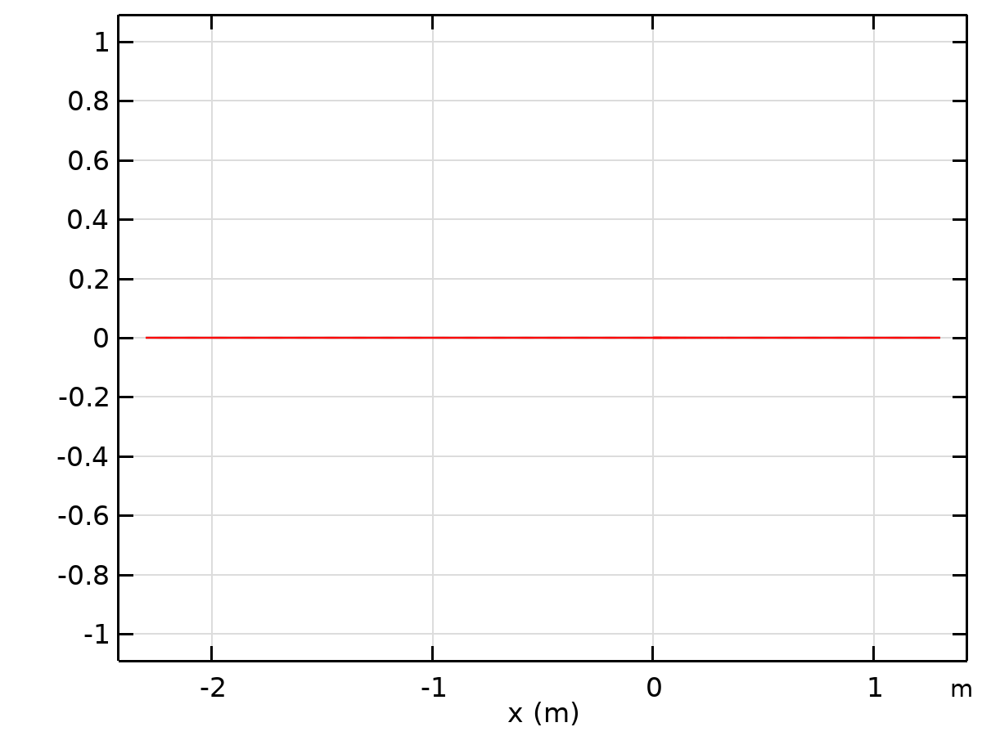

Dataset: Grid 1D 1g

### Grid 1D 5

Data

| **Description** | **Value** |
| --- | --- |
| Function | All |
| Refresh |  |

Parameter bounds

| **Description** | **Value** |
| --- | --- |
| Name | x |
| Minimum | -2.4 |
| Maximum | 2.4 |

Grid

| **Description** | **Value** |
| --- | --- |
| Resolution | 10000 |
| Point distribution | Mixed uniform/exponential |



Dataset: Grid 1D 5

### Grid 1D 2d

Data

| **Description** | **Value** |
| --- | --- |
| Function | All |
| Refresh |  |

Parameter bounds

| **Description** | **Value** |
| --- | --- |
| Name | x |
| Minimum | -2.4 |
| Maximum | 2.4 |

Grid

| **Description** | **Value** |
| --- | --- |
| Resolution | 10000 |
| Point distribution | Mixed uniform/exponential |



Dataset: Grid 1D 2d

### Grid 1D 1h

Data

| **Description** | **Value** |
| --- | --- |
| Function | All |
| Refresh |  |

Parameter bounds

| **Description** | **Value** |
| --- | --- |
| Name | x |
| Minimum | -2.4 |
| Maximum | 2.4 |

Grid

| **Description** | **Value** |
| --- | --- |
| Resolution | 10000 |
| Point distribution | Mixed uniform/exponential |



Dataset: Grid 1D 1h

### Grid 1D 2e

Data

| **Description** | **Value** |
| --- | --- |
| Function | All |
| Refresh |  |

Parameter bounds

| **Description** | **Value** |
| --- | --- |
| Name | x |
| Minimum | -2.4 |
| Maximum | 2.4 |

Grid

| **Description** | **Value** |
| --- | --- |
| Resolution | 10000 |
| Point distribution | Mixed uniform/exponential |



Dataset: Grid 1D 2e

### Grid 1D 3b

Data

| **Description** | **Value** |
| --- | --- |
| Function | All |
| Refresh |  |

Parameter bounds

| **Description** | **Value** |
| --- | --- |
| Name | x |
| Minimum | -2.4 |
| Maximum | 2.4 |

Grid

| **Description** | **Value** |
| --- | --- |
| Resolution | 10000 |
| Point distribution | Mixed uniform/exponential |



Dataset: Grid 1D 3b

### Grid 1D 3c

Data

| **Description** | **Value** |
| --- | --- |
| Function | All |
| Refresh |  |

Parameter bounds

| **Description** | **Value** |
| --- | --- |
| Name | x |
| Minimum | -2.4 |
| Maximum | 2.4 |

Grid

| **Description** | **Value** |
| --- | --- |
| Resolution | 10000 |
| Point distribution | Mixed uniform/exponential |



Dataset: Grid 1D 3c

### Grid 2D 1a

Data

| **Description** | **Value** |
| --- | --- |
| Function | All |
| Refresh |  |

Parameter bounds

| **Description** | **Value** |
| --- | --- |
| Name | x |
| Minimum | 2.5 |
| Maximum | 8 |
| Name | y |
| Minimum | 0.045 |
| Maximum | 4.34 |

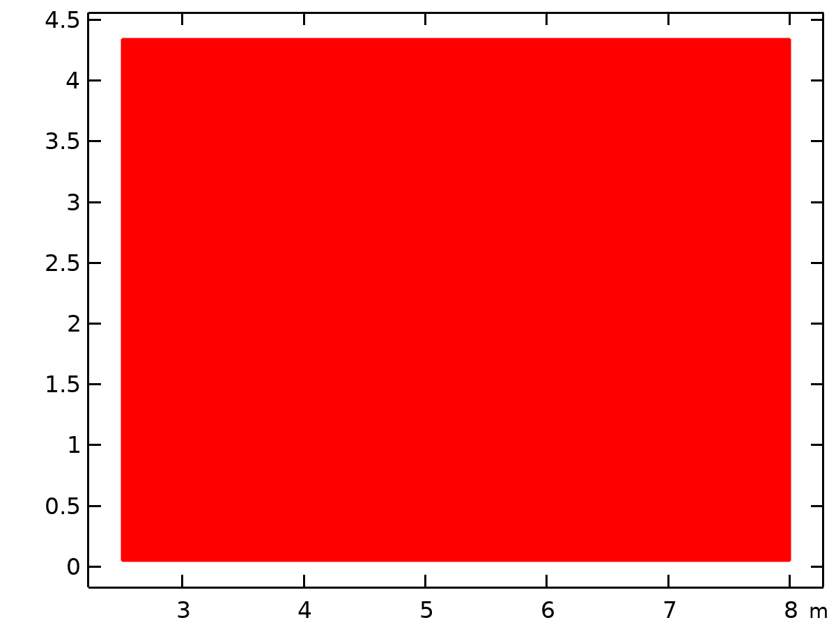

Dataset: Grid 2D 1a

### Grid 2D 2

Data

| **Description** | **Value** |
| --- | --- |
| Function | tbp (tbp) |
| Refresh |  |

Parameter bounds

| **Description** | **Value** |
| --- | --- |
| Name | x |
| Minimum | 2.5 |
| Maximum | 8 |
| Name | y |
| Minimum | 0.045 |
| Maximum | 4.34 |



Dataset: Grid 2D 2

### Grid 2D 3

Data

| **Description** | **Value** |
| --- | --- |
| Function | tbp (tbp) |
| Refresh |  |

Parameter bounds

| **Description** | **Value** |
| --- | --- |
| Name | x |
| Minimum | 2.5 |
| Maximum | 8 |
| Name | y |
| Minimum | 0.045 |
| Maximum | 6.34 |

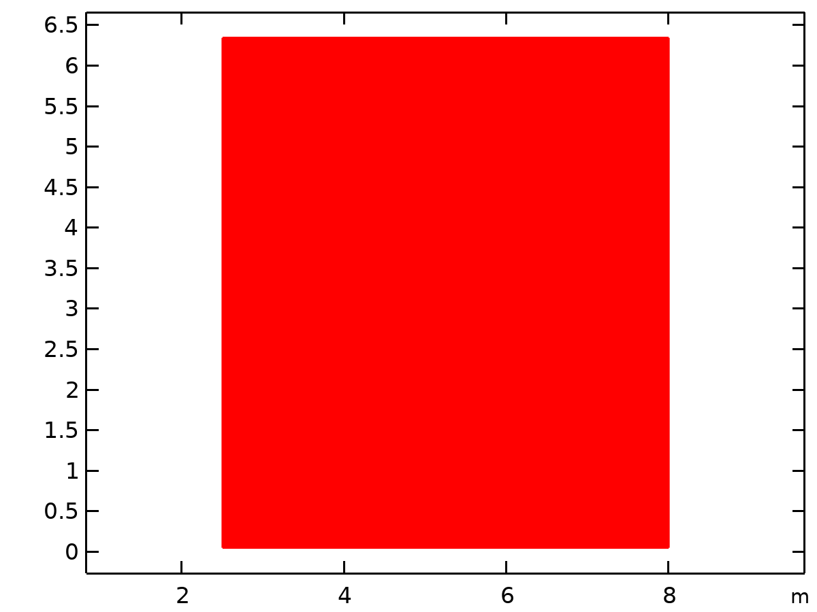

Dataset: Grid 2D 3

### Grid 2D 4

Data

| **Description** | **Value** |
| --- | --- |
| Function | tbp (tbp) |
| Refresh |  |

Parameter bounds

| **Description** | **Value** |
| --- | --- |
| Name | x |
| Minimum | 2.5 |
| Maximum | 6.91 |
| Name | y |
| Minimum | 0.045 |
| Maximum | 6.34 |

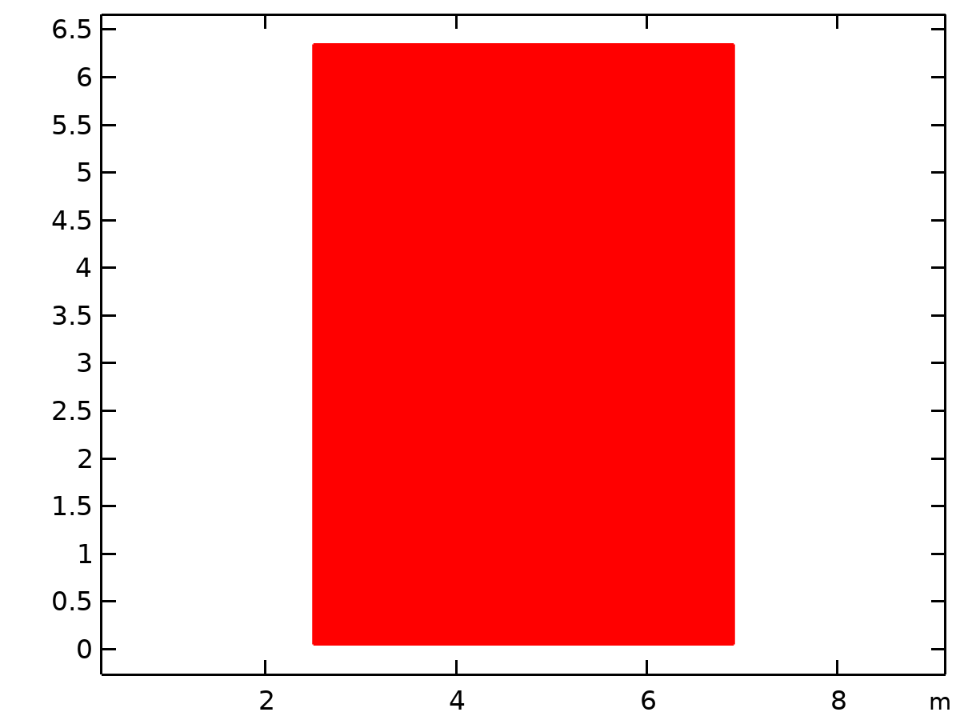

Dataset: Grid 2D 4

### Grid 3D 5

Data

| **Description** | **Value** |
| --- | --- |
| Function | tbp (tbp) |
| Refresh |  |

Parameter bounds

| **Description** | **Value** |
| --- | --- |
| Name | x |
| Minimum | 2.5 |
| Maximum | 8 |
| Name | y |
| Minimum | 0.045 |
| Maximum | 6.9 |
| Name | z |
| Minimum | 0.01 |
| Maximum | 6.3 |

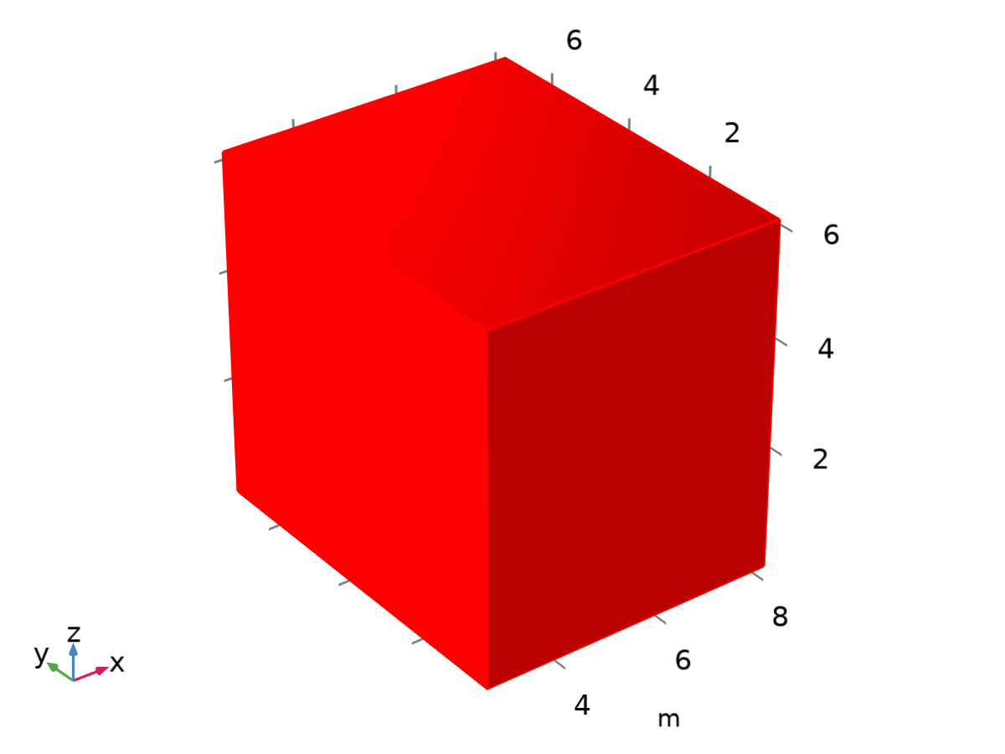

Dataset: Grid 3D 5

### Grid 1D 4a

Data

| **Description** | **Value** |
| --- | --- |
| Function | All |
| Refresh |  |

Parameter bounds

| **Description** | **Value** |
| --- | --- |
| Name | x |
| Minimum | -2.4 |
| Maximum | 2.4 |

Grid

| **Description** | **Value** |
| --- | --- |
| Resolution | 10000 |
| Point distribution | Mixed uniform/exponential |



Dataset: Grid 1D 4a

### Grid 1D 5a

Data

| **Description** | **Value** |
| --- | --- |
| Function | All |
| Refresh |  |

Parameter bounds

| **Description** | **Value** |
| --- | --- |
| Name | x |
| Minimum | -2.4 |
| Maximum | 2.4 |

Grid

| **Description** | **Value** |
| --- | --- |
| Resolution | 10000 |
| Point distribution | Mixed uniform/exponential |



Dataset: Grid 1D 5a

### Grid 1D 6

Data

| **Description** | **Value** |
| --- | --- |
| Function | All |
| Refresh |  |

Parameter bounds

| **Description** | **Value** |
| --- | --- |
| Name | x |
| Minimum | -2.4 |
| Maximum | 2.4 |

Grid

| **Description** | **Value** |
| --- | --- |
| Resolution | 10000 |
| Point distribution | Mixed uniform/exponential |



Dataset: Grid 1D 6

### Grid 1D 7

Data

| **Description** | **Value** |
| --- | --- |
| Function | All |
| Refresh |  |

Parameter bounds

| **Description** | **Value** |
| --- | --- |
| Name | x |
| Minimum | -2.4 |
| Maximum | 2.4 |

Grid

| **Description** | **Value** |
| --- | --- |
| Resolution | 10000 |
| Point distribution | Mixed uniform/exponential |



Dataset: Grid 1D 7

### Grid 1D 8

Data

| **Description** | **Value** |
| --- | --- |
| Function | All |
| Refresh |  |

Parameter bounds

| **Description** | **Value** |
| --- | --- |
| Name | x |
| Minimum | -2.4 |
| Maximum | 2.4 |

Grid

| **Description** | **Value** |
| --- | --- |
| Resolution | 10000 |
| Point distribution | Mixed uniform/exponential |



Dataset: Grid 1D 8

### Grid 1D 9

Data

| **Description** | **Value** |
| --- | --- |
| Function | All |
| Refresh |  |

Parameter bounds

| **Description** | **Value** |
| --- | --- |
| Name | x |
| Minimum | -2.4 |
| Maximum | 2.4 |

Grid

| **Description** | **Value** |
| --- | --- |
| Resolution | 10000 |
| Point distribution | Mixed uniform/exponential |



Dataset: Grid 1D 9

### Grid 1D 10

Data

| **Description** | **Value** |
| --- | --- |
| Function | All |
| Refresh |  |

Parameter bounds

| **Description** | **Value** |
| --- | --- |
| Name | x |
| Minimum | -2.4 |
| Maximum | 2.4 |

Grid

| **Description** | **Value** |
| --- | --- |
| Resolution | 10000 |
| Point distribution | Mixed uniform/exponential |



Dataset: Grid 1D 10

### Grid 1D 1i

Data

| **Description** | **Value** |
| --- | --- |
| Function | All |
| Refresh |  |

Parameter bounds

| **Description** | **Value** |
| --- | --- |
| Name | x |
| Minimum | 0 |
| Maximum | 1 |

Grid

| **Description** | **Value** |
| --- | --- |
| Resolution | 10000 |
| Point distribution | Mixed uniform/exponential |

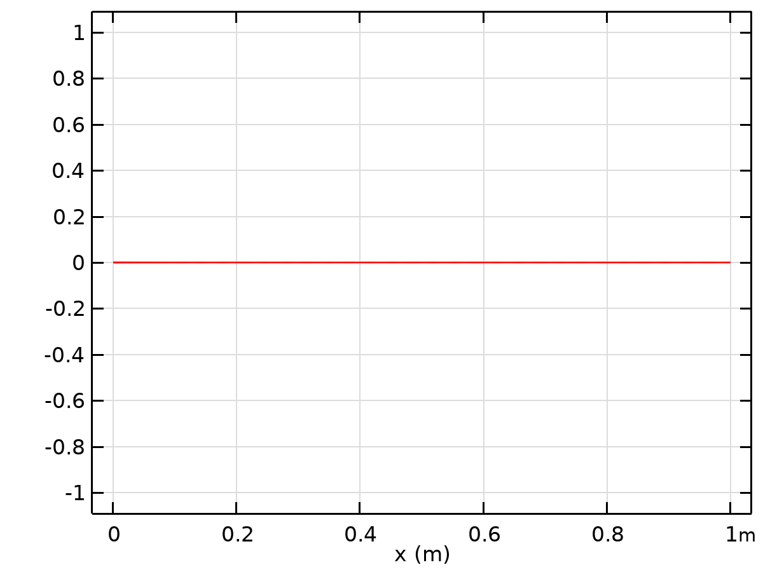

Dataset: Grid 1D 1i

### Grid 1D 1j

Data

| **Description** | **Value** |
| --- | --- |
| Function | All |
| Refresh |  |

Parameter bounds

| **Description** | **Value** |
| --- | --- |
| Name | x |
| Minimum | 0 |
| Maximum | 1 |

Grid

| **Description** | **Value** |
| --- | --- |
| Resolution | 10000 |
| Point distribution | Mixed uniform/exponential |



Dataset: Grid 1D 1j

### Grid 1D 2f

Data

| **Description** | **Value** |
| --- | --- |
| Function | All |
| Refresh |  |

Parameter bounds

| **Description** | **Value** |
| --- | --- |
| Name | x |
| Minimum | 0 |
| Maximum | 1 |

Grid

| **Description** | **Value** |
| --- | --- |
| Resolution | 10000 |
| Point distribution | Mixed uniform/exponential |



Dataset: Grid 1D 2f

### Grid 1D 3d

Data

| **Description** | **Value** |
| --- | --- |
| Function | All |
| Refresh |  |

Parameter bounds

| **Description** | **Value** |
| --- | --- |
| Name | x |
| Minimum | 0 |
| Maximum | 1 |

Grid

| **Description** | **Value** |
| --- | --- |
| Resolution | 10000 |
| Point distribution | Mixed uniform/exponential |



Dataset: Grid 1D 3d

### Grid 1D 4b

Data

| **Description** | **Value** |
| --- | --- |
| Function | All |
| Refresh |  |

Parameter bounds

| **Description** | **Value** |
| --- | --- |
| Name | x |
| Minimum | 0 |
| Maximum | 1 |

Grid

| **Description** | **Value** |
| --- | --- |
| Resolution | 10000 |
| Point distribution | Mixed uniform/exponential |



Dataset: Grid 1D 4b

### Grid 1D 5b

Data

| **Description** | **Value** |
| --- | --- |
| Function | All |
| Refresh |  |

Parameter bounds

| **Description** | **Value** |
| --- | --- |
| Name | x |
| Minimum | 0 |
| Maximum | 1 |

Grid

| **Description** | **Value** |
| --- | --- |
| Resolution | 10000 |
| Point distribution | Mixed uniform/exponential |



Dataset: Grid 1D 5b

### Grid 1D 6a

Data

| **Description** | **Value** |
| --- | --- |
| Function | All |
| Refresh |  |

Parameter bounds

| **Description** | **Value** |
| --- | --- |
| Name | x |
| Minimum | 0 |
| Maximum | 1 |

Grid

| **Description** | **Value** |
| --- | --- |
| Resolution | 10000 |
| Point distribution | Mixed uniform/exponential |



Dataset: Grid 1D 6a

## Plot Groups

### 1D Plot Group 1

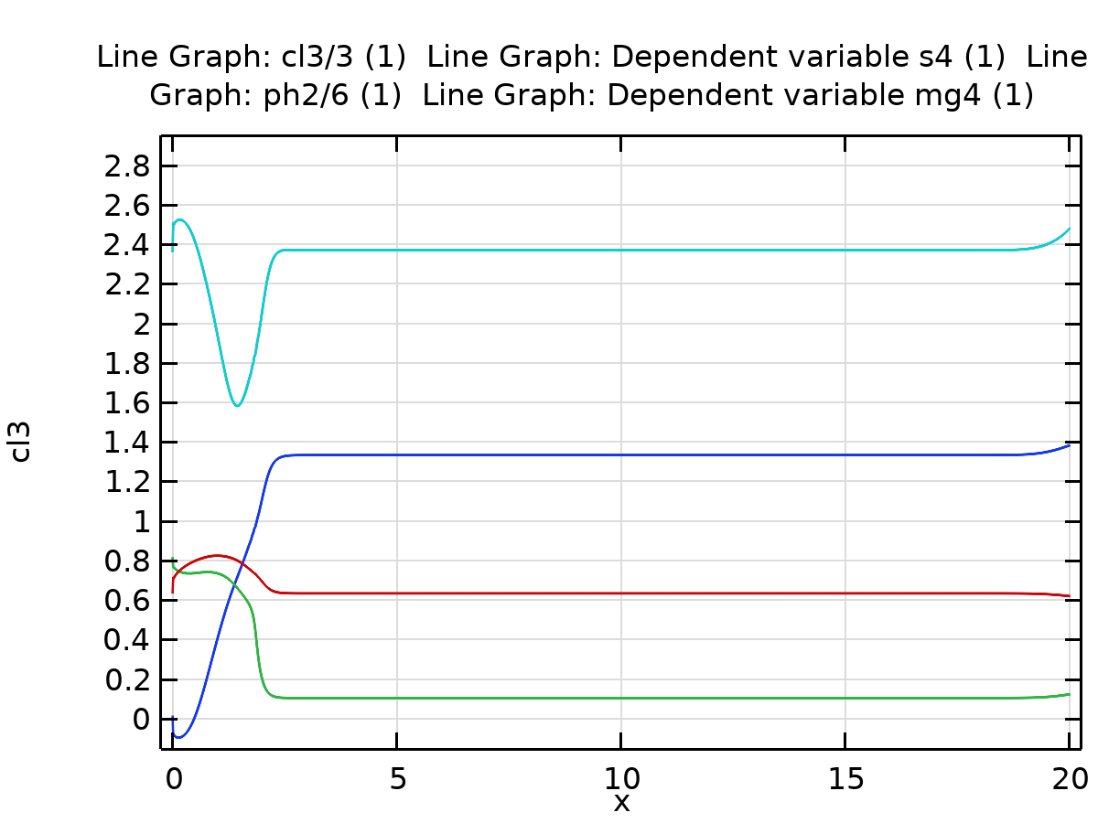

Line Graph: cl3/3 (1) Line Graph: Dependent variable s4 (1) Line Graph: ph2/6 (1) Line Graph: Dependent variable mg4 (1)

### 1D Plot Group 2

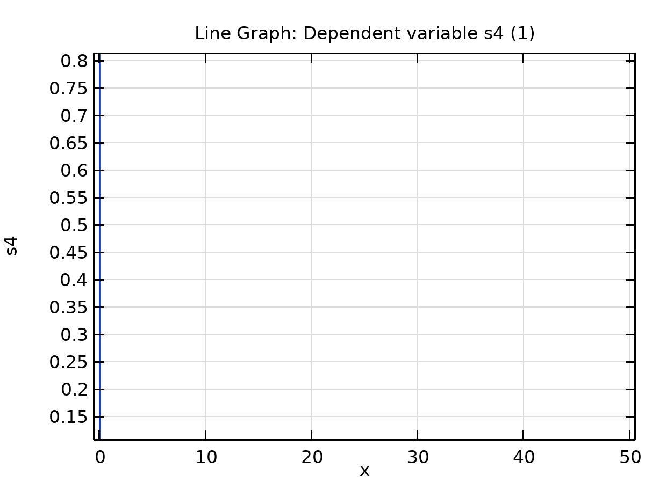

Line Graph: Dependent variable s4 (1)

### 1D Plot Group 3

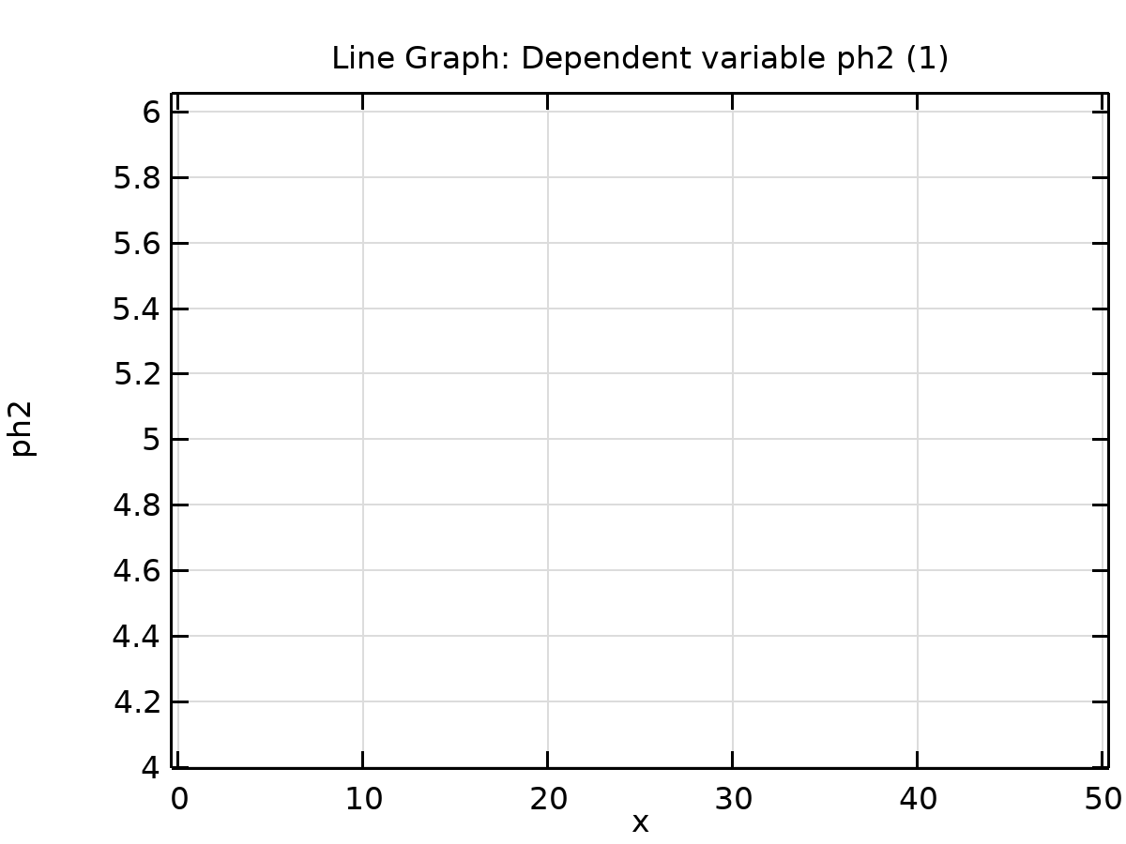

Line Graph: Dependent variable ph2 (1)

### 1D Plot Group 4

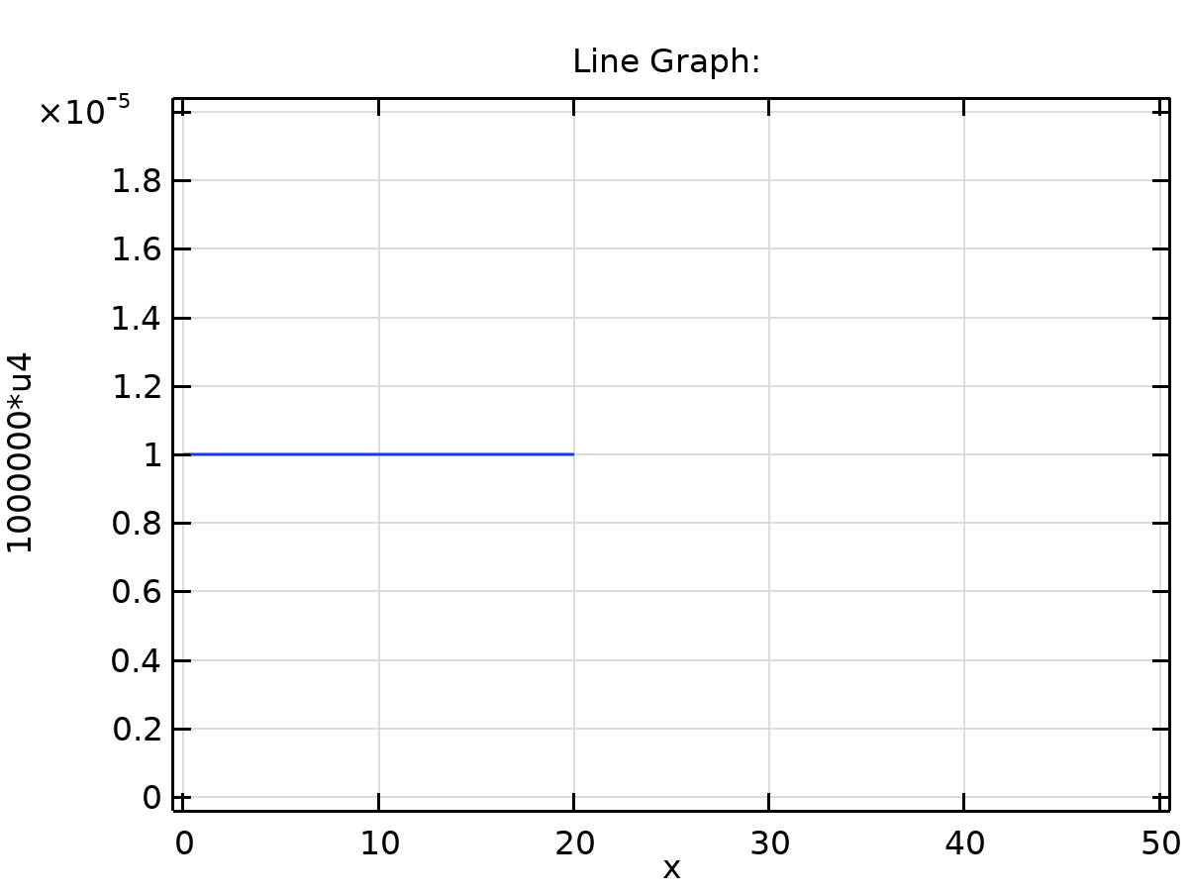

Line Graph:

### 1D Plot Group 5

### 1D Plot Group 6

### 1D Plot Group 7

### 1D Plot Group 8



krwls(x)

### 1D Plot Group 9

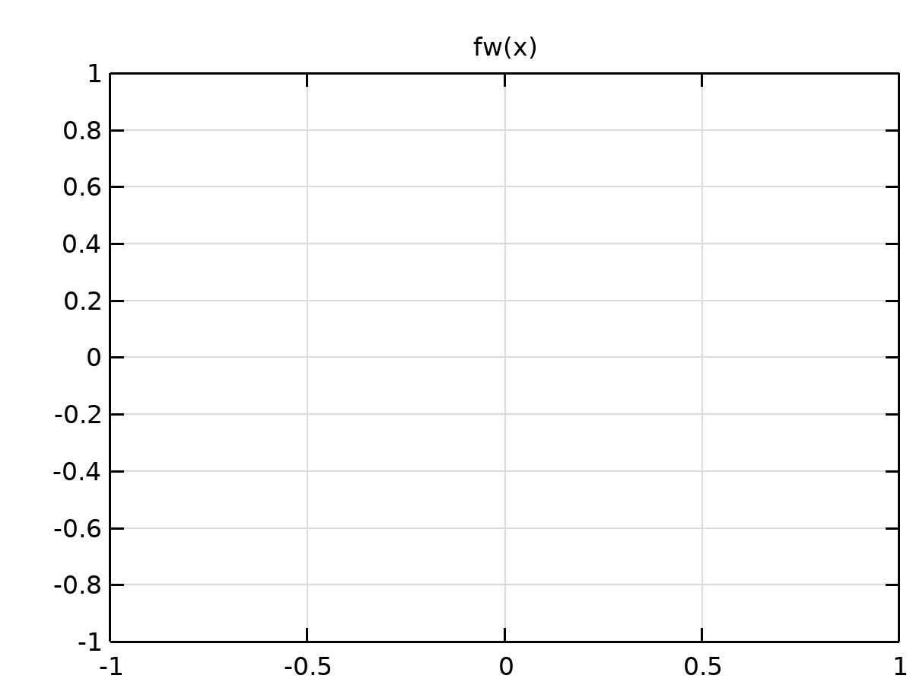

fw(x)

### 1D Plot Group 10



krw(x)

### 1D Plot Group 11

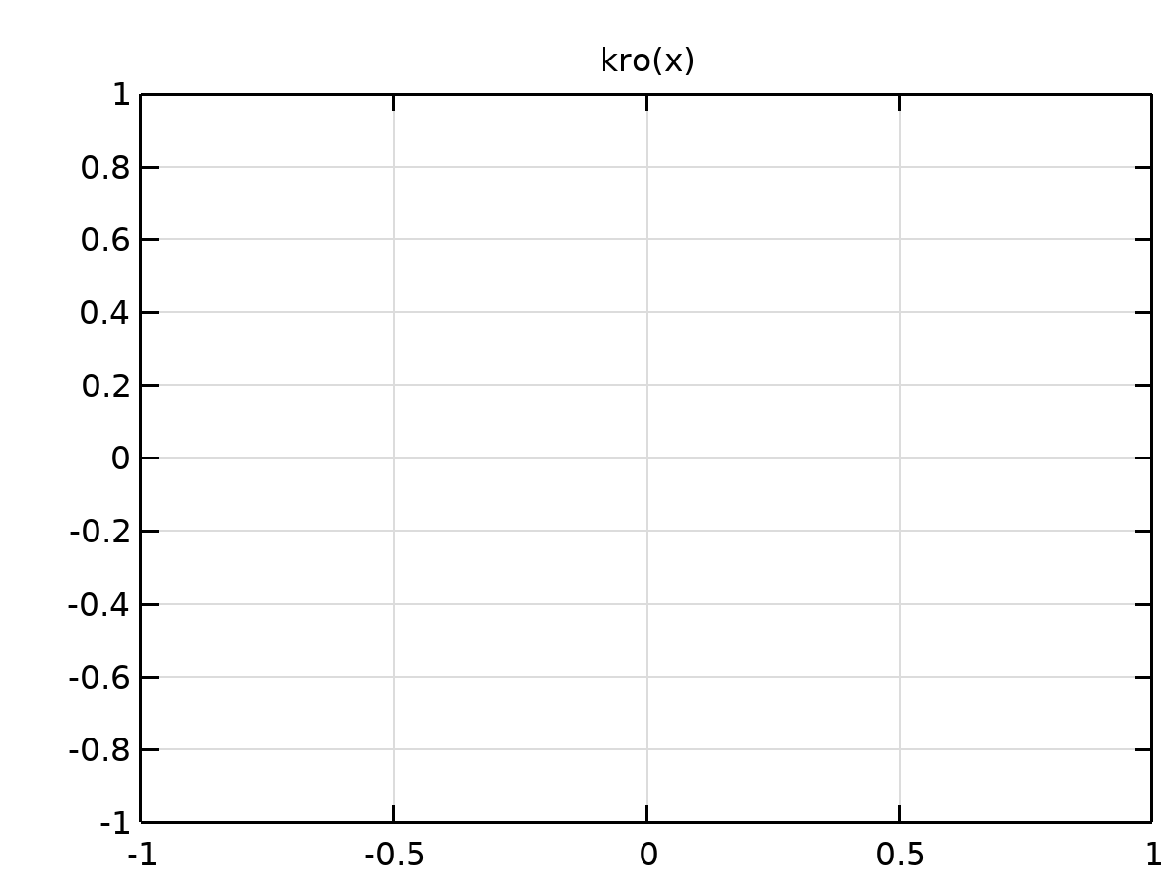

kro(x)

### 1D Plot Group 12

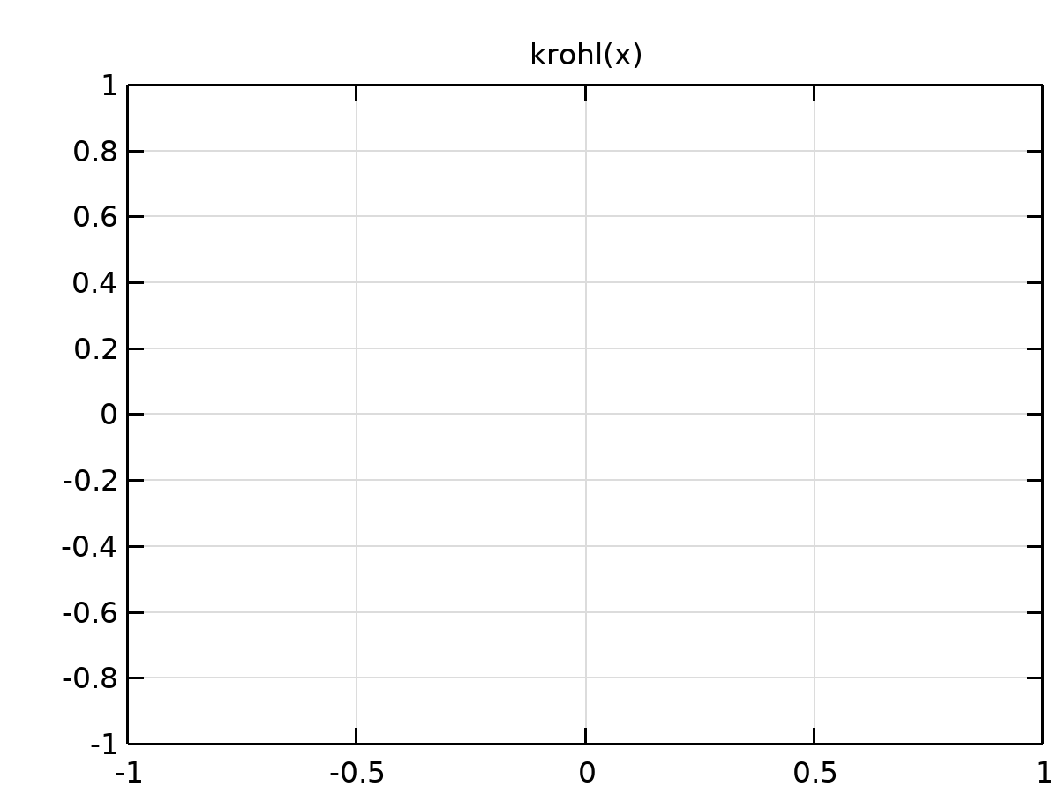

krohl(x)

### 1D Plot Group 14



krohl(x)

### 1D Plot Group 15



Mgini(x)